TOPIC: Space

Subtopic 3: Our planet
Pre-test
Teaching phase 1: Continents and oceans
Application phase 1: Continents and oceans
Teaching phase 2: Wind direction
Application phase 2: Wind direction
Teaching phase 3: The Great Trek
Application phase 3: The Great Trek
Evaluation phase

Pre-test

Hi there! How well do you know our planet? Today we are going to study the map of the world! First answer these questions to see what you already know.

Titel: Question 1

Which statement is true?
- Europe borders on South America.
- There are three oceans on our planet.
- Europe is one of the seven continents on our planet.
- Africa borders on Oceania.

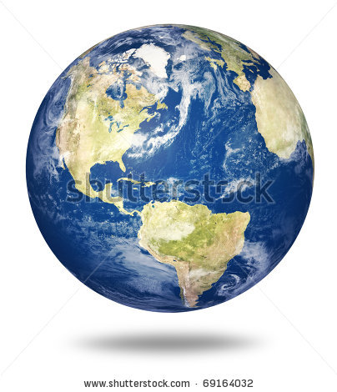
Titel: Question 2

On which continent are the Himalayas located?
- Europe
- Africa
- South America
- Asia

Titel: Question 3

When a cold north wind blows through our country (yellow circle), what region does this wind come from?
- Region 1
- Region 2
- Region 3
- Region 4

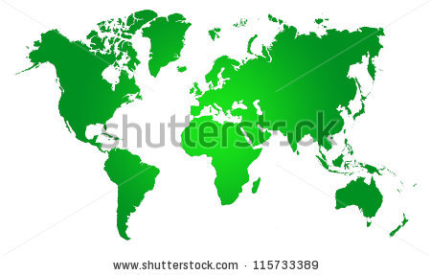
1
4
2
3

Titel: Question 4

Here is a map of the world. Which statement is true?
- North America is north of South America.
- Africa is north of Europe.
- Oceania is north of Asia.
- Antarctica is north of the North Pole.
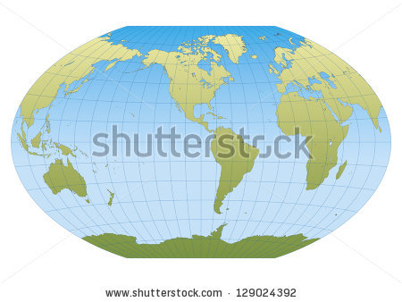

Titel: Question 5

Dmitri lives in Moscow (Russia, A). He would like to travel to Hong Kong(China, B). Take a good look at the scale at the bottom left of this map: 1 cm on the map represents 2000 km on the ground. The distance between Moscow and Hong Kong is around 4 centimetres on the map. What is the distance between Moscow and Hong Kong on the ground?
- Around 6.000 km
- Around 8.000 km
- Around 8000 cm
- Around 800 km
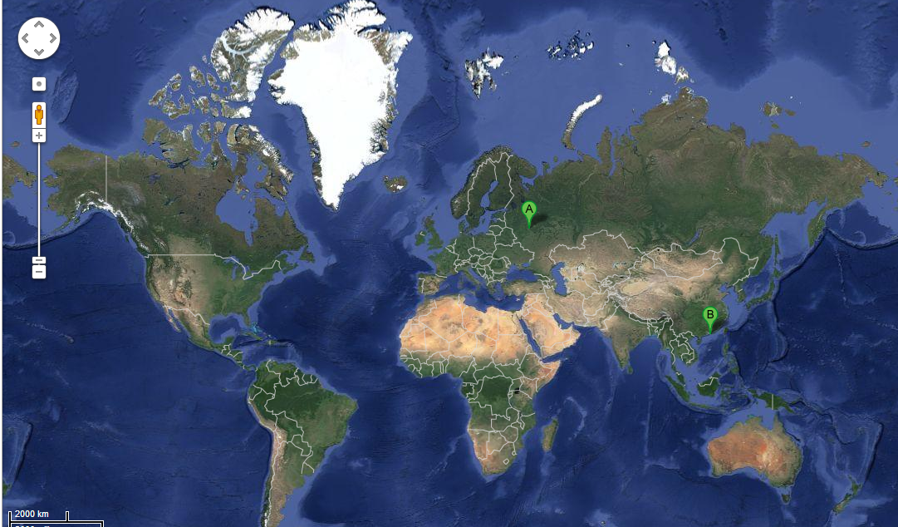

Teaching phase 1: Continents and oceans

Titel: Continents and oceans

Belgium is in Europe and Europe is one of the seven continents. Wow, the Earth is really big! Time to take a closer look at our globe!
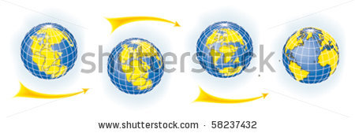
Planet Earth came into existence around 4.56 billion years (that's 4,560,000,000 years) ago. The Earth looked very different at that time. All the continents used to be joined together. Little by little, they moved apart.

Now there are seven continents spread across our planet.
Here are all seven:
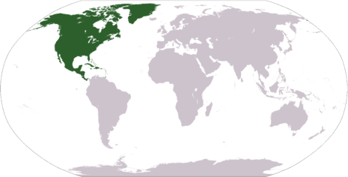
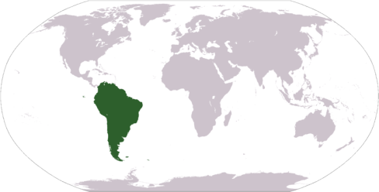
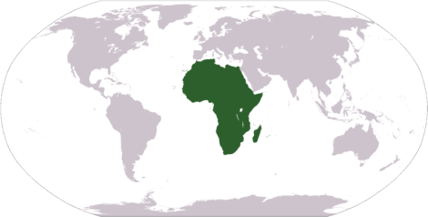
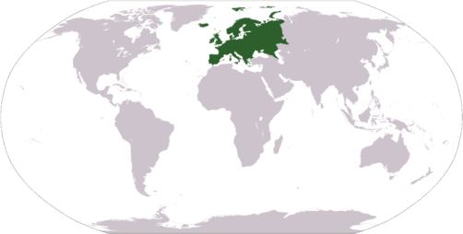

1. North America
2. South America
4. Africa
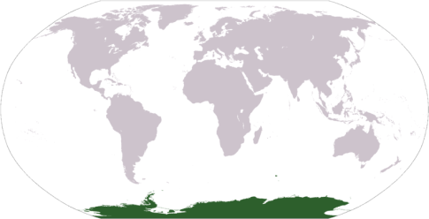
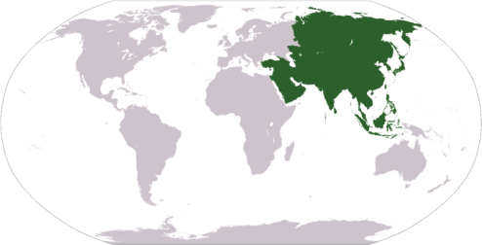
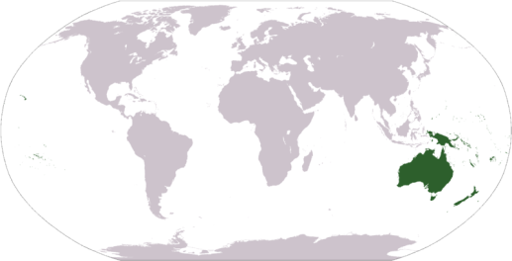
3. Europe
5. Asia
6. Oceania
7. Antarctica
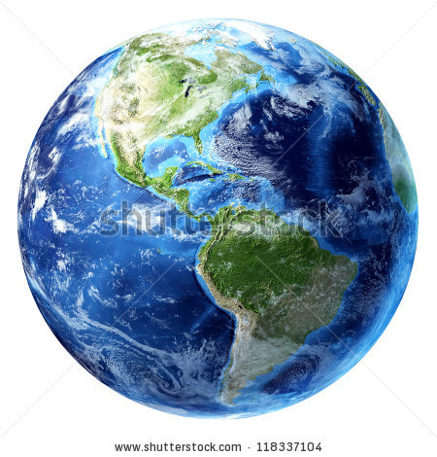
If you looked at our planet from outer space, you would see a blue sphere. The reason for that is all the water flowing between the continents. There are five major oceans:

- the Pacific Ocean
- the Arctic Ocean (close to the North Pole)
- the Atlantic Ocean
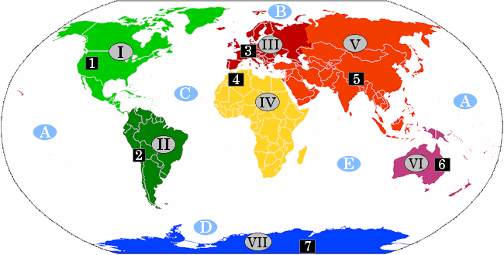
- the Southern or Antarctic Ocean (close to the South Pole)
- the Indian Ocean

We can also identify an important mountain range on each continent:

- In North America (I, light green) you have the Rocky Mountains (1).
- In South America (II, dark green) you have the Andes (2).
- In Europe (III, red) you have the Alps (3).
- In Africa (IV, yellow) you have the Atlas Mountains (4).
- In Asia (V, orange) you have the Himalayas (5).
- In Oceania (VI, purple) you have the Great Dividing Range (6).
- In Antarctica (VII, blue) you have the Transantarctic Mountains (7).
Application phase 1 (application 1): Continents and oceans

Titel: Continents and oceans

The globe has broken up into seven pieces! Can you put each continent back in its proper place? Drag each continent to the right box. We'll give you one for free. Antarctica (black) is already in the right spot.

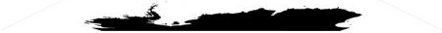

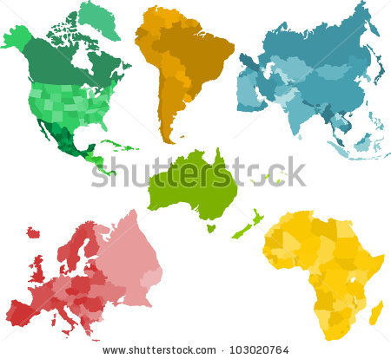
Answer

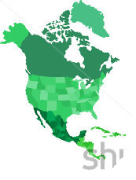 | 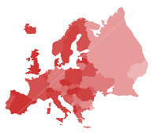 | 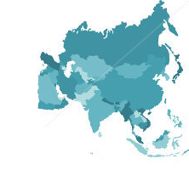
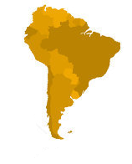 | 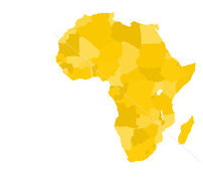 | 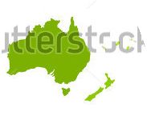

Juist: Well done!
Fout na eerste poging: Your answer is not quite right. Try again.
Fout na tweede poging: Better luck next time! Take a look at the right answer.

Application phase 1 (application 2): Continents and oceans

Titel: Continents and oceans

Captain Sushii would like to sail from Asia to South Africa (green arrow).

True or false? Captain Sushii has to cross the Indian Ocean to travel from Asia to South Africa.

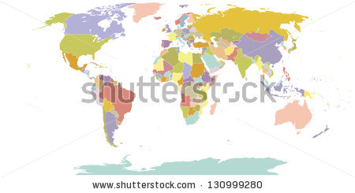



Antwoord:True.
Juist: Well done!
Fout: That's not right! Captain Sushii has to cross the Indian Ocean to travel from Asia to South Africa.

Titel: Continents and oceans
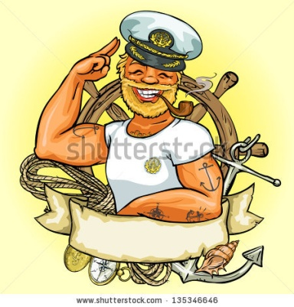
Captain John would like to sail from North America to Europe (green arrow).

True or false? Captain John has to sail across the Pacific Ocean to travel from North America to Europe.
Antwoord: False.
Juist: Good answer!
Fout: That's not right. Captain John has to sail across the Atlantic Ocean to travel from North America to Europe.

Titel: Continents and oceans
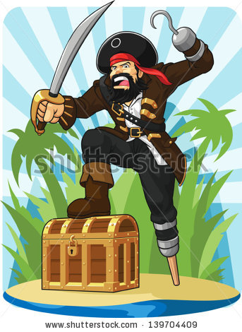
Captain Blackbeard lives in South America. He is a true treasure seeker. He heard in the pub that there is some hidden treasure on Antarctica. Now he wants to go and dig up that treasure (green arrow).

True or false? Captain Blackbeard has to cross the Arctic Ocean to reach Antarctica.

Antwoord: False.
Juist: Excellent!
Fout: That's not right. Captain Blackbeard has to cross the Southern Ocean to sail from South America to Antarctica.

Titel: Continents and oceans
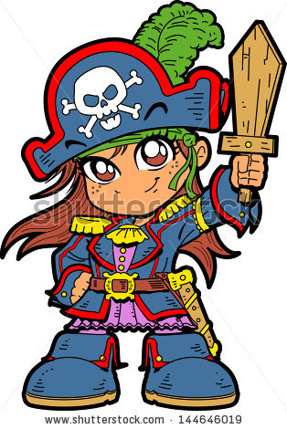
Captain Dorothea wants to cross the Pacific Ocean in order to travel from North America to Asia.

True or false? The green arrow shows the correct route for Captain Dorothea.

TIP: Take a good look at the location of the continents on this map!

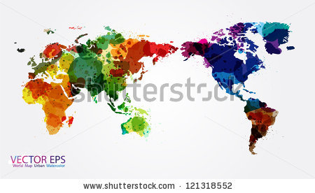
Antwoord: True.
Juist: Goed!
Fout: That's not right. The green arrow shows the correct route for Captain Dorothea. This is how she can cross the Pacific Ocean.
Application phase 1 (application 3): Continents and oceans

Titel: Continents and oceans

Each continent on our planet has an important mountain range. Match each mountain range with the right continent.

North America |  | Alps
South America |  | Andes
Europe |  | Transantarctic Mountains
Africa |  | Rocky Mountains
Asia |  | Atlas Mountains
Oceania |  | Himalayas
Antarctica |  | Great Dividing Range

Answer

North America |  | Alps
South America |  | Andes
Europe |  | Transantarctic Mountains
Africa |  | Rocky Mountains
Asia |  | Atlas Mountains
Oceania |  | Himalayas
Antarctica |  | Great Dividing Range

Juist: Well done!
Fout na eerste poging: Your answer is not quite right. Try again.
Fout na tweede poging: That's not right, take a look at the right answer.

Teaching phase 2: Wind direction
Titel: Wind direction

Do you sometimes watch the weather forecast? You can learn quite a bit from it about the wind directions!

On a map of the world or a globe you will often see lines. These allow you to determine the exact location of a place.

The vertical lines are meridians. They run from top to bottom, from the North Pole (top of the globe) to the South Pole (bottom of the globe).

The horizontal lines run from left to right, between west and east. The most important of these is the equator. It runs right through the middle of the earth.

North Pole
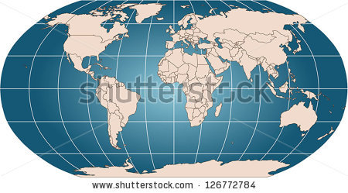

equator
N

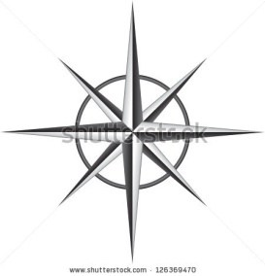

South Pole
Not only is there water running between the various continents, but windis also constantly blowing! From east to west and from north to south ... in the weather report you often hear that the wind is blowing from one particular direction. We call that the wind direction.
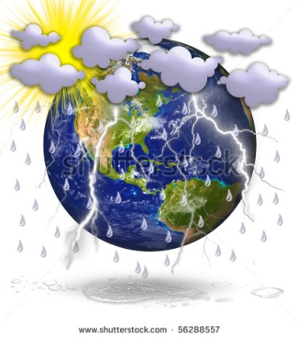
For example: "There is a tropical south wind" or "A cold rain front will be moving across the country from west to east".

To determine the wind direction, we need a compass. The four cardinal directions are north (N), east (E), south (S) and west (W). The directions between them are northeast (NE), southeast (SE), southwest (SW) and northwest (NW).
E
NE
SW
NW
W
SE
N

S
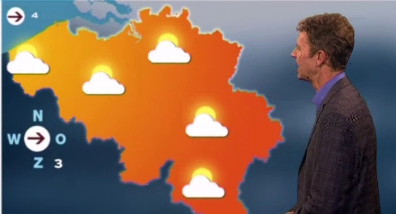
On this illustration with weatherman Frank Deboosere there is a west wind blowing through Belgium. The wind is coming from the west and blowing towards the east, as the arrow indicates.

Watch out!
Don't fall into the trap! The arrow points east, but the wind is blowing from the west. We therefore call it a west wind (and not an east wind).
Application phase 2 (application 1): Wind direction

Titel: Wind direction

Here is a map of the world. Drag each name to the right box.

North Pole | South Pole | equator

Answer
North Pole
South Pole
equator

Juist: Well done!
Fout na eerste poging: Your answer is not quite right. Try again.
Fout na tweede poging: Better luck next time! Take a look at the right answer.

Application phase 2 (application 2): Wind direction

Titel: Wind direction

Here you see five compass roses. From which direction is the wind blowing? Match each wind direction with the right compass rose.

north wind |  | 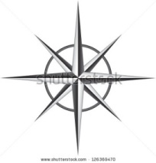
east wind
southeast wind
west wind
southwest wind

Answer
Juist: Well done!
Fout na eerste poging: Your answer is not quite right. Try again. Do you still remember that the wind gets its name from the direction from which it comes?
Fout na tweede poging: Better luck next time! Take a look at the right answer.

north wind
east wind
southeast wind
west wind
southwest wind

Application phase 2 (application 3): Wind direction

Titel: Wind direction

Take a good look at the world map and at the compass rose.

True or false? Above the equator a southwest wind is blowing into North America.

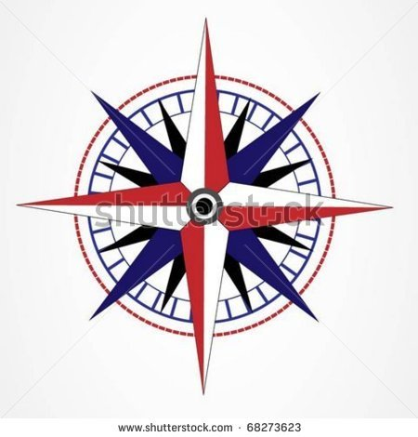
Antwoord:True
Juist: Well done!
Fout: That's not right. The wind (yellow arrow) is coming from the southwest and blowing across North America (red circle), a continent that is above the equator (black line).

Titel: Wind direction

Take a good look at the world map and at the compass rose.

True or false? Above the equator a southeast wind is blowing towards Africa.
Antwoord:False
Juist: Well done!
Fout: That's not right. The wind is coming from the southeast (yellow arrow) and blowing into Africa (red circle). The wind does not come from above the equator (orange dotted line).
Titel: Wind direction

Take a good look at the world map and at the compass rose.

True or false? A northeast wind is blowing from Antarctica towards Oceania.
Antwoord:False.
Juist: Well done!
Fout: That's not right. It is a southwestern wind (yellow arrow) that is blowing from Antarctica towards Oceania (red circle).

Titel: Wind direction

Take a good look at the world map and at the compass rose.

True or false? An east wind is blowing below the equator from Africa towards South America.

Antwoord:True
Juist: Well done!
Fout: That's not right. An east wind (yellow arrow) is blowing below the equator (black line) from Africa towards South America (red circle).
Teaching phase 3: The Great Trek

Titel: The Great Trek

Thanks to cars, aeroplanes and ships, we are able to go on long journeys. But how far, exactly? That's what we are going to discover now!
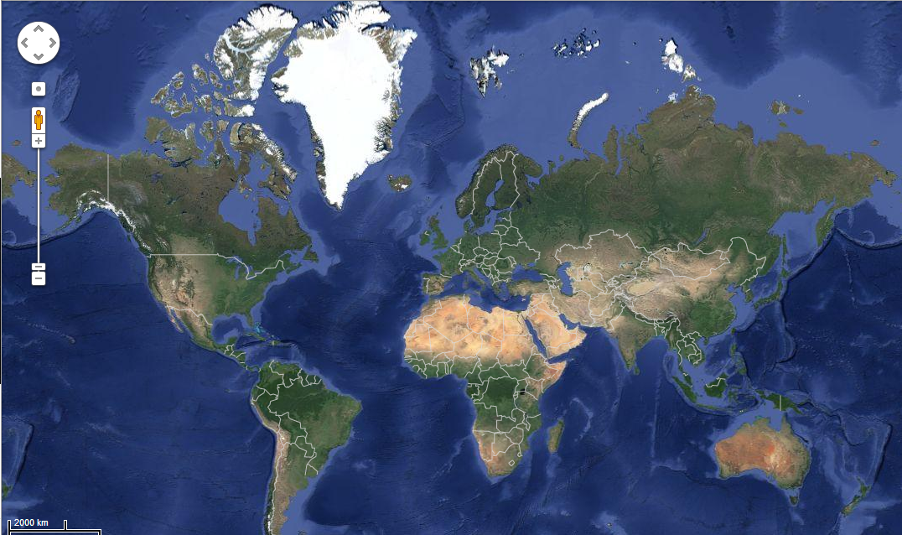
Here is a map of the world. The scale is located at the bottom left (red circle). 1 cm on the map represents 2000 km on the ground.

Using this scale, you can calculate the distance between the various continents.

Please note! We always measure using straight lines. This gives us an idea of the distance 'as the crow flies'. In other words, we don't take into account the existing roads, flight paths or shipping routes.

When we make calculations on such a large scale, the distance is always approximate. During the exercises we say ' approximately 2000 km' instead of 'exactly 2000 km'.

Application phase 3 (application 1): The Great Trek

Titel: The Great Trek

On this map of the world you see the equator (brown line). The equator encircles the entire globe and is therefore equal to the circumference of the Earth.

The scale of this map is
2000 km

or 1 cm on the map represents 2000 km on the ground.

The equator on this map measures approximately 20 cm.

True or false?
If someone wants to travel around the world along the equator, he or she will have to cover 40,000 km.

Antwoord:True
Juist: Good job! Did you use your notebook to make the calculations?
Fout: That's not right. The length of the equator is approximately 20 x 2000 km = 40,000 km. Did you use your notebook to make the calculations?
Titel: The Great Trek
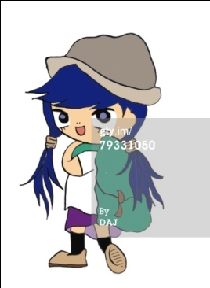

Caroline lives in Amsterdam (the Netherlands, yellow circle). She would like to travel to Chile in South America (red circle).

The scale of this map is
2000 km

or 1 cm on the map represents 2000 km on the ground.

The distance between the Netherlands and Chile measures about 5.5 cm on this map.

True or false?
The distance between the Netherlands and Chile on the ground is approximately 55,000 km.

Antwoord: False.
Juist: Well done!
Fout: That's not right. The distance between the Netherlands and Chile on the ground is approximately 5.5 x 2000 km = 11,000 km. Did you use your notebook to make the calculations?

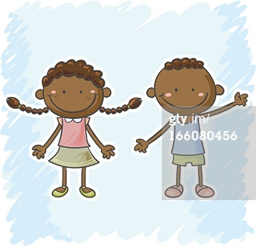
Titel: The Great Trek

Désiré and Aïsha live in Brussels (yellow circle). They moved to Brussels when they were 2 years old. Their grandma still lives in Congo, in Africa (green circle). During the summer months, Désiré and Aisha would like to stay with her.

The scale of this map is
2000 km

or 1 cm on the map represents 2000 km on the ground.
The distance on the map between Belgium and Congo is about 3 cm.

True or false?
Désiré and Aisha have to travel approximately 3000 km if they want to visit their grandma in Congo.
Antwoord: False.
Juist: Well done!
Fout: That's not right. Désiré and Aisha have to travel about 6000 km to visit their grandma in Congo: 3 x 2000 km = 6000 km. Did you use your notebook to make the calculations?

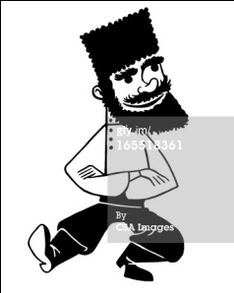
Titel: The Great Trek

Roman lives in Russia, the largest country in the world. He would like to travel across his own country from west to east.
The scale of this map is
2000 km

or 1 cm on the map represents 2000 km on the ground.

The distance between the westernmost and the easternmost point of Russia is about 5 cm on this map.

True or false?
Roman has to cover approximately 10,000 km to cross his whole country.
Antwoord: True
Juist: Well done!
Fout: That's not right. Roman has to cover approximately 10,000 km if he wants to cross Russia: 5 x 2000 km = 10,000 km. Did you use your notebook to make the calculations?

Application phase 3 (application 2): The Great Trek

Titel: The Great Trek
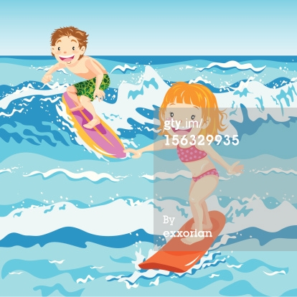
Matt and Daisy live in New York, in North America (yellow circle). They would like to go on a surfing holiday.
Matt wants to go to South Africa (green circle), but Daisy would prefer Spain (red circle).

The scale of this map is
2000 km

or 1 cm on the map represents 2000 km on the ground.

True or false? The surfing destination that is closest to New York is Spain.

Tip: Try solving this exercise without using the scale calculation!
Antwoord:True
Juist: Well done!
Fout: That's not right. Spain is closer to New York than South Africa.
Evaluation phase

You've done an excellent job! Can you answer these questions to show what you have learned?

Titel: Question 1

Which continent is shown in green?
- North America
- Europe
- Asia
- Oceania

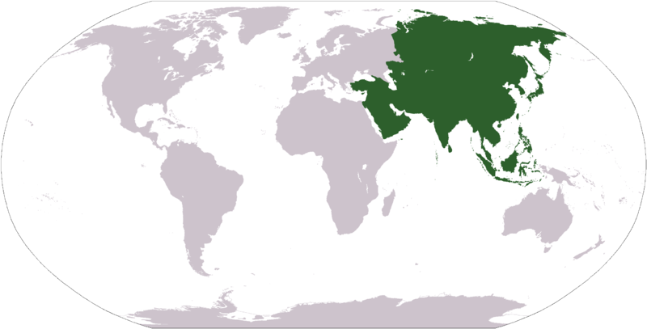

Juist: Well done!
Fout: Oops! Asia is the continent shown in green.

Titel: Question 2

Which ocean lies between America, Europe and Africa?
- Pacific Ocean
- Atlantic Ocean
- North Sea
- Arctic Ocean

Juist: Well done!
Fout: Oops! The Atlantic Ocean lies between America, Europe and Africa.

Titel: Question 3

What is the name of the red line on the globe?

- zero meridian
- equator
- North Pole
- South Pole

Juist: Well done!
Fout: Oops! The red line represents the equator.

Titel: Question 4

Which wind blows through our country, according to weatherman Frank Deboosere?

- northeast wind
- southwest wind
- southeast wind
- northwest wind

Juist: Well done!
Fout: Oops! Weatherman Frank Deboosere forecasts that a northwest wind will blow throw our country. You can see that on the compass rose on the TV screen.

Titel: Question 5

The scale of this world map says that 1 cm on the map represents 2000 km on the ground. We would like to go on a journey from the northernmost point of Africa (A) to the southernmost point of Africa (B).
Which statement is true?
- The distance between A and B calculated using the scale will be longer than the distance by road (blue line).
- The distance between A and B calculated using the scale will be shorter than the distance by road (blue line).
- The distance between A and B calculated using the scale will be the same length as the distance by road (blue line).
- The distance between A and B calculated using the scale will be half as long as the distance by road (blue line).
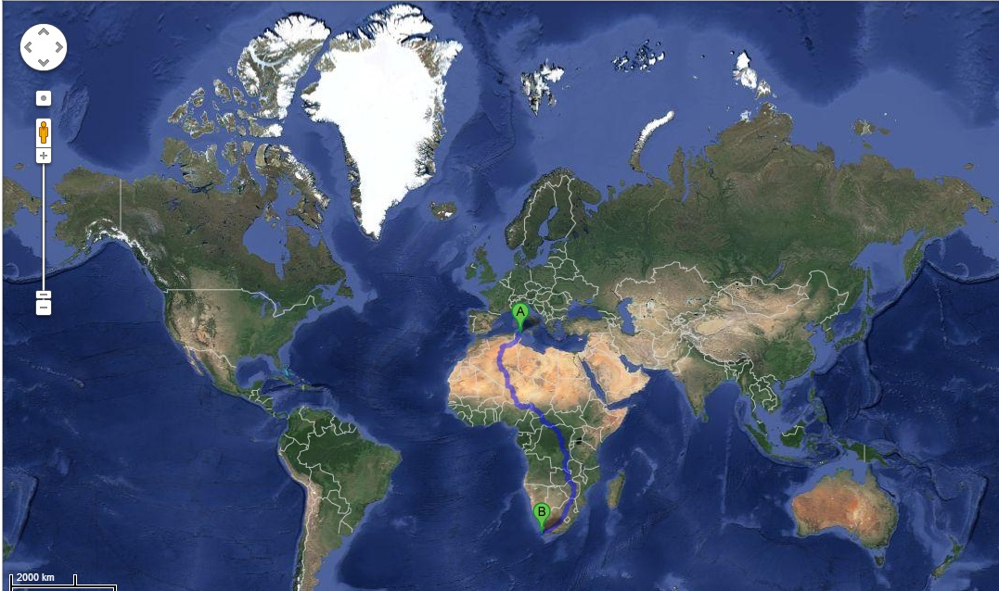
Juist: Well done!
Fout: Oops! The distance between A and B calculated using the scale will be shorter than the distance by road (blue line). Calculations using the scale give us the distance as the crow flies, that is, in a straight line from point A to point B.

