TOPIC: Space

Subtopic 2: Europe
Pre-test
Teaching phase 1: European Union
Application phase 1: European Union
Teaching phase 2: Neighbouring countries
Application phase 2: Neighbouring countries
Teaching phase 3: A journey through Europe
Application phase 3: A journey through Europe
Evaluation phase

Pre-test

Hello! Are you familiar with Europe and the European Union? Today you will learn the names of the most important parts and locate them on a map! First answer these questions to see what you already know.

Titel: Question 1

Which statement is true?
- The European Union is a collection of three countries: Belgium, the Netherlands and Luxembourg.
- The capital of France is Berlin.
- Europe is one of the seven continents.
- The European Union was established in 2005.

Titel: Question 2

We are looking for a country that belongs to Europe and to the European Union, namely Spain. Where is Spain on this map?

A
D
C
B

Titel: Question 3

Italy is in Europe. Which statement is true?
- Italy is in northern Europe.
- Italy is west of Switzerland.
- Italy is north of Norway.
- Italy is north of the Mediterranean Sea.

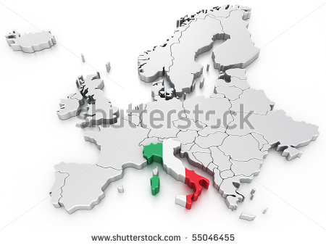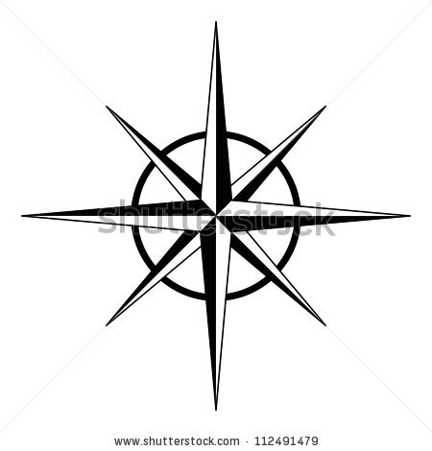
N

Titel: Question 4

Which statement is true?
- Portugal is a neighbour of Spain.
- The Netherlands is a neighbour of England.
- Switzerland is a neighbour of Hungary.
- Luxembourg is a neighbour of the Czech Republic.

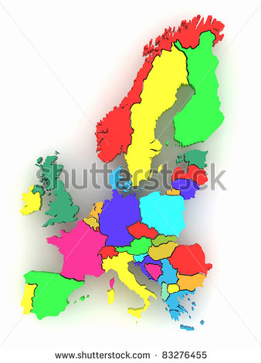

Titel: Question 5

This is what Europe looks like from outer space. This map is on a scale of 1:33333333. What exactly does that mean?
- 1 cm on the map represents 33,333,333 centimetres on the ground.
- 1 m on the map represents 33,333,333 centimetres on the ground.
- 1 cm on the map represents 333333 kilometres on the ground.
- 1 m on the map represents 333.333 kilometres on the ground.
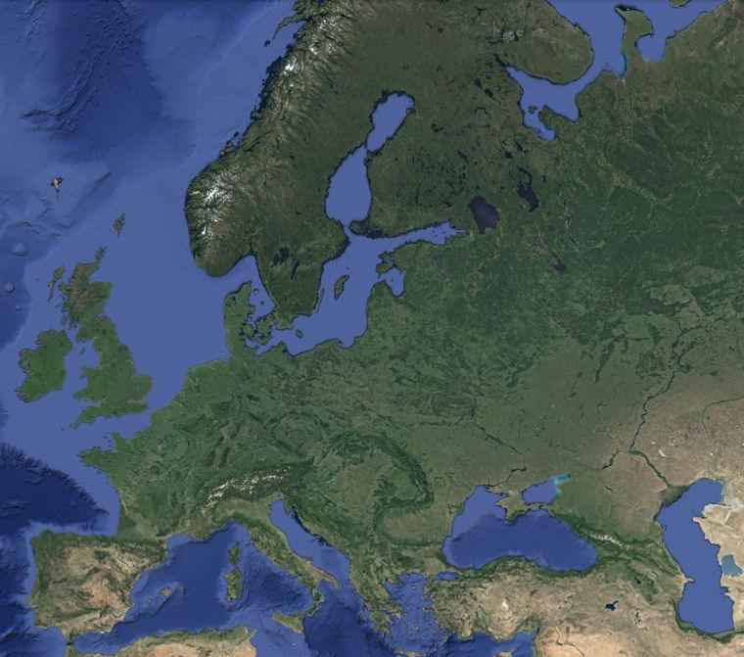

Teaching phase 1: European Union
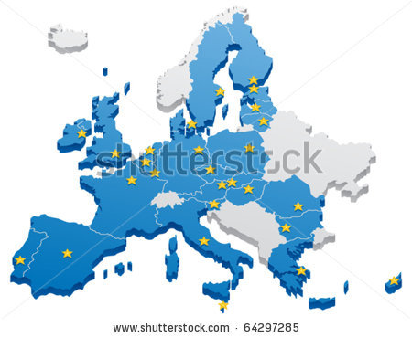
Titel: European Union
Have you ever heard of the European Union? Let's go and explore together!

The European Union (EU) is a group of European countries who work together. In 2013 there are 28 countries that belong to the EU.

A little bit of history...

At the end of the Second World War, in 1945, Europe was completely in ruins. France came up with a good idea: instead of fighting each other, they wanted to work together. Germany agreed right away! They decided to share raw materials such as coal and steel with each other. Belgium, Italy, Luxembourg and the Netherlands also joined in. This collaboration soon expanded: more countries joined and more things were shared (work, food, etc.). In 1992 the group of countries received a new name: the European Union (EU).

What do the EU countries do?

The countries of the European Union have a number of competences or matters for which they are responsible:
° Taking care of nature together: fighting pollution, protecting animals, etc.
° creating jobs for as many people as possible, so that everyone can earn enough money.
° Some – but not all – EU countries use the same currency: the euro.
° Helping each other as much as possible with their problems: laying new railways, creating additional jobs, etc.
° Helping poor countries: sending food, collecting clothing, etc.
° Working together to preserve peace, so that there will never again be war in the EU.
° The people who live in the EU enjoy a great deal of freedom. They can choose to study, live or work in any EU country, for example.
Which countries are part of the EU?
Please note! Not all European countries belong to the European Union.
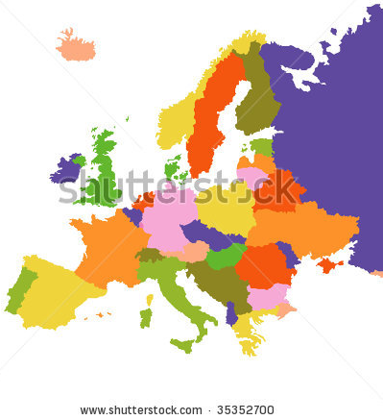
The European Union regularly expands. In 2013 there are 28 countries in the EU.
 | Country | Capital | Flag
1 | Belgium | Brussels
2 | Bulgaria | Sofia
3 | Cyprus | Nicosia
4 | Denmark | Copenhagen
5 | Germany | Berlin
6 | Estonia | Tallinn | 28-
7 | Finland | Helsinki
8 | France | Paris | 7
9 | Greece | Athens
10 | Hungary | Budapest | 6
11 | Ireland | Dublin | 4  14
12 | Italy | Rome | 1  11
13 | Croatia | Zagreb | 18  15
14 | Latvia | Riga | 27-
15 | Lithuania | Vilnius | 16  20
16 | Luxembourg | Luxembourg | 5
17 | Malta | Valletta | 26-  24-
18 | Netherlands | Amsterdam | 8  19
19 | Austria | Vienna | 10  22
20 | Poland | Warsaw | 23
21 | Portugal | Lisbon | 13  21  25-
22 | Romania | Bucharest | 2
23 | Slovenia | Ljubljana | 12
24 | Slovakia | Bratislava | 3
25 | Spain | Madrid
26 | Czech Republic | Prague
27 | United Kingdom | London | 9  17
28 | Sweden | Stockholm

Application phase 1 (application 1): European Union

Titel: European Union

Not all European countries are members of the European Union. This map shows all the EU countries in dark blue. Those European countries that do not belong to the EU are light grey.
1
2

True or false? Norway and Switzerland are not members of the European Union.




Antwoord: True.
Juist: Good job! Norway and Switzerland are not members of the European Union.
Fout: That's not right! Norway and Switzerland are not members of the European Union.
Application phase 1 (application 2): European Union

Titel: European Union

Every country has a capital. Connect each country in the European Union with the correct capital.

Belgium |  | Luxembourg
Germany |  | London
Greece |  | Dublin
Spain |  | Amsterdam
France |  | Athens
Ireland |  | Rome
Italy |  | Brussels
Luxembourg |  | Madrid
Netherlands |  | Paris
United Kingdom |  | Berlin

Answer
Juist: Well done!
Fout na eerste poging: Your answer is not quite right. Try again.
Fout na tweede poging: That's not entirely correct. Take a look at the right answer.

Belgium |  | Luxembourg
Germany |  | London
Greece |  | Dublin
Spain |  | Amsterdam
France |  | Athens
Ireland |  | Rome
Italy |  | Brussels
Luxembourg |  | Madrid
Netherlands |  | Paris
United Kingdom |  | Berlin

Application phase 1 (application 3): European Union

Titel: European Union

The European Union has various tasks.

True or false? One of the tasks of the EU countries is to care for the natural environment, for example by protecting wild birds.

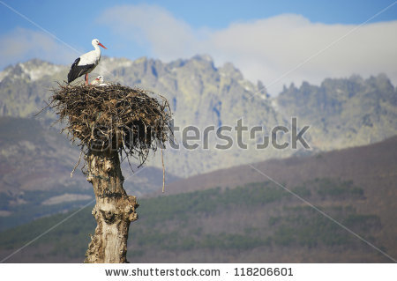

Antwoord: True.
Juist: Good answer!
Fout: That's not right. Protecting nature is one of the tasks of the EU countries.

Titel: European Union

The euro has made it easier to do business, shop or travel in the European Union. You can just take along your own money.

True or false? All EU countries use the euro as a means of payment.

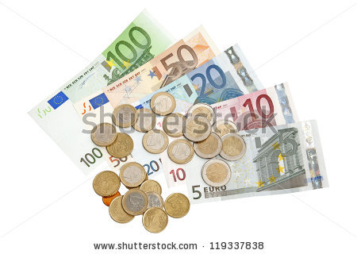

Antwoord: That's not right.
Juist: Excellent!
Fout: That's not right. Not all EU countries use the euro. The countries can decide for themselves. The 11 Member States of the European Union who don't use the euro (yet) are Denmark, Sweden, the United Kingdom, Hungary, Latvia, Lithuania, Poland, the Czech Republic, Bulgaria, Romania and Croatia.

Titel: European Union

The European Union has various tasks.

True or false? The EU helps poor countries around the world. For instance, the EU sends money, teachers and doctors to help people in difficult circumstances such as war, disease, drought, natural disasters, floods, etc.


Antwoord: True.
Juist: Excellent!
Fout: That's not right. Helping poor countries is one of the tasks of the EU.

Application phase 1 (application 4): European Union

Titel: European Union

Every country has a flag. Which flag belongs to which country of the European Union? Drag the flags to the correct country.

Belgium | Netherlands | France | Germany | United Kingdom | Denmark

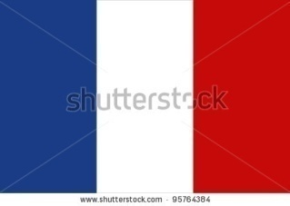 | 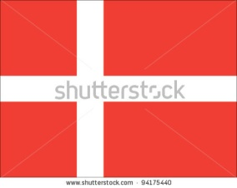 | 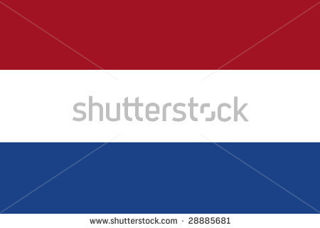 | 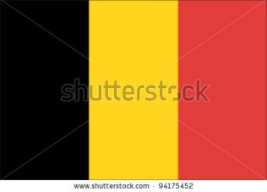 | 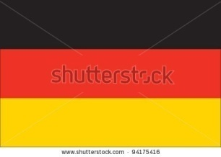 | 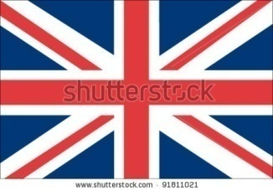

Answer
Juist: Well done!
Fout na eerste poging: Your answer is not quite right. Try again.
Fout na tweede poging: That's not right, take a look at the right answer.

Belgium | Netherlands | France | Germany | United Kingdom | Denmark

Teaching phase 2: Neighbouring countries

Titel: Neighbouring countries

In this part we will learn about neighbouring countries. First, let's take a look at our own neighbours.

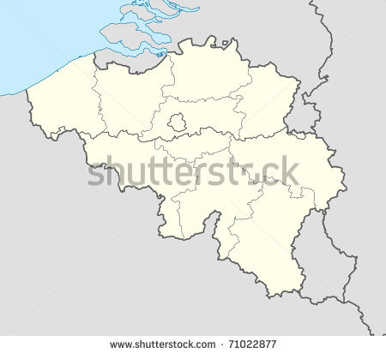
Neighbouring countries are countries that lie immediately next to another. In other words: a neighbouring country is a country that borders on another country.

On this map we can see that Belgium has four neighbouring countries: (1) the Netherlands, (2) Germany, (3) Luxembourg and (4) France. Belgium also borders on the (5) North Sea.

Do you remember the compass rose?
A compass rose helps us to read a map correctly. A compass has two main axes: the vertical North-South axis and the horizontal West-East axis. They indicate the four cardinal directions: north (N), east (E), south (S) and west (W). The compass also has two minor axes, indicating the four intermediate directions: northeast (NE), southeast (SE), southwest (SW) and northwest (NW).
South (S)
SE
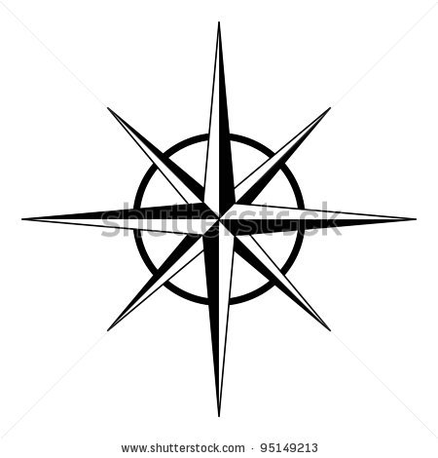

Application phase 2 (application 1): Neighbouring countries
Titel: Neighbouring countries

Here you can see a map of Belgium. Everything that borders on Belgium has been assigned a number. Connect each number with the right country of the right sea.

1 |  | North Sea
2 |  | France
3 |  | Netherlands
4 |  | Germany
5 |  | Luxembourg

Answer
Juist: Well done!
Fout na eerste poging: Your answer is not quite right. Try again.
Fout na tweede poging: That's not right, take a look at the right answer.

1 |  | North Sea
2 |  | France
3 |  | Netherlands
4 |  | Germany
5 |  | Luxembourg

Application phase 2 (application 2): Neighbouring countries

Titel: Neighbouring countries

Take a good look at the map and at the compass rose.

True or false? I live in Brussels (Belgium, orange circle) and my uncle Frédéric lives in Paris (France, yellow circle). I have to travel north to visit him.
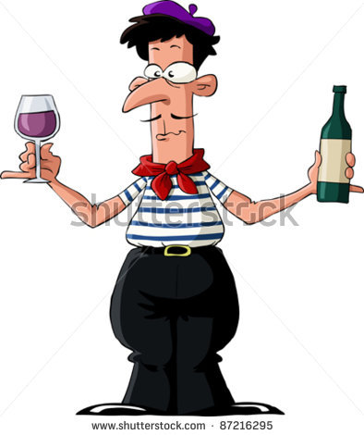
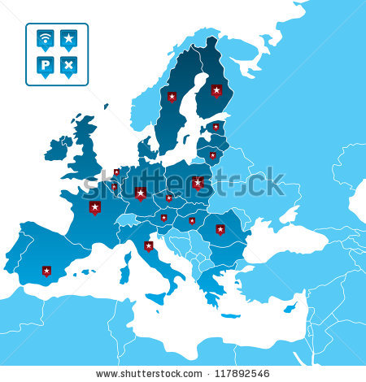
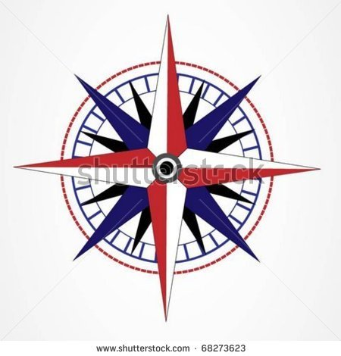
Antwoord: False
Juist: Well done!
Fout: That's not right. I have to travel southwest to visit Uncle Frédéric in Paris.

Titel: Neighbouring countries

Take a good look at the map and at the compass rose.

True or false? I live in Brussels (Belgium, orange circle) and my sister Iepke lives in Amsterdam (Netherlands, yellow circle). I have to travel northeast to visit her.


Antwoord: True
Juist: Well done!
Fout: That's not right. I have to drive northeast to visit my sister Iepke in Amsterdam.

Titel: Neighbouring countries

Take a good look at the map and at the compass rose.

True or false? I live in Brussels (Belgium, orange circle) and my friend Brunhilde lives in Berlin (Germany, yellow circle). She has to travel east to visit me.


Antwoord: False
Juist: Well done!
Fout: That's not right. Brunhilde has to travel west to visit me in Brussels.

Titel: Neighbouring countries

Take a good look at the map and at the compass rose.


True or false? I live in Brussels (Belgium, orange circle) and my grandmother Giovanna lives in Rome (Italy, yellow circle). She has to travel north to visit me.

Antwoord: False
Juist: Well done!
Fout: That's not right. My grandmother Giovanna has to travel northwest to visit me in Brussels.

Teaching phase 3: A journey through Europe

Titel: A journey through Europe
Will you come along on a journey of discovery through Europe? There are so many interesting sites to visit! Don't forget to take notes so that you can use them for the exercises.
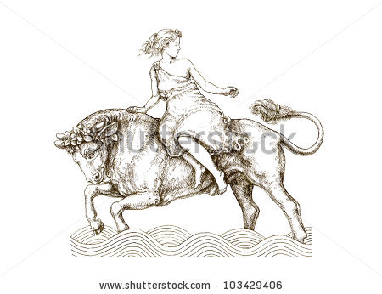
Do you know the legend of the birth of Europe?

3000 years ago, there lived a beautiful princess in Greece. Her name was Europa. Zeus, the ruler of the Greek gods, disguised himself as a bull and took Princess Europa off to an island. Zeus and Europa had a son, Minos. He got some of his people to move to all neighbouring countries, thus spreading European civilisation.

Europe (3, dark red) is one of the seven continents. The other continents are North America (1, light green), South America (2, dark green), Africa (4, yellow), Asia (5, orange), Oceania (6, purple) and Antarctica (7, blue).

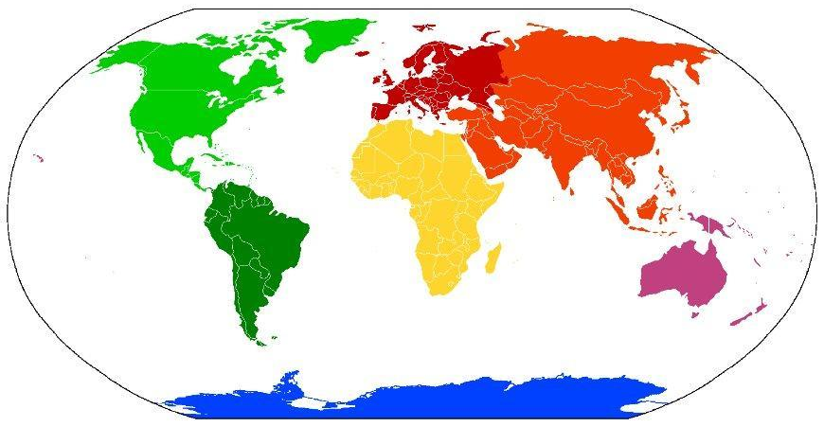
X
From north to south, Europe (3) stretches from the North Pole (X) in the north to the Mediterranean Sea (between 3 and 4) in the south. From east to west, Europe stretches from Asia (5) in the east to the Atlantic Ocean (A) in the west.
3
1
4
5
A

2
6
7
You can take some wonderful trips in Europe. For example, you can climb the Elbruz, the tallest mountain (5642 m), or sail down the Danube, the longest river (2829 km).

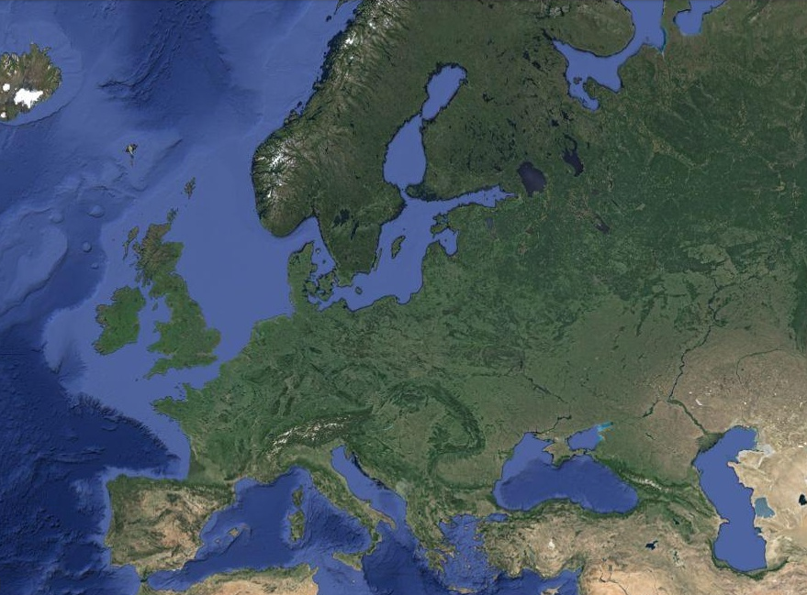
Before we start our tour of Europe, we would like to know how far we need to drive, fly or sail. The scale on a map can help us.
Do you remember?

A scale is a horizontal line showing how many meters a distance on the map represents on the ground.
The scale can also be shown as a ratio using a colon. For example, 1:100 or 1 cm on the map represents 100 cm on the ground.

1 cm on the map of Europe represents 250 km on the ground.

| | or 1:25000000
250 km

NOTE
A scale using a ratio always gives 1 cm on the map and the number of cm on the ground!
Example:
scale 1:25000000 → 1 cm on the map = 25,000,000 cm or 250 km on the ground
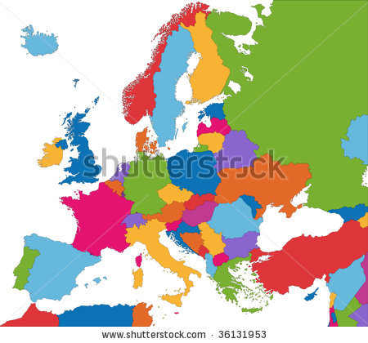
Here you can see a map of Europe.

The scale of this map is 1:25000000
or
250 km

The distance on the map between Brussels (Belgium, orange)
and Madrid (Spain, blue) is 5 cm.

We can calculate the actual distance in two different ways:

- using the scale with the ratio
- using the scale with the line

- The first way: 1:25000000 or 1 cm on the map is equal to 25,000,000 cm on the ground.
5 cm on the map = 5 x 25,000,000 cm = 125,000,000 cm on the ground, or converted into kilometres, 1250 km

- The second way: The line is 1 cm and represents 250 km. The distance on the map is 5 cm.
5 cm on the map = 5 x 250 km = 1250 km on the ground

Conclusion: According to our scale calculation, the distance between Brussels and Madrid is 1250 km.
Application phase 3 (application 1): A journey through Europe

Titel: A journey through Europe

Now for a bit of practice! Which distance is the longest distance on the ground ? Click on the correct box. You can use your notebook to do your calculations.

2 cm on a map with a scale of 1:2500 | 3 cm on a map with a scale of 1:2000 | 4 cm on a map with a scale of 1:100

Antwoord:

2 cm on a map with a scale of 1:2500 | 3 cm on a map with a scale of 1:2000 | 4 cm on a map with a scale of 1:100

Juist: Well done!
Fout na eerste poging: That is not the correct answer. Try again.
Fout na tweede poging: That's not right. 2 cm on a map with a scale of 1:2500 is 2 x 2.500 cm = 5.000 cm on the ground. 3 cm on a map with a scale of 1:2000 is 3 x 2000 cm = 6000 cm on the ground. 4 cm on a map with a scale of 1:100 is 4 x 100 cm = 400 cm on the ground. 3 cm on a map with a scale of 1:2000 is therefore the longest distance.

Titel: A journey through Europe

Which distance is the shortest distance on the ground? Click on the correct box. You can use your notebook to do your calculations.

3 cm on a map with a scale of  500 km | 5 cm on a map with a scale of  320 km | 7 cm on a map with a scale of  250 km

Antwoord:

3 cm on a map with a scale of  500 km | 5 cm on a map with a scale of  320 km | 7 cm on a map with a scale of  250 km

Juist: Well done!
Fout na eerste poging: That is not the correct answer. Try again.
Fout na tweede poging: That's not right. 3 cm on a map with a scale of 500 km is 3 x 500 km = 1.500 km on the ground. 5 cm on a map with a scale of 320 km is 5 x 320 km = 1.600 km on the ground. 7 cm on a map with a scale of 250 km is 7 x 250 km = 1.750 km on the ground. 3 cm on a map with a scale of 500 km is therefore the shortest distance on the ground.

Titel: A journey through Europe

Which distance is the shortest distance on the ground? Click on the correct box. You can use your notebook to do your calculations.

4 cm on a map with a scale of 1:30000000 | 3 cm on a map with a scale of  400 km | 7 cm on a map with a scale of 1:1000000

Antwoord:

4 cm on a map with a scale of 1:30000000 | 3 cm on a map with a scale of  400 km | 7 cm on a map with a scale of 1:1000000

Juist: Well done!
Fout na eerste poging: That is not the correct answer. Try again.
Fout na tweede poging: That's not right. 4 cm on a map with a scale of 1:30000000 is 4 x 30,000,000 cm = 120,000,000 cm = 1.200 km on the ground. 3 cm on a map with a scale of 400 km is 3 x 400 km = 1200 km on the ground. 7 cm on a map with a scale of 1:1000000 is 7 x 1,000,000 cm = 7,000,000 cm = 70 km on the ground. 7 cm on a map with a scale of 1:1000000 is therefore the shortest distance on the ground.

Application phase 3 (application 2): A journey through Europe

Titel: A journey through Europe
Now that we can easily do scale calculations, we can start our journey through Europe!

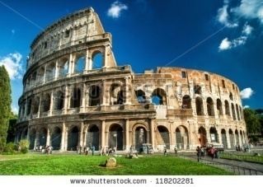
After Madrid (Spain, blue) we would like to visit the Colosseum in Rome (Italy, yellow). We will have to drive for a while and then sail across the Mediterranean Sea.

The scale of this map is 1:25000000
or
250 km

The distance on the map between Madrid and Rome is 4.5 cm.

True or false?
According to the scale calculation, the distance between Madrid and Rome is 1125 km on the ground.

Antwoord: True
Juist: Well done!
Fout: That's not right. The distance between Madrid and Rome on the ground is 1125 kilometres (4.5 x 250 km = 1125 km). Did you use your notebook to make the calculations?

Titel: A journey through Europe
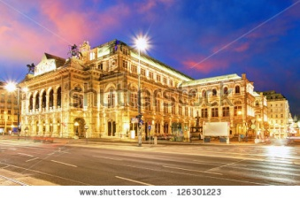
After Rome (Italy, red circle) we would like to attend an opera in Vienna (Austria, black circle).

The scale of this map is 1:25000000
or
250 km

The distance on the map between Rome and Vienna is 3 cm.

True or false?
According to the scale calculation, the distance between Rome and Vienna is 750 m on the ground.
Antwoord: False
Juist: Well done!
Fout: That's not right. The distance between Rome and Vienna on the ground is 750 km (3 x 250 km = 750 km). Did you use your notebook to do your calculations?

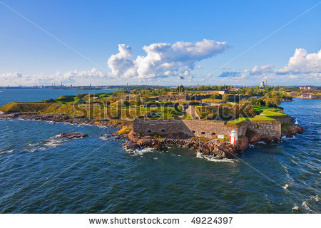
Titel: A journey through Europe
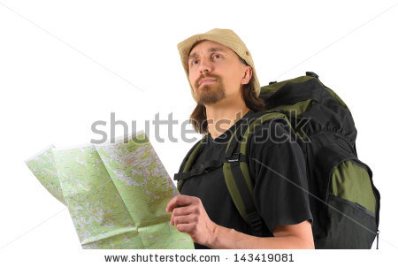
After Vienna (Austria, orange) we would like to climb the fortresses around Helsinki (Finland, yellow).

The scale of this map is 1:25000000
or
250 km

The distance on the map between Vienna and Helsinki is 6 cm.

True or false?
According to the scale calculation, the distance between Vienna and Helsinki is 1500 km on the ground.

Antwoord: True
Juist: Well done!
Fout: That's not right. The distance between Vienna and Helsinki on the ground is 1500 km (6.5 x 250 km = 1500 km). Did you use your notebook to do your calculations?

Titel: A journey through Europe
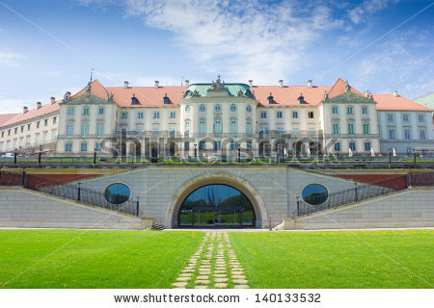
After Helsinki (Finland, yellow) we will end our journey through Europe in the royal palace in Warsaw (Poland, blue).

The scale of this map is 1:25000000 or
250 km

The distance on the map between Vienna and Helsinki is 4 cm.

True or false? According to the scale calculation, the distance between Helsinki and Warsaw is 10,000 km on the ground.

Antwoord: False
Juist: Well done!
Fout: That's not right. The distance between Helsinki and Warsaw on the ground is 1000 km (4 x 250 km = 1000 km). Did you use your notebook to do your calculations?

Evaluation phase

You've done a great job! Can you answer these questions to show what you have learned?

Titel: Question 1

Which European country is shown with a red arrow here?
- Switzerland
- Italy
- Ireland
- Portugal

Juist: Well done!
Fout: Oops! The red arrow points to Italy.

Titel: Question 2

Which country that is not a member of the European Union is shown with a red arrow here?
- Sweden
- Norway
- Turkey
- Switzerland

Juist: Well done!
Fout: Oops! The red arrow points to Norway.

Titel: Question 3

Which of the following is not a competenceof the European Union?

- Providing for jobs for EU residents
- Paying the head of state of each of the EU countries
- Ensuring that the levels of air pollution in Europe don't get too high
- Preserving peace in Europe

Juist: Good job! The EU does indeed help create jobs, protect nature and preserve peace. But the EU does not pay the head of state of each country. The countries are fully responsible for that themselves.
Fout: Oops! The EU does not pay the head of state of each country. The countries are fully responsible for that themselves. The EU does help create jobs, protect nature and preserve peace.

Titel: Question 4

I live in Finland (yellow circle) and my friend Lars lives in Denmark (red circle). In what direction do I have to travel to visit my friend?

- southeast
- northwest
- northeast
- southwest

Juist: Well done!
Fout: Oops! I have to travel southwest to visit my friend Lars in Denmark.

Titel: Question 5

I would like to drive from the Eiffel Tower in Paris (France, pink) to the Charles Bridge in Prague (Czech Republic, yellow).
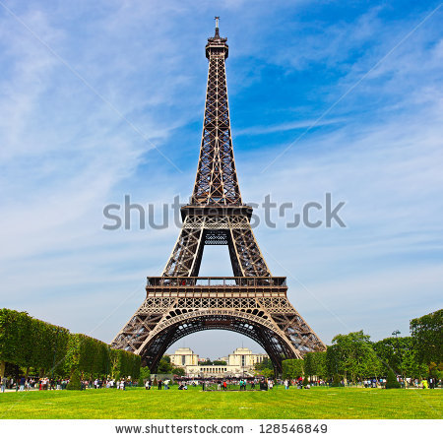
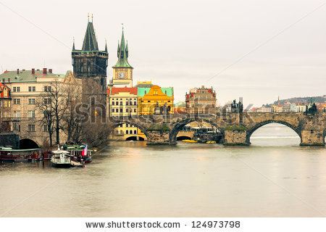

The scale of this map is 1:25000000. The distance on the map is 3.5 cm.

How many kilometres are there between Paris and Prague, according to the scale calculation?

- 875 km
- 875 m
- 875,000 km
- 87.5 km

Juist: Well done!
Fout: Oops! According to the scale calculation, the distance between Paris and Prague is 875 km (3.5 x 25,000,000 cm = 87,500,000 cm = 875 km).

