TOPIC: Nature
Subtopic 6: The animal kingdom
Pre-test
Teaching phase 1: Eat or be eaten
Application phase 1: Eat or be eaten
Teaching phase 2: What's on the menu?
Application phase 2: What's on the menu?
Teaching phase 3: How animals are classified
Application phase 3: How animals are classified
Evaluation phase

Pre-test

Let's explore the fascinating animal kingdom. After all, we are also part of that kingdom. But what do you already know about it? Let's start off with a few questions.

Titel: Question 1

What are herbivores?
- Animals that eat only grass
- Animals that eat only plants
- Animals that eat only meat
- Animals that eat both meat and plants

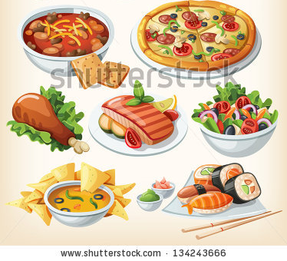

Titel: Question 2

What class of animals do humans belong to?

- Amphibians
- Reptiles
- Mammals
- Birds
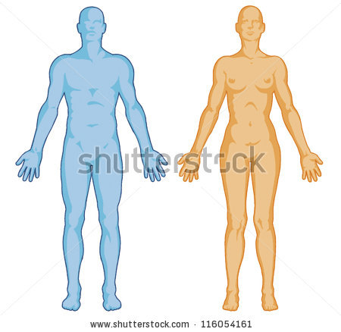

Titel: Question 3

What do lions eat?

- Grass
- Corn
- Bananas
- Meat
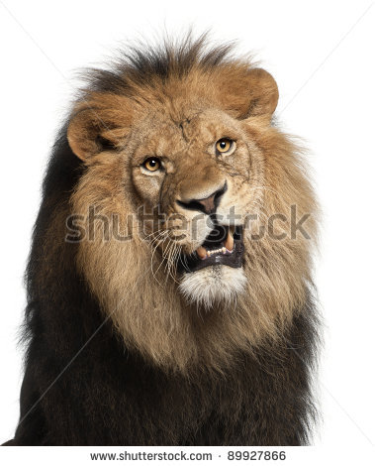

Titel: Question 4

Why do rabbits have large incisors?

- To fight with other rabbits
- To communicate with other animals
- To scratch themselves if they are itchy
- To be able to eat plants more easily

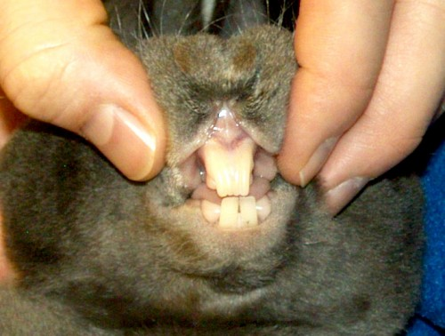

Titel: Question 5

Who eats whom?

- Eagles eat grass.
- Frogs eat snakes.
- Snakes eat mice.
- Blackflies eat ladybirds.

Teaching phase 1: Eat or be eaten

Titel: Eat or be eaten

All living beings need food to survive. Organisms must eat, but in turn are eaten by other organisms. This is called the food chain. Let's take a closer look.
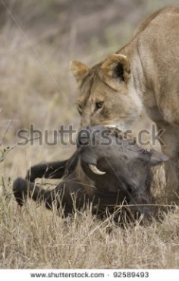

Animals at the zoo or on a farm are fed by their caregivers. In real nature it doesn't work that way, of course. Animals in the wild have to look for food or hunt for prey. And while looking for something to eat, they may get eaten themselves. This creates a food chain. One organism is food for another , and in turn becomes the prey of yet another animal.

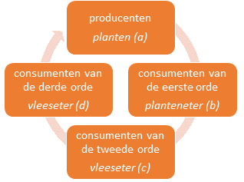
The food chain is made up of various groups:
1. producers
plants
- The food chain always starts with plants. We call them producers because they make food with the aid of sunlight, air and water.
- Plants are eaten by herbivores or plant-eaters. They are also called primary consumers.
- Herbivores are in turn eaten by carnivores or meat-eaters. These meat-eaters are called secondary consumers.
2. primary consumers
herbivores
4. tertiary consumers
carnivores
- These carnivores are eaten by other carnivores. We call the latter group of carnivores tertiary consumers. They are not eaten by any other animals, but after they die they are broken down into tiny pieces by bacteria. These pieces end up in the soil and become food for plants.
3. secondary consumers
carnivores
Titel: Eat or be eaten

Let's try to visualise these relations in the food chain.
Most food chains consist of three to five levels. The longest chain has ten levels. In fact, it is a never-ending process. There are several ways to illustrate the relations between the food levels:
- You can represent a food chain in a diagram. Relationships between organisms are then indicated with arrows.
- You can also represent the various levels in a pyramid. The plants are then at the bottom of the pyramid, while the tertiary consumers are at the top.
- Finally, you can also use a food web. This provides an overview of all possible combinations of feeding relations. One animal may be eaten by several different types of animal, for example.

1
2
3
Titel: Eat or be eaten

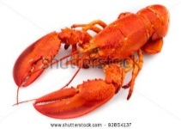

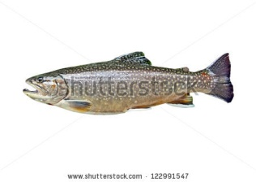
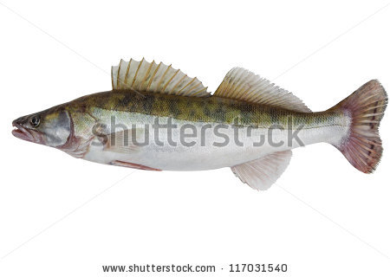
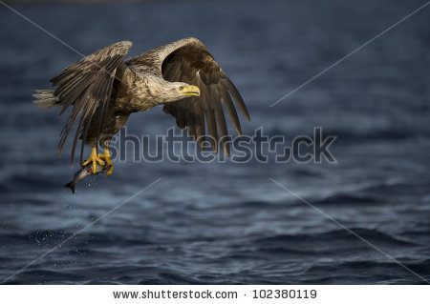
Let's look at two examples of food chains to make everything clear.
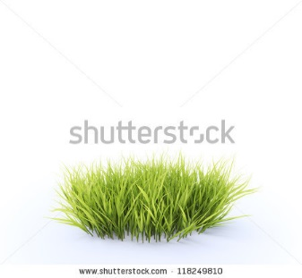
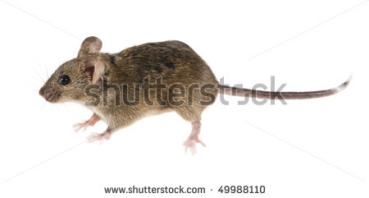
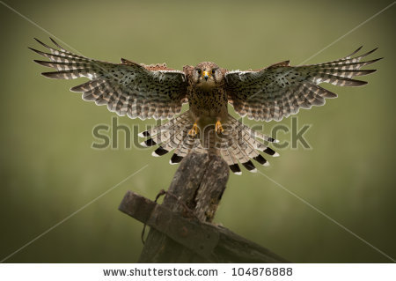
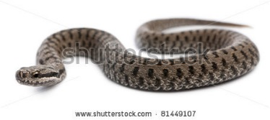

1. Mice feed on grass.
2. Mice are eaten by snakes.
3. Snake, in turn, are food for eagles.

1. Algae are the primary food for crayfish.
2. Crayfish are eaten by trout.
3. Pike love to eat trout. Since pike are bigger, they can easily catch trout.
4. Finally, pike are eaten by sea hawks.

Application phase 1 (application 1): Eat or be eaten

Titel: Eat or be eaten

Who is eaten by whom? Put the words and their corresponding images below in the correct order.
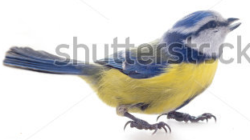

blue tit



blackflies

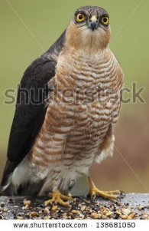

sparrow hawk



willow leaf

Answer:
willow leaf
blackflies
blue tit
sparrow hawk

Juist: Well done!
Fout na eerste poging: Try again. Take another look at your notebook.
Fout na tweede poging: Oops! You did your best!
Titel: Eat or be eaten

Who is eaten by whom? Put the words and their corresponding images below in the correct order.

elderberry
blackfly
dragonfly
ladybird
frog
buzzard
snake


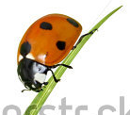
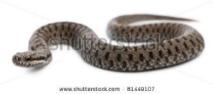
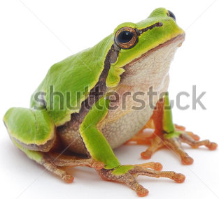
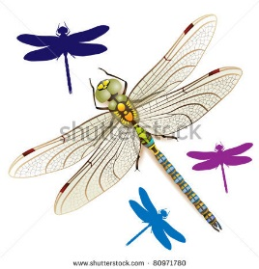
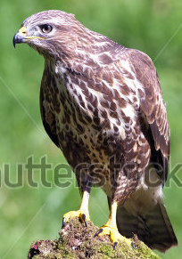
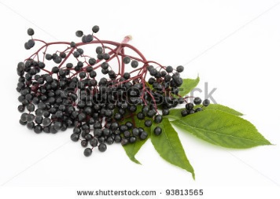

Juist: Well done!
Fout na eerste poging: Take another look at your notes, that might help!
Fout na tweede poging: Oops! You did your best!

Answer

blackfly
ladybird
dragonfly
elderberry

frog
snake
buzzard

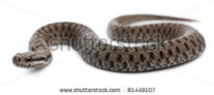

Teaching phase 2: What's on the menu?

Titel: What's on the menu?

The animal kingdom is very big and every animal is different. Yet some animals are considered to belong to the same group.

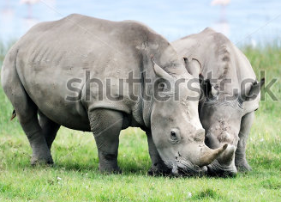
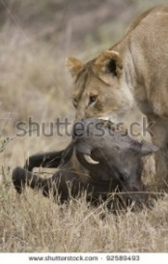
In the section on the food chain we talked about plant-eaters, also known as herbivores. These are animals that eat only plants. But not all animals eat only plants!
There are also meat-eaters. Their name says it all: they eat only meat. They are known as carnivores.
There are also organisms that eat both plants and meat. These are known as omnivores. Animals belonging to the same category have shared characteristics.

Herbivores, carnivores and omnivores have different types of teeth, different intestines and different eyes.
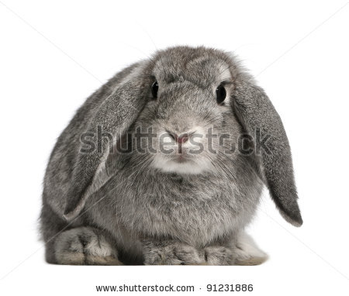
Herbivores must be able to chew and grind plants thoroughly. That is why they need strong incisors. In order to grind the food, they have flat molars. Their tongue is also important, as they use it to collect grass.
Plants take longer to digest. That is why herbivores have very long intestines.
Finally, herbivores have side-mounted eyes. This all-round vision allows them to watch out for predators while they are eating.
An example of a herbivore is a rabbit.

Teaching phase 2: What's on the menu?

Titel: What's on the menu?

What do the teeth, intestines and eyes of carnivores and omnivores look like, then? I will tell you in just a moment.

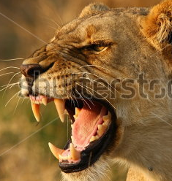
Carnivores have to be able to catch and kill their prey. For this reason they have very large canines. In order to be able to tear their prey, they have sharp molars. Incisors are less useful in their case, so these are smaller than those of herbivores.
Meat is easier to digest than plants. So the intestines of carnivores are shorter than those of herbivores. Meat-eaters are usually slender and flexible, this makes them better at hunting their prey.
Meat-eaters are predators. In order to see their prey from afar, they have eyes at the front of their heads. An example of a carnivore is a lion.


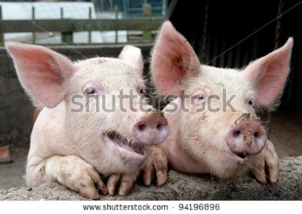
Omnivores have to be able to get down both meat and plants. Therefore their incisors, canines and molars are all about the same size.
The intestines of omnivores are of average length. They must be able to digest both meat and plants. Some omnivores have eyes at the front of the head, while others have side-mounted eyes. An example of an omnivore is a pig.

Teaching phase 2: What's on the menu?

Titel: What's on the menu?

Let's look at an overview of the differences between herbivores, carnivores and omnivores. Pay close attention and use your notebook to help you remember!

 | Plant-eaters = herbivores | Meat-eaters = carnivores | Plant- and meat-eaters = omnivores
Teeth | Strong incisors and flat molars | Large canines and sharp molars | All teeth are about the same size
Intestines | Long | Short | Average length
Eyes | On the side of the head | At the front of the head | At the front or on the side of the head
Example | rabbits, horses, squirrels, cows, giraffes, hippopotami, zebras, deer, etc. | lions, tigers, bird spiders, crocodiles, snakes, sharks, salamanders, etc. | pigs, bears, blackbirds, humpback whales, chimpanzees, humans, etc.
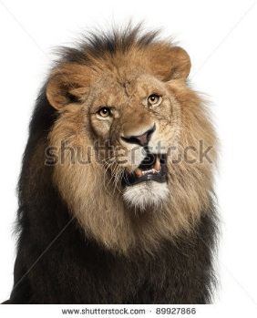

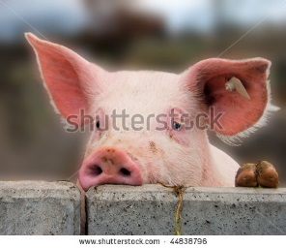

Application phase 2 (application 1): What's on the menu?

Titel: What's on the menu?

Is the following statement true or false?

Herbivores mostly eat plants, but sometimes meat as well.

Antwoord: False
Juist: Well done!
Fout: Oops! Plant-eaters or herbivores eat only plants. Meat-eaters or carnivores eat only meat. It is the omnivores that eat both meat and plants.
Application phase 2 (application 1): What's on the menu?

Titel: What's on the menu?

Is the following statement true or false?

A lion is an omnivore.

Antwoord: False
Juist: Very good!
Fout: Sorry. A lion is a carnivore. Have a good look at those large canines.

Application phase 2 (application 1): What's on the menu?

Titel: What's on the menu?

Is the following statement true or false?

The teeth of an omnivore are all about the same size.



Antwoord: True
Juist: Keep up the good work!
Fout: The statement was true. Omnivores eat both meat and plants. Therefore all their teeth are about the same size. Just think of your own teeth.

Application phase 2 (application 1): What's on the menu?

Titel: What's on the menu?

Is the following statement true or false?

The intestines of carnivores are longer than those of herbivores.

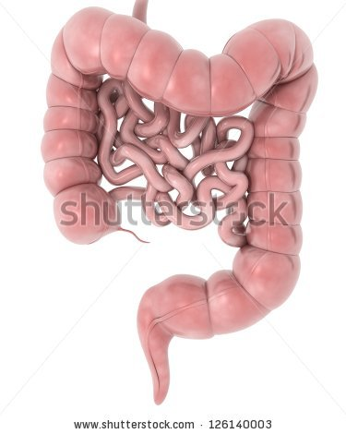

Antwoord: False
Juist: Very good!
Fout: No, sorry. It is the intestines of the herbivore that are longer, since plants are harder to digest.

Application phase 2 (application 1): What's on the menu?

Titel: What's on the menu?

Is the following statement true or false?

Herbivores have eyes on the side of their heads.



Antwoord: True
Juist: Well done! Do you remember why? This allows them to watch out for any approaching danger while they are eating.
Fout: The statement was true. This allows them to watch out for any approaching danger while they are eating.

Teaching phase 3: How animals are classified

Titel: How animals are classified
There are millions of species of animals. That is why scientists divide animals up into groups that range from very general categories down to very specific ones.
Let's have a look at the classification of the lion:
- The animal kingdom is the largest group.
- The animal kingdom consists of more than 30 phyla. One such phylum includes all vertebrates or animals with backbones. Another phylum comprises all invertebrates or animals without backbones.
- Each phylum is divided into a number of classes. For example, the vertebrate phylum includes the class of mammals.
- Each class consists of orders. The class of mammals, for instance, has 27 orders, including the order of predators.
- Each order is divided into families. The order of predators, for instance, consists of around 15 families. For example, the felines.
- Each family is further subdivided into genera. In the family of felines, for instance, we can distinguish the genus of lynxes, pumas and panthers.
- Finally, each genus consists of various species. Lions, for example, are one species.

1. Kingdom (e.g. animal kingdom)
2. Phylum (e.g. vertebrates)
3. Class (e.g. mammals)
4. Order (e.g. predators)
5. Family (e.g. felines)
6. Genus (e.g. panthers)
7. Species (e.g. lion)
Titel: How animals are classified
Let's take a look at the phylum to which we humans belong: that of vertebrate animals.

Vertebrates are divided up into five classes: mammals, birds, fish, reptiles and amphibians. There is one thing they all have in common: a spinal column. If you feel your back, you can feel little bumps along your spine. These are your vertebrae. They are very important for your body, as they give your body support. The spinal column supports your skull and is connected to your limbs.

Did you know?
A person has 33 or 34 vertebrae.

Each class has its specific characteristics. We will discuss a number of characteristics for each class of vertebrate animals.
- Can these animals regulate their own body temperature?
- What does their skin look like?
- Where do they live?
- How do they breathe?
- How are their offspring born?

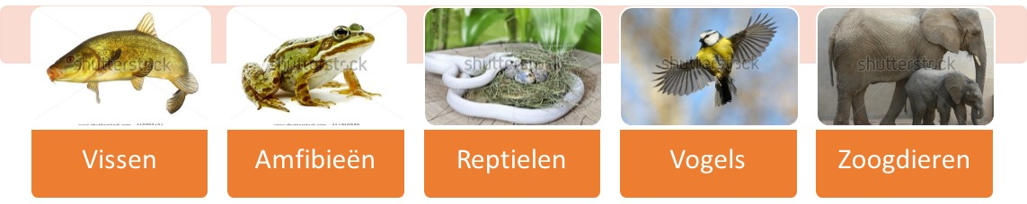
Fish
Amphibians
Reptiles
Birds
Mammals
Titel: How animals are classified
 | Fish | Amphibians | Reptiles | Birds | Mammals
Skin | Epidermis and scales | Epidermis | Dry scales | Feathers | Hair
Respiration | With gills | First with gills and through the skin; as they grow they lose their gills and breathe with their lungs and through the skin | With lungs | With lungs | With lungs
Temperature | Cold-blooded (*2) | Cold-blooded | Cold-blooded | Warm-blooded (*1) | Warm-blooded
Progeny | In eggs without a shell | In eggs without a shell | In eggs with a leathery shell | In eggs with a hard shell | Viviparous (*3)
Natural environment | Water | Water  Land | Water  Land | Water  Land  Air | Water  Land  Air
Example | Goldfish  Eel  Seahorse | Salamander  Frog  Toad | Snake  Turtle  Lizard | Sparrow  Penguin  Ostrich | Human  Dolphin  Bat

(*1) Warm-blooded: This means the body temperature is adjusted automatically. The animal does not have to do anything to warm up or cool off.
(*2) Cold-blooded: This means animals have to lie in the sun to get warm or seek out the shade to cool off.
(*3) Viviparous: The mother brings live young into the world; they do not hatch from an egg.

Application phase 3 (application 1): How animals are classified

Titel: How animals are classified

We have just seen the classification of a lion. Now we will apply this classification to the honeybee. Match these names with the right group.

Apidae
Honeybee
Arthropods

Hymenoptera
Animal kingdom
Insects

Apidae

Group | Example
Species
Genus
Family
Order
Class
Phylum
Kingdom

Answer

Group | Example
Species | Honeybee
Genus | Apis
Family | Apidae
Order | Hymenoptera
Class | Insects
Phylum | Arthropods
Kingdom | Animal kingdom

Juist: Well done, congratulations!
Fout na eerste poging: Try again. Think carefully. Maybe your notes can help.
Fout na tweede poging: Sorry. Take a look at the answer and use your notebook, that might help.

Application phase 3 (application 2): How animals are classified

Titel: How animals are classified
Match these characteristics to the right group within the vertebrates.
Epidermis

Feathers

Hair
Dry scales
Epidermis and scales

 | Fish | Amphibians | Reptiles | Birds | Mammals
Skin

 | Fish | Amphibians | Reptiles | Birds | Mammals
Skin

Juist: You did really well!
Fout na eerste poging: Try again. You can do it! Maybe your notes can help.
Fout na tweede poging: Sorry. That was not easy!

Application phase 3 (application 3): How animals are classified
Titel: How animals are classified
Match these characteristics to the right group within the vertebrates.
With lungs

First with gills and then through the skin. As they grow, they lose their gills and breathe with their lungs and through the skin.
With gills

 | Fish | Amphibians | Reptiles  Birds  Mammals
Respiration

Application phase 2 (application 4): How animals are classified
Titel: How animals are classified
Match these classes of vertebrates with the right characteristic.

Reptiles
Mammals
Birds
Fish
Amphibians
Cold-blooded | Warm-blooded

Application phase 3 (application 5): How animals are classified
Titel: How animals are classified
Match these characteristics to the right group within the vertebrates.
Viviparous

Eggs without a shell
Eggs with a leathery shell

Eggs with a hard shell

 | Fish  Amphibians | Reptiles | Birds | Mammals
Progeny

Application phase 2 (application 6): How animals are classified
Titel: How animals are classified
Match these classes of vertebrates with the right characteristic.

Reptiles
Mammals
Birds
Fish
Amphibians
Live only in water | Live in water and on land | Live in water, on land and in the air

Application phase 3 (application 7): How animals are classified

Titel: How animals are classified

Match the examples to the right group within the vertebrates.
Penguin

Goldfish

Salamander
Human
Snake

 | Fish | Amphibians | Reptiles | Birds | Mammals
Example

Evaluation phase
Let's see what you have remembered about the animal kingdom. Good luck!
Titel: Question 1
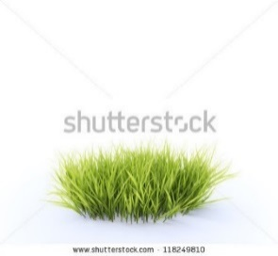
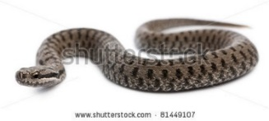
The food chain consists of various levels. What is the first level called?

- Producers
- Primary consumers
- Secondary consumers
- Tertiary consumers

Juist: Well done! Keep up the good work!
Fout: Oops! These were the producers, i.e. grass and plants. They are at the start of every food chain.

Titel: Question 2

What is wrong with the food pyramid below?
Grass
Fly
Salmon
Human
- The human and the fly must switch places.
- The grass and the salmon must switch places.
- The fly and the salmon must switch places.
- This food chain is correct. Everything is in its right place.

Juist: Fantastic!
Fout: Oops! The grass and the salmon must switch places. The grass is eaten by the fly, which in turn is eaten by the salmon. The salmon, in turn, is eaten by humans.

Titel: Question 3

Which group has the longest intestines?

- Carnivores
- Herbivores
- Omnivores
- Each group has intestines of about the same length.

Juist: Congratulations! You really know this!
Fout: Oops! It was the herbivores. They have the longest intestines.

Titel: Question 4

Do you remember why herbivores have longer intestines than omnivores or carnivores?
- Plants contain more waste than meat.
- Herbivores have to digest larger portions than omnivores or carnivores.
- Plants contain fewer vitamins than meat.
- Plants take longer to digest than meat.

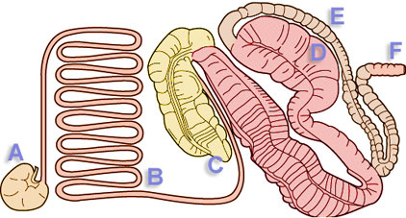
Juist: You are doing great! Keep it up!
Fout: Better luck next time! Plants take longer to digest than meat.

Titel: Question 5

Which of these vertebrates is warm-blooded?

- Fish
- Reptiles
- Mammals
- Amphibians

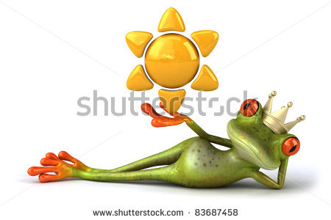

Juist: Well done! You are an ace!
Fout: The correct answer was mammals. Their body temperature is regulated automatically.

