TOPIC: Body
Subtopic 4: Reproduction
Pre-test
Teaching phase 1: Babies come from cabbage patches, don't they?
Application phase 1: Babies come from cabbage patches, don't they?
Teaching phase 2: First blah blah ... then boom boom
Application phase 2: First blah blah ... then boom boom
Teaching phase 3: From egg and sperm to baby
Application phase 3: From egg and sperm to baby
Evaluation phase

Pre-test

Today you are going to learn about where we come from. What do you already know? You can show us by answering a few questions!
Question 1

How long does a full-term pregnancy last?
- 3 months
- 6 months
- 9 months
- 12 months


Question 2

At what age can a girl get pregnant?

- From the age of 15.
- From her first menstruation.
- From the moment her breasts begin to grow.
- From the moment she has sex for the third time.



Question 3

Which of these activities is permitted during pregnancy?

- Exercise
- Dieting
- Smoking
- Drinking alcohol

Question 4

What does 'sterilization' mean?

- It is the moment when a man ejaculates.
- It is the moment when the penis hardens if a man is sexually aroused.
- It is a specific phase of pregnancy.
- It is an operation after which a man or woman can no longer conceive a child.



Question 5

How many ovaries does a woman have?

- 1
- 2
- 3
- 4



Teaching phase 1: Babies come from cabbage patches, don't they?

Babies come from cabbage patches, don't they?

You know that babies don’t grow in cabbage patches and that storks don’t drop them off, but where do they come from? I am going to take you through the reproductive system.
Boys are born with a penis, testicles and a prostate gland (9). Girls have a vagina and vulva (4). Girls also have a uterus, ovaries and fallopian tubes, all of which are internal. These are the primary sexual characteristics. That means these characteristics have been there from birth.
During puberty a lot happens in your body. Girls develop breasts (1), broader hips (2) and armpit and pubic hair (3). Furthermore, they begin to menstruate: you’ll find out what that is in a moment. Boys grow facial hair (5), chest hair (7), pubic hair (8), broader shoulders and a deeper voice (6). These are the secondary sexual characteristics. That means these sexual characteristics only begin to develop in puberty. The body produces hormones for this purpose. Hormones are special substances carried by the blood.
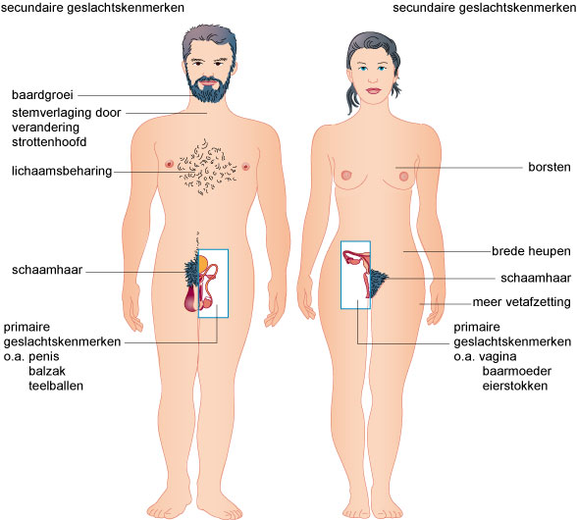
5
6
7
8
9
1
2
3
4

Babies come from cabbage patches, don't they?

Now we are going to take a closer look at both the male and female reproductive systems. Are you ready? We’ll begin with the men.

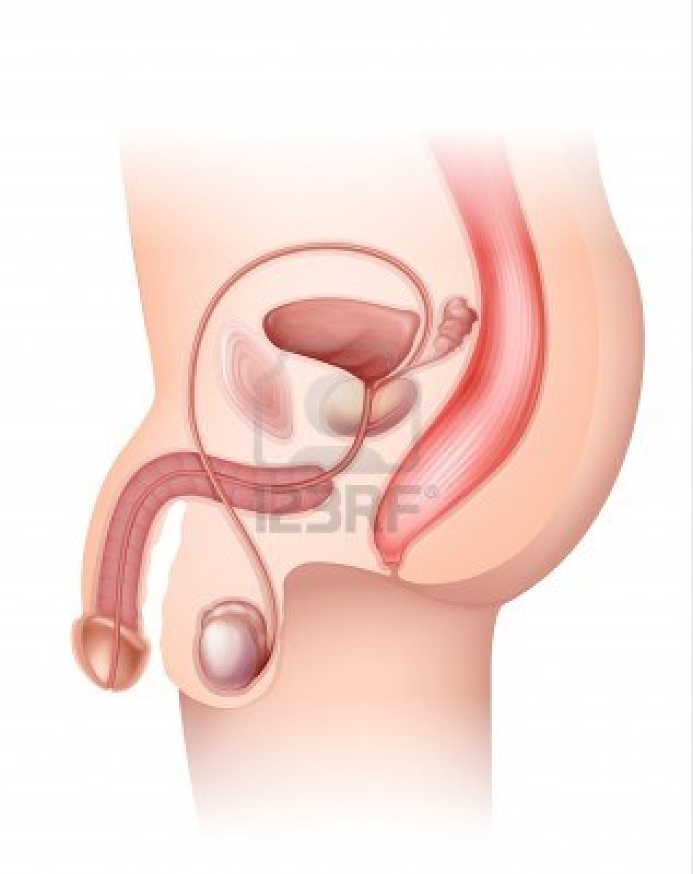
2. Epididymis
1. Testicle or testes
8. Penis
3. Scrotum
7. Prostate
4. Vas deferens
5. Urethra
6. Seminal vesicle


Interesting fact!
During an ejaculation 300 to 500 million sperm are simultaneously released from the penis.

The testicles or testes (1) produce sperm. The sperm move to the epididymis (2), where they are stored temporarily. The testicles and the epididymis are located in the scrotum (3). This is outside the body. This means the sperm are exposed to the perfect temperature in which to develop. Our body temperature, 37°C, would be much too warm. The vas deferens (4) transports the sperm from the epididymis to the urethra (5). The seminal vesicle (6) and the prostate (7) together produce seminal fluid. The seminal fluid mixes with the sperm cells from the epididymis to form the semen. During ejaculation, the semen containing many sperm cells is discharged via the urethra, which is found in the penis (8).

Babies come from cabbage patches, don't they?

Now we are going to take a look at the female reproductive system. Don’t forget to use your notebook as a memory aid.
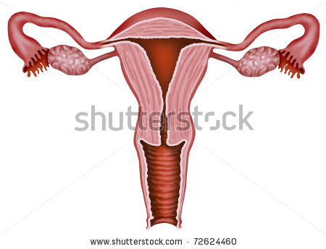
4. Uterus
3. Fallopian tube
2. Egg
1. Ovary
5. Vagina

From birth, every woman has two ovaries (1), one on the right and one on the left. This is where the eggs are produced. Every four weeks a new egg (2) develops in an ovary. During that four week period, there is one ovulation. The mature egg is rejected by the ovary.
The egg travels into the fallopian tube (3). Following sexual intercourse between a man and a woman, the egg in the fallopian tube can be fertilised by a sperm cell. Next, the egg travels to the uterus (4). In the uterus a thick, spongy lining of mucus and blood forms to receive the egg. If the egg is fertilised, it will nestle in the wall of the uterus. There, the fertilised egg will develop into a baby.
If the egg is not fertilised in the fallopian tube, it dies. In that case the mucus and blood lining is not needed. The unfertilised egg, the mucus and blood are shed through the vagina (5). This is called menstruation, during which women experience monthly blood loss.

Application phase 1 (application 1): Babies come from cabbage patches, don't they?

Babies come from cabbage patches, don't they?

Do you remember which sexual characteristics belong to a boy and which belong to a girl? Drag the words to the right column.
uterus
testicle
ovary

prostate
vagina
penis

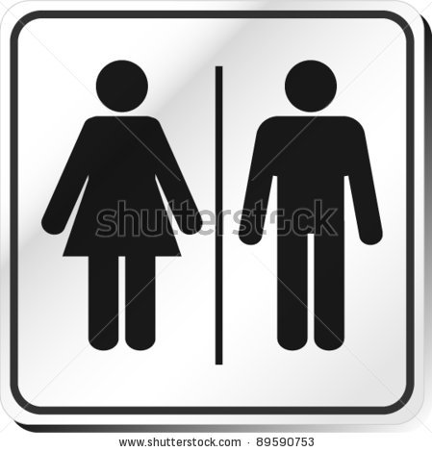
Girl | Boy

Solution
Girl | Boy
vagina | prostate
uterus | penis
ovary | testicle

Great!
That's not entirely correct. Try again.
Sorry. Better luck next time!

Application phase 1 (application 2): Babies come from cabbage patches, don't they?

Babies come from cabbage patches, don't they?

Label the characteristics below using the terms below. Drag the characteristics to the correct number.

Ovary
Vagina
Egg
Fallopian tube
Uterus

2
1
4
5
3

1
2
3
4
5

Good job!
Try again. Think carefully.
Sorry. You did your best!

Solution

1 | Fallopian tube
2 | Uterus
3 | Vagina
4 | Egg
5 | Ovary

Application phase 1 (application 3): Babies come from cabbage patches, don't they?

Babies come from cabbage patches, don't they?

Match the correct part of the male reproductive system with its function.

Testicles
Vas deferens
Prostate
Urethra
Spermcellsexit the body through this tube

Protects the testicles
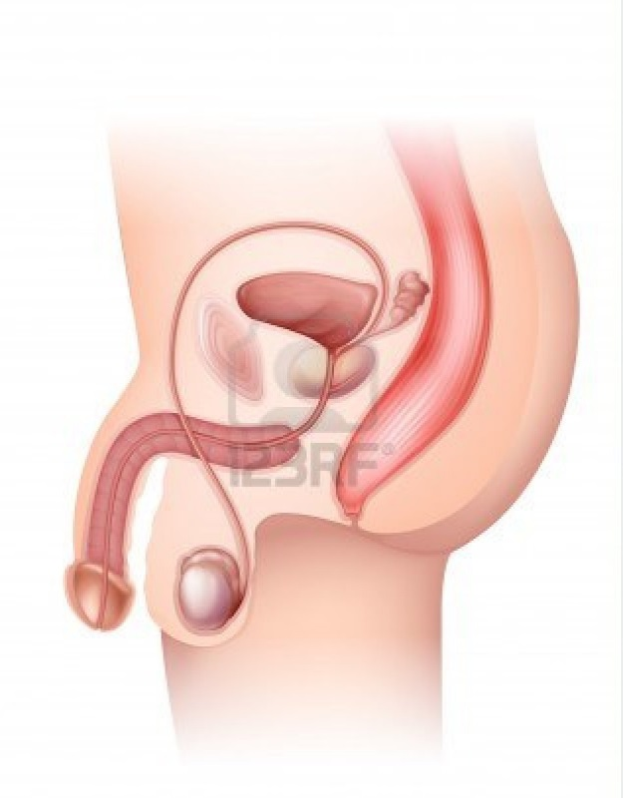
Epididymis
Testicle
Penis
Scrotum
Prostate
Vas deferens
Urethra

Produces seminal fluid

Temporarily stores the sperm

Scrotum
Carries sperm to the urethra

Epididymis
Produce sperm

Keep up the good work!
Have a look at the diagram and your notebook; that should help!
Sorry. Better luck next time!

Solution

Testicles
Vas deferens
Prostate
Urethra
Sperm exit the body through this tube
Protects the testicles
Produces seminal fluid
Temporarily stores the sperm
Scrotum
Carries sperm to the urethra
Epididymis
Produce sperm

Teaching phase 2: First blah blah ... then boom boom!

First blah blah ... then boom boom!

Of course babies don’t just appear out of nowhere. First, sexual intercourse must take place. Let’s take a look at exactly what happens.

When a man and woman are attracted to each other, they do a lot of talking and kissing. If they have a longer relationship, they will have sexual contact, or sexual intercourse. That’s where the title of this section comes from: first blah blah…then boom boom. After a while couples often wish to have a child. Until then, contraceptive methods are used to prevent pregnancy. You’ll learn more about that a bit later.
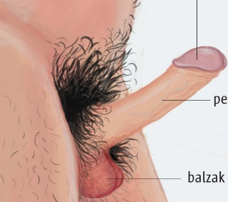
During sexual contact the man and woman become aroused. The man’s penis becomes hard and stiff. This is called an erection. During sex, the stiffened penis enters the woman’s vagina. This is called penetration. Both the vagina and the penis become moist during arousal, and so the penis can easily slide in.


When the man ejaculates, sperm exits the penis and directly enters the woman’s vagina. The sperm swim to the woman's uterus and fallopian tubes. If there is an egg in the fallopian tube, only one sperm can penetrate the wall of the egg. This is called fertilization.
The fertilised egg nestles itself in the uterus and grows for 9 months. After 9 months, the baby is born.

First blah blah ... then boom boom!

Not every couple wishes to have a baby. Let’s take a look to see how you can prevent pregnancy.

If a couple is not yet ready to have a baby, they can use contraceptive methods. These help to prevent pregnancy. Here is a brief overview of the main methods.


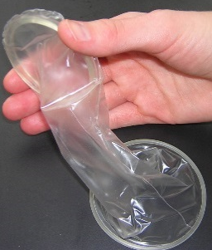
The condom is the only contraceptive that also protects against sexually-transmitted diseases. It is very important to apply it correctly. Otherwise it can tear and a woman could still get pregnant. There are male and female condoms. The male condom fits around the penis. The female condom is placed in the vagina. Condoms are available in different types and colours.

Women who take the pill must take it every day at around the same time, for three weeks. Then no pills are taken for the next seven days, and menstruation occurs. Not every woman takes the same pill. Women have to consult their doctor. The doctor will decide which pill is most suitable.

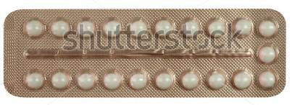

First blah blah ... then boom boom!

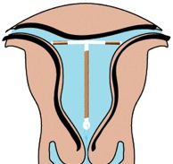
1
2
The intrauterine device (IUD) (1) is a device that is placed in the woman's uterus (2). Only a doctor is qualified to do this. The IUD can stay in place for five years. However, it is important to have it checked annually. At that time the doctor will check to see if the IUD is still correctly positioned.

Finally, sterilization is also an option. This means that the couple will never again be able to have children. Therefore, it requires some serious thought. Both men and women can undergo sterilization.

In the case of the man, the vas deferens is cut. This means the sperm can no longer move from the epididymis to the urethra.
In the case of the woman, the fallopian tubes are tied. This means the sperm cannot reach the egg.

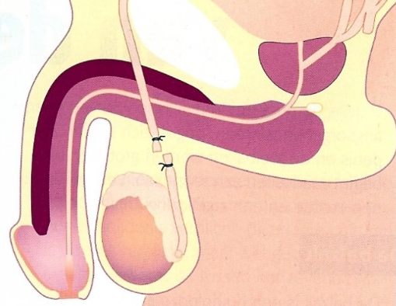
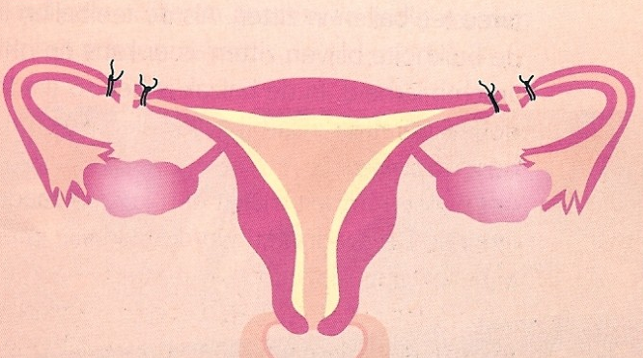

Application phase 2 (application 1): First blah blah ... then boom boom!

First blah blah ... then boom boom!

Move the characteristics of the various contraceptive methods steps to the correct column.

You have to remember it every day.
It is good for 5 years.

You can never again have a baby.
It protects against disease.

Condom | Pill | Sterilization | IUD

Congratulations! You remembered it all.
Try again.
Sorry. Take a good look at the solution!

Application phase 2 (application 2): First blah blah ... then boom boom!

First blah blah ... then boom boom!

Who can use this contraceptive? Move each contraceptive method to the correct column.
Condom

Sterilization

Pill

IUD

Only women can use it | Both men and women can use it

Congratulations! You remembered it all.
Try again.
Sorry. Take a good look at the solution!

Teaching phase 3: From egg and sperm to baby

From egg and spermcell to baby
After the egg and the spermcell have found each other, the embryo grows for nine months … Let’s take a look at how a baby develops!

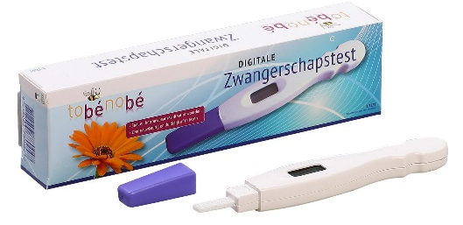
If a woman stops menstruating, it can mean that she is pregnant. To know for sure, she should take a pregnancy test and go to the doctor. If a woman is pregnant, her breasts begin to swell. Many women experience nausea during the first months of pregnancy. It is important for pregnant women to take extra care of their health. They need to eat healthily, and cannot eat everything; they must not smoke and must not drink any alcohol. This also applies to women who breastfeed.
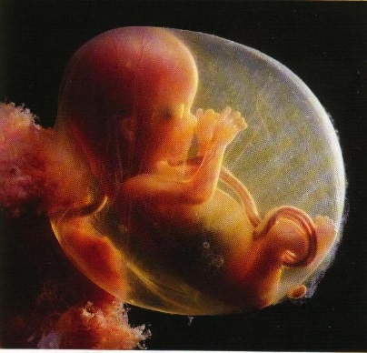

The baby grows very rapidly during those nine months. It floats in amniotic fluid. The amniotic fluid protects it from external shocks. It ensures that the baby doesn’t become dehydrated, and that it is always nice and warm. The baby is connected to its mother by the umbilical cord. That is how the mother provides food and oxygen to the baby so that it can develop.
Interesting fact!
After 20 weeks in the uterus, the baby can have dreams.

From egg and sperm to baby
Do you have any idea how a baby develops? I’ll take you on a tour of the uterus of a pregnant woman.
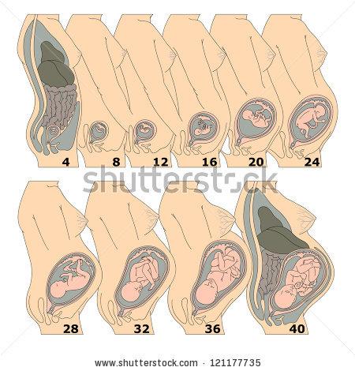
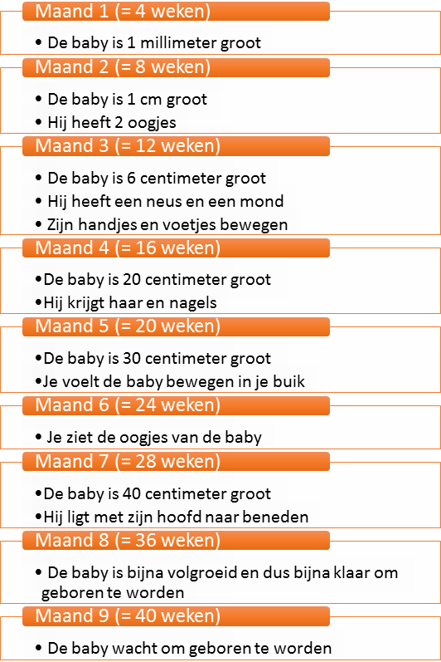
Month 1 ( = 4 weeks)
- The baby is 1 millimetre long
Month 2 ( = 8 weeks)
- The baby is 1 cm long
- It has 2 eyes
Month 3 ( = 12 weeks)
- The baby is 6 centimetres long
- It has a nose and a mouth
- Its hands and feet move
Month 4 ( = 16 weeks)
- The baby is 20 centimetres long
- It grows hair and nails
Month 5 ( = 20 weeks)
- The baby is 30 centimetres long
- The mother can feel the baby moving inside her
Month 6 ( = 24 weeks)
- You can see the baby's eyes
Month 7 ( = 28 weeks)
- The baby is 40 centimetres long
- The baby is positioned head down
Month 8 ( = 36 weeks)
- The baby is almost fully-grown and is almost ready to be born
Month 9 ( = 40 weeks)
- The baby is waiting to be born

Application phase 3 (application 1): From egg and sperm to baby

From egg and sperm to baby
Can you match the stages of development with the correct month of pregnancy?
Month 1
The baby's hands and feet begin to move.

Month 3
The mother can feel the baby moving inside her.

Month 5
The baby is waiting to be born.

The baby is 1 millimetre long.

The baby is positioned head down.

Month 7

Month 9

Solution

Month 1
The baby's hands and feet begin to move.

Month 3
The mother can feel the baby moving inside her.

Month 5
The baby is 1 millimetre long.

The baby is waiting to be born.

Month 7

The baby is positioned head down.

Month 9

Well done, congratulations!
Try again.
Sorry. Check the correct answer carefully.

Evaluation phase
Let us take a look what you remember. Good luck!
Question 1

Which of the following is not a primary sexual characteristic in girls?

- Uterus
- Vagina
- Breasts
- Fallopian tubes


Fantastic!
Sorry. It was the breasts. They are not present in a baby girl.

Question 2

Which of the following is not an important function of amniotic fluid for a baby?

- It protects from external shocks.
- It nourishes the baby.
- It ensures the right temperature for the baby.
- It protects against dehydration.

Good job!
Sorry. The correct answer is b. The baby receives nourishment from its mother via the umbilical cord.

Question 3

Which birth control method can be used by both men and women?

- Pill
- Condom
- IUD
- Tying the fallopian tubes

Congratulations! Keep up the good work!
Sorry. There are condoms for both men and women.

Question 4

What exactly happens during fertilization?

- One spermcell penetrates the wall of one egg.
- One egg penetrates the wall of one sperm.
- The penis penetrates the vagina.
- The egg is released by the ovary.

You're doing very well!
Not quite. During fertilization one spermcell penetrates the wall of one egg.

Question 5

How many eggs develop every four weeks in a woman's body?
- 1
- 2
- 3
- 4

You did a great job!
Better luck next time. You did your best!

