TOPIC: Body
Subtopic 3: Physical development
Pre-test
Teaching phase 1: Rock-a-bye baby
Application phase 1: Rock-a-bye baby
Teaching phase 2: Wow, I'm growing!
Application phase 2: Wow, I'm growing!
Teaching phase 3: House, garden, baby?
Application phase 3: House, garden, baby?
Teaching phase 4: All grown up at last or old and worn out?
Application phase 4: All grown up at last or old and worn out?
Evaluation phase

Pre-test

You have probably heard adults say: “My, how you’ve grown!” We're going to see what you know already about your body’s development, from childhood to old age.
Question 1

Which statement is true?
- Men live longer than women.
- Women live longer than men.
- Men and women live equally long.
- This is different in each country.


Question 2

Which statement is false?

- The oldest person in the world was 112 years old.
- In your lifetime you grow the most from your birth to about age 20.
- Life expectancy is the same in every country of the world.
- When a husband dies, the wife becomes a widow.

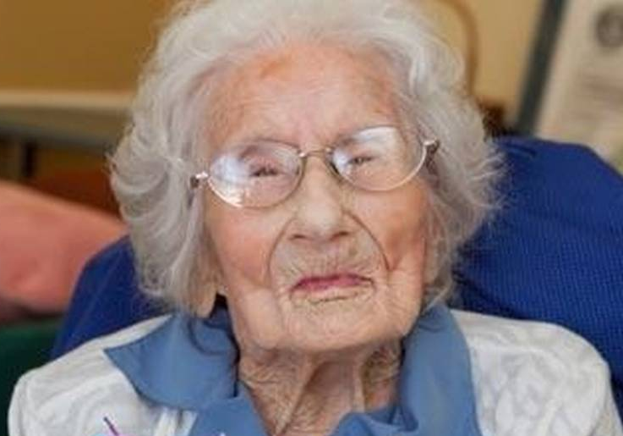

Question 3

What does it mean when a girl first begins to menstruate?

- She is fertile now and can have children.
- She can now have sex.
- It is a sign that she is an adult.
- It just happens, without any special significance.



Question 4

Which statement is true?

- We don't live as long today as we did 100 years ago.
- Only men live longer now than they did 100 years ago.
- Only women live longer now than they did 100 years ago.
- Both men and women live longer now than they did 100 years ago.

BeforeNow

Question 5
In de webversie stond ere en extra antwoordvak, ik heb dit verwijderd omdat er maar 4 antwoordmogelijkheden zijn.

On average, at what age does a child generally take his or her first steps?

- 6 months
- 1 year
- 2 years
- 3 years



Teaching phase 1: Rock-a-bye baby

Rock-a-bye baby

You are born as a tiny baby, but the first years are very important for later growth. Let’s find out why!

From the time of your birth it takes about 20 years to become an adult. You triple in height and gain 20 times your weight. You can see that clearly on the graph.






Baby
20 months
7 years
18 years
13 years
Your body continues to make new cells while growing. These cells make your skin, bones, and muscles ... grow longer and thicker.
When a baby is born you can tell right away if it is a girl or a boy. This is because boys and girls have different physical characteristics. Boys have a penis and testicles. Girls have a vagina and vulva. When you grow, a lot changes. Babies learn to laugh, sit, crawl, walk, talk...
From the age of 3 they go to school and learn much more!

Interesting fact!
Children today are 2 centimetres taller than they were 100 years ago at the same age.

Rock-a-bye baby

Let’s take a look at what children learn in their early years. Do you remember when you learned to walk and to ride a bike?

Now your body is starting to grow quickly. That's called a growth spurt.
Boys go though a growth spurt 2 years later than girls.

You learn how to read, write and do arithmetic maths at school.

You learn to ride a bike and to write neatly.

You can walk, run, kick a ball, climb ...
You can say about 100 words.

You can speak clearly and you know 1000 words.

You can sit up.

You understand basic words.
You take your first steps.

You sleep a lot.

4 days
You cry if you are hungry or cold.
You make laughing sounds.

6 weeks
6 months
1 year
2 years
4-5 years
5-6 years
7-10 years
11-13 years

Application phase 1 (application 1): Rock-a-bye baby

Rock-a-bye baby

You learn a lot in your first years. Can you place the right characteristics under the right age group?
You make laughing sounds.

You can sit up.
You take your first steps.

You can walk and run.

You know 1000 words.

You learn to read.

You go through a growth spurt.

You learn to ride a bike.

6 weeks | 6 months | 1 year | 2 years | 4-5 years | 5-6 years | 7-10 years | 11-13 years



Good job! Excellent job! You remembered that very well.
That's not completely correct. Think carefully again.
Sorry, check the correct answer carefully.
Solution

6 weeks | 6 months | 1 year | 2 years | 4-5 years | 5-6 years | 7-10 years | 11-13 years
You make laughing sounds. | You can sit up. | You take your first steps. | You can walk and run. | You know 1000 words. | You learn to read. | You learn to ride a bike. | You go through a growth spurt.

Teaching phase 2: Wow, I'm growing!

Wow, I'm growing!

From the age of 11, major changes occur in your body. That is why the period from 12-16 years has its own name: puberty. Are you curious to know what you and your classmates can expect? Pay close attention and take notes of the most important details in your notebook!

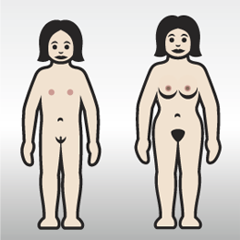
1
2
3
Girls grow a lot during puberty. They don't just grow taller, but many parts of their body grow too.
Girls’ breasts begin to grow from about their eleventh to their eighteenth year (1). They also develop broader hips (2). That is why you hear people speak about the ‘female body shape’. Girls also grow hair in their armpits and around the vagina (3).

During puberty, girls have a white vaginal discharge for the first time. This can last one or two years. After that they begin to menstruate. This makes it possible for them to have children later. As long as they are not pregnant, they will bleed once a month during menstruation or their period. They use tampons or sanitary napkins to absorb the blood. Menstruation is sometimes accompanied by cramps, a sore back, or other complaints.


Wow, I'm growing!

So what happens with the boys? Don’t forget that you can use your notebook!

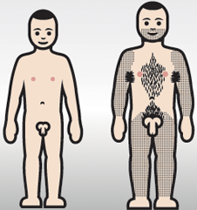
1
2
3
4
Boys also grow a lot during puberty, until they are about seventeen years old. Their growth spurt starts a little later than it does in girls. As well, the penis and testicles become larger (1). When the testicles begin to grow, the production of semen begins. This is a white, sticky fluid. There are many spermcells in the fluid. During sexual contact with a woman, pregnancy can occur. During puberty a boy can emit semen for the first time. This is his first ejaculation, the so-called ‘wet dream’.
Boys develop broader shoulders (2). They also grow hair in many places: they grow a beard, a moustache and hair on their arms and legs. Like girls, they grow hair in their armpits and around their genital area, the penis (3). Boys’ voices also get deeper during puberty. Their voice ‘breaks’ (4).
Interesting fact!
The changes don’t happen to every boy and girl at the exactly the same age.

Wow, I'm growing!

To help you out, here’s an overview of the main changes in boys and girls.

Girls | Boys
Girls grow a lot | Boys grow a lot
Girls’ breasts grow | Boys' penis and testicles grow
Girls’ hips broaden | Boys' shoulders broaden
Girls grow hair in their armpits and around the genital area | Boys grow a beard, a moustache and hair in their armpits, on their legs and arms and pubic hair
Girls have their first menstrual period | Boys have their first ejaculation
Girls develop acne | Boys develop acne
 | Boys’ voices deepen

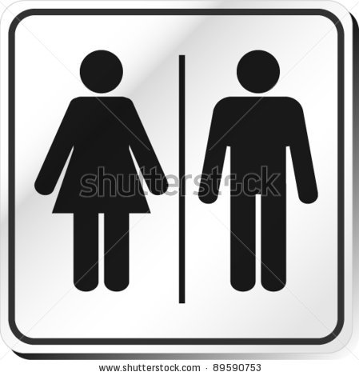
Application phase 2 (application 1): Wow, I'm growing!

Wow, I'm growing!

Is the following statement true or false?

Both boys and girls grow hair in their armpits and around their genitals during puberty.

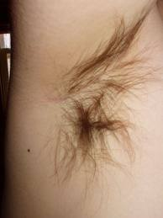

True
Good job!
Sorry, but that was true.

Wow, I'm growing!

Is the following statement true or false?

On average, boys have a growth spurt at the same time as girls.



False.
Fantastic!
Sorry, that was false. Boys start their growth spurt a little later.
Wow, I'm growing!

Is the following statement true or false?

Girls’ voices become a little higher during puberty.



False.
Congratulations!
Sorry, that was false. Boys’ voices become deeper during puberty. Girls’ voices don’t change at all.

Wow, I'm growing!

Is the following statement true or false?

Girls have their first ‘wet dream’ during puberty.



False.
Bravo!
That is incorrect. It is the boys who have a ‘wet dream’. This means that they have released semen for the first time.

Wow, I'm growing!

Is the following statement true or false?

Girls have a white discharge some time before their first period.



True
Excellent job! You remembered that very well.
Sorry. But that was true.

Teaching phase 3: House, garden, baby?

House, garden, baby?

When you graduate from secondary school, there are many more changes in your life. You are no longer in puberty but an adolescent. As soon as you turn 18, you are an adult. You leave secondary school and begin a new life. Some people go on to further studies, and others start work.
Your parents no longer represent you; you are responsible for yourself. In other words, you become independent. This means that you do more and more things for yourself. But you also have more responsibilities. For example, you have to take care of yourself, make sure you eat well and stay healthy … and step by step you become more grown up.
As soon as you get a job, you will earn your own money. Your parents won’t be paying for everything you need any more. Most youngsters don’t continue to live at home with their parents. If you live alone, you’ll find out how expensive everything is. You will have monthly expenses, such as gas and electricity, that must be paid on time.
Interesting fact!
Students living in a rented room cost their parents more than € 12,000 a year!

Teaching phase 3: House, garden, baby?

House, garden, baby?


If you have a partner, you can share expenses. In the past, men usually went to work while women kept house. Now many women also work full-time outside the home.
People have to work increasingly longer. That means they retire later. Some people are not able to work so much because their health does not allow it. Fortunately there are excellent provisions for such individuals in Belgium. For example, they can receive subsidies, and when they grow old they can live in a retirement home.
Some couples marry, but others just live together. Nowadays more and more young couples live together, and fewer get married. Unfortunately more and more couples are getting divorced. Sometimes they find a new partner and re-marry, and sometimes they stay single.

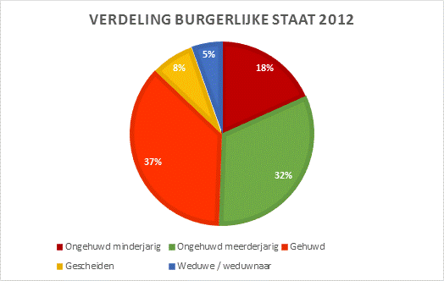

Unmarried minor
Unmarried adult
Married
Divorced
Widow/widower

Population of Belgium
Figures for 2012

Application phase 3: House, garden, baby?

House, garden, baby?

Take a good look at the pie chart. Which statement is true?

- 25% of the Belgian population has lost a partner to death. The surviving partner is a widow or widower.
- Less than 10% of Belgian couples are divorced.
- More than 50% of the Belgian population are married.
- More than 35% of the Belgian population are single adults.

Congratulations, you have understood the chart!
Sorry. Take a good look at the legend accompanying the chart.
Sorry. 8% of the Belgian population are divorced.

Teaching phase 4: All grown up at last or old and worn out?

All grown up at last or old and worn out?
And suddenly everything starts to slow down. What happens to your body? Think about the differences between you and your grandma …

When you are twenty years old, you are at your peak: your body is fully grown. It is important that you live a healthy lifestyle and get enough exercise. You can start eating a little less. Once you get close to thirty, you need less energy for growth.
As we age we see many changes. Your organs and muscles become weaker, your senses work less effectively …
Do you see the differences in the photo? Older people have grey or white hair. Their skin begins to sag, and they get wrinkles. Their bones become weaker and thinner. As a result, they shrink.


Around the age of fifty, women reach menopause. That means they have their last menstruation and can no longer bear children. During this time they often experience headaches, sweating and mood swings.
We also talk about male menopause. Men remain fertile, but it isn't as easy for them to father children. Men, too, have more aches and pains.

All grown up at last or old and worn out?
Did you know that we live a lot longer than in the past?


In 1843, approximately 170 years ago, the average life expectancy was forty years. Now the average life span is eighty years. This is the result of improved living conditions in Belgium. Doctors can do more than in the past. We take better care of ourselves. Therefore good hygiene, good medication and a varied diet are very important. This is definitely not the case in every country! Living conditions are not the same everywhere. In Monaco the average lifespan is 90 years, and in South Africa only 49 years.
Did you know that women in Belgium live an average of 83 years and men 78 years? This has to do with lifestyle. Unfortunately, it doesn’t mean that just because women live longer they are also are healthier. They often have pain in their joints and bones. If a woman loses her husband through death, she is a widow. If a man loses his wife, he becomes a widower.
Interesting fact!
The oldest woman in the world turned 122 years old.

Application phase 4 (application 1): All grown up at last or old and worn out?

All grown up at last or old and worn out?
Is the following statement true or false?

When you reach the age of twenty, you have to keep eating a lot so that you can continue to grow.



False.
Fantastic!
Sorry, that was false. Around the age of twenty you are fully grown and you need less energy for growth.
All grown up at last or old and worn out?
Is the following statement true or false?

Women enter menopause around the age of fifty.



True
Excellent job! You remembered that very well.
Sorry, but that was correct.

All grown up at last or old and worn out?
Is the following statement true or false?

When men are in male menopause, they can no longer father children.



False.
Good job!
Men are always fertile, although it isn’t as easy to father children.

All grown up at last or old and worn out?
Is the following statement true or false?

We don't live as long today as we did 100 years ago.



False.
Excellent job. You did that very well!
No, sorry. Thanks to good living conditions we live much longer.

All grown up at last or old and worn out?
Is the following statement true or false?

On average, women live longer than men.

True
Yes that's right, you did well.
Sorry, but that was correct.

Evaluation phase
Let's take a look now at what you remember about physical development. Good luck!
Question 1

What does menopause mean for women?

- They can now marry.
- They can't have any more children.
- Their breasts begin to grow.
- They can no longer have sex.

Excellent job!
Sorry. Menopause means that women become infertile and can no longer bear children.

Question 2

Which statement is false?

- We live longer now due to better medications.
- We live longer now because of a more varied diet.
- We live longer now due to better hygiene.
- We live longer now due to a better environment.



Congratulations!
Sorry. The correct answer is d. We don't live longer now due to a better environment. In fact, there is more pollution now than in the past.

Question 3

What is the average age of the onset of puberty?

- 6 to 9 years
- 9 to 11 years
- 12 to 16 years
- 16 to 18 years

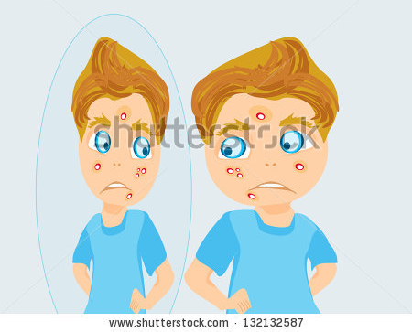

Good job!
Sorry. Puberty is the period from 12 to 16 years.

Question 4

What is semen?

- A white, sticky substance that comes out of the penis when a boy ejaculates.
- The blood that girls lose during menstruation.
- The white fluid that girls discharge before their first menstruation.
- A substance that ensures that the penis will grow during a boy’s puberty.

You are doing very well! Keep up the good work!
Sorry. Semen is a white, sticky substance that comes out of the penis when a boy ejaculates.

Question 5

Which statement is true?
- Women live longer and are healthier than men.
- Women live longer, but are not healthier than men.
- Women don't live as long, but are healthier than men.
- Women don't live as long and are not healthy as men.

You did a great job!
Better luck next time. Women live longer than men, but are not healthier.

