TOPIC: Body

Subtopic 2: Digestion
Pre-test
Teaching phase 1: You are what you eat
Application phase 1: You are what you eat
Teaching phase 2: Your stomach as a bagpipe
Application phase 2: Your stomach as a bagpipe
Teaching phase 3: Large and small & co.
Application phase 3: Large and small & co.
Teaching phase 4: No drivel in the pancreas and liver!
Application phase 4: No drivel in the pancreas and liver!
Evaluation phase

Pre-test

Hi there! Today I am going to take you through the digestive system. Do you know what goes on in there? First, let's check how much you already know!
Question 1

Which two organs are connected to the oesophagus?

- The mouth and the stomach
- The stomach and the intestines
- The small and the large intestine
- The liver and the intestines

Question 2

Which of the following is not an intestine?

- The large intestine
- The duodenum
- The pancreas
- The jejunum

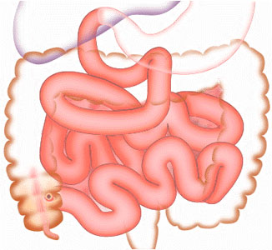
Question 3

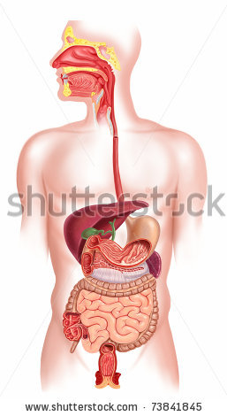
What is the average length of an adult digestive tract?

- 2 metres
- 5 metres
- 9 metres
- 14 metres

Question 4

Where is your liver?

- In the lower right of your ribcage
- In the upper right of your ribcage
- In the lower right of your abdominal cavity
- In the upper right of your abdominal cavity

Question 5

Which part of the digestive system is indicated by number 1 on the picture?
1

111111
- The stomach
- The liver
- The large intestine
- The pancreas

Teaching phase 1: You are what you eat

You are what you eat

Every day you eat some yummy food. What you eat has to go somewhere. What happens to the food you put into your mouth?

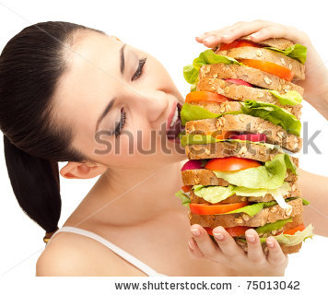
We need food daily in order to survive. Food provides us with essential nutrients. There are different types of nutrients, and each has a specific function in our body:
- We need fuel to give us energy to study, to do sports and to play. We find this fuel in carbohydrates and fats.
- We need building materials in order to grow. We find these in proteins and water.
- To protect us from illness, we need vitamins and minerals.

You can’t see these elements in your daily meals. Our food has to be broken down into very small bits, so that the nutrients can end up in our blood. Blood can then carry them through our body.

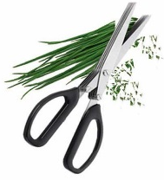
This is why it is called ‘digestion’: our food is broken down, or digested, into very tiny particles. To do this, we need the help of many organs which together form the digestive system.
ENZYME
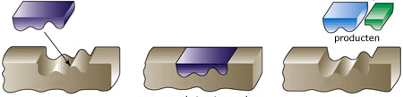
In each of these organs, such as the mouth, the stomach and the intestines, digestive juices are added to our food. These juices contain enzymes. These are very tiny particles that ‘chop up’ our large pieces of food.
products

You are what you eat

The digestive system consists of a number of organs. Take a look at where the organs fit in your body.
1

111111
2
3
5
7

111111
8
9
13

111111
4
11
12
6
10

1 | Mouth
2 | Oesophagus
3 | Liver
4 | Pancreas
5 | Stomach
6 | Small intestine
7 | Duodenum (part of the small intestine)
8 | Jejunum (part of the small intestine)
9 | Ileum (part of the small intestine)
10 | Large intestine
11 | Appendix
12 | Rectum
13 | Anus

You are what you eat

Are you ready? We'll start with the mouth and the oesophagus! Don't forget to use your notebook. It can help as a memory aid!
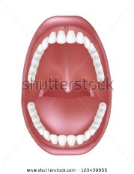

In your mouth you chew your food into small pieces and it mixes with saliva. That's why it is very important to chew well with your teeth. Chewing well makes the pieces of food small enough for the enzymes in saliva to do their work. Your tongue helps to push the food between your teeth. The saliva makes the food slippery, so that it is easy for you to swallow. The tongue then helps to push the food toward the oesophagus.

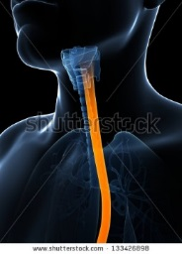
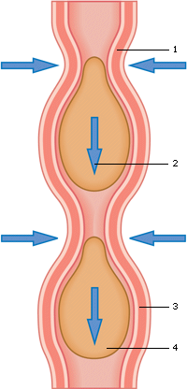
The oesophagus is a muscular tube approximately thirty centimetres long. It passes the food from the mouth to the stomach by alternately contracting and relaxing. This is known as peristaltic movements. The oesophagus doesn’t process food. At the passage between the oesophagus and the stomach there is a sphincter. It opens when food enters the stomach from the oesophagus. Then it closes again. That is so that no food can return to the oesophagus once it is in the stomach.

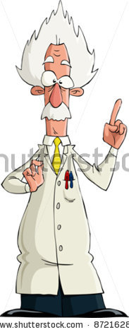
Interesting fact!
Every day you produce more than one litre of saliva!

You are what you eat

Let me give you an overview of the organs at the beginning of the digestive tract.


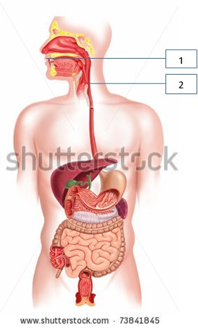
Mouth (1)
Teeth
Saliva
Tongue
Oesophagus (2)

Interesting fact!
An adult digestive tract is 9 metres long!

Application phase 1 (application 1): You are what you eat

You are what you eat

Can you name the organs below? Look carefully at where the lines point and drag the organs to the correct number.
1
3
2
5
4

Stomach
Liver

Rectum
Oesophagus

Large intestine

1
2
3
4
5

Good job!
That's not quite right. Try again. Check your notebook; does it help?
Sorry. Try to remember where everything is, and that will help you next time!

Solution

1 | Oesophagus
2 | Stomach
3 | Liver
4 | Large intestine
5 | Rectum

Application phase 1 (application 2): You are what you eat

You are what you eat

What is 'peristaltic movement'?

- The act of chewing food well
- The alternating contraction and relaxation of an organ
- The mixing of food with saliva
- The opening and closing of the sphincter

Excellent job! You remembered that very well.
Oops. Try another answer.
Sorry. It is the alternate contracting and relaxing of an organ, such as the oesophagus.

Teaching phase 2: Your stomach as a bagpipe

Your stomach as a bagpipe

So what's the next step? Your stomach!

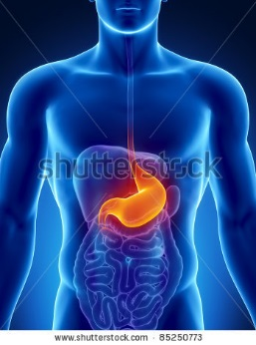
Your stomach is approximately in the middle of your digestive system, and looks like a stretchy bag. Food is kneaded and mixed with stomach acid which is produced in the stomach itself. Stomach acid is made up in part of hydrochloric acid and enzymes. Hydrochloric acid makes your food accessible to the enzymes. It also kills germs in the food.
A hot meal stays in the stomach for an average of three hours. If you eat very greasy food, your stomach will need more time to digest everything. At the end of the stomach we find another sphincter. It seals off the stomach and passes food in small amounts to the small intestine.
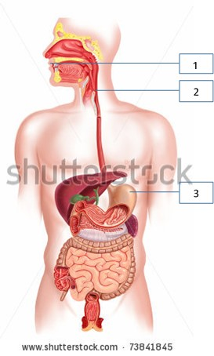

Mouth (1) Oesophagus (2)Stomach (3)
Interesting fact!
Our stomach can hold almost 2 litres of food!


Application phase 2 (application 1): Your stomach as a bagpipe

Your stomach as a bagpipe

Is the following statement about the stomach true or false?

Your stomach is approximately in the middle of your digestive system.

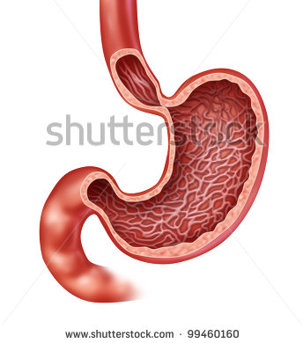

True
Good job!
Sorry, that was correct.
Application phase 2 (application 1): Your stomach as a bagpipe

Your stomach as a bagpipe

Is the following statement about the stomach true or false?

If you eat very greasy food, your stomach will need less time to digest everything.

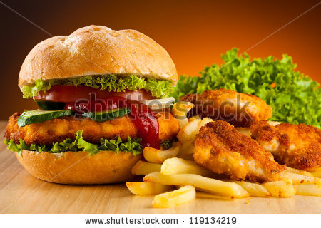

False.
Congratulations!
That's not correct. If you eat very greasy food, your stomach will on the contrary need more time to digest everything.
Application phase 2 (application 1): Your stomach as a bagpipe

Your stomach as a bagpipe

Is the following statement about the stomach true or false?

The sphincter at the end of the stomach seals off the stomach and passes food in tiny portions to the large intestine.

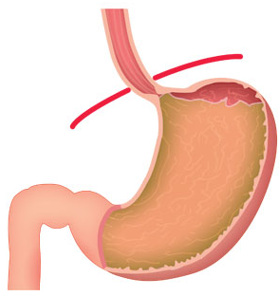

False.
Good job!
Sorry. It seals off the stomach and passes food in small amounts to the small intestine, not the large intestine.
Teaching phase 3: Large and small & co.

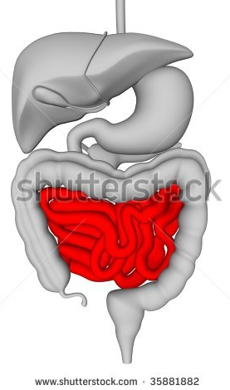
Large and small & co.
After it leaves the stomach, food enters the intestines. The intestines are really long!
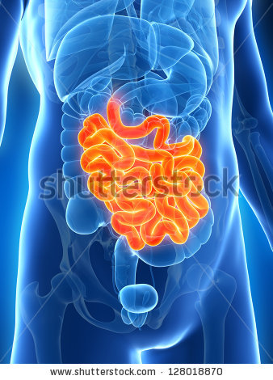
The small intestine is around five metres long and consists of three parts: the duodenum, the jejunum, and the ileum:
1. The duodenum is the first part of the small intestine. Its length is equal to about the width of twelve fingers (that's what its name means). So if you take your thumb and imagine putting twelve of them next to each other, you can see how long the duodenum is.
2. Next, the food pulp (chyme) enters the jejunum. It is two metres long.
3. The jejunum is followed by the ileum, which is about three metres long.
The small intestine is very important for digestion. This is where the food is digested into micronutrients. These are absorbed by the blood through the wall of the small intestine. The blood transports these nutrients to the various organs in our body.

Interesting fact!
If you unravelled the small intestine, it would be as large as a tennis court!

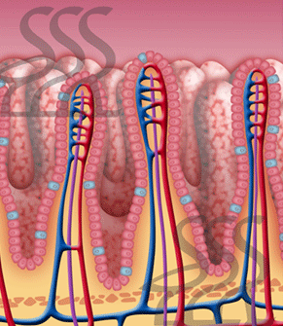
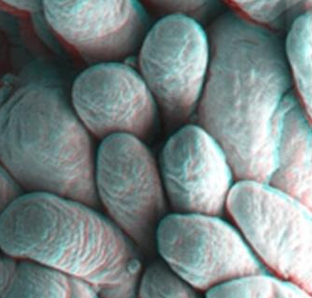

The wall of the small intestine has many folds and tinyprotrusions.. These are the intestinal villi.

Large and small & co.
The small intestine is not the end of the road, you know. There is still a long way to go, so pay attention and take good notes!
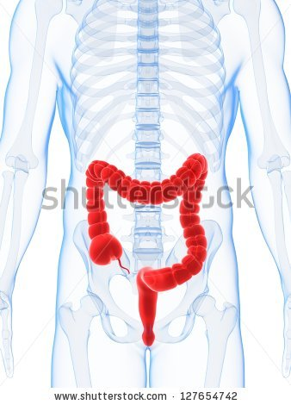
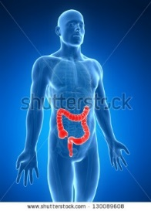
Food molecules that the body cannot use end up in the large intestine. There, the body forms solid faeces, stool or waste. The large intestine is about one metre long. It looks like an upside-down U in the abdominal cavity. The point at which the small intestine joins the large intestine is the appendix. It is as big as a finger.
The stool that your body produces at that moment consists of a watery mush. The large intestine removes moisture and salts from the stool. If too little liquid is removed from your stool, you have diarrhoea. If the stool moves through the large intestine too slowly, you can get constipation. That means it is hard to go to the toilet.

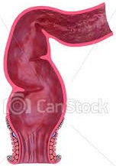
The next section of the intestines is called the rectum. This is where the stools are stored. When the rectum is full, the brain receives a signal and you feel the urge to go to the toilet. It takes an average of 24 hours for stool to pass through the entire large intestine. Finally, the stools leave your body through the anus.
Interesting fact!
The large intestine contains millions of bacteria that feed on our leftovers!

Large and small & co.
As you can see, we have studied almost all of the organs in the digestive system. Do you know which two organs are still missing? I’ll show you in a minute!
Mouth (1) Oesophagus (2) Stomach (3) Small intestine (7)
Appendix (9) Large intestine (8) Rectum (10) Anus (11)
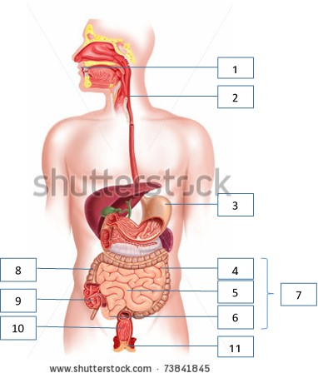
Application phase 3 (application 1): Large and small & co.

Large and small & co.
Can you match the descriptions below with the correct term?

Small intestine
Duodenum
Jejunum
Ileum
The second section of the small intestine, which is about two metres long.

Storage site for the stools.

The third section of the small intestine, which is about three metres long.

Appendix
Large intestine
Rectum
The wall of this intestine has many folds and tiny projections.

This intestine is about one metre long and looks like an upside-down U in the abdominal cavity.

The first section of the small intestine.

The point at which the small intestine joins the large intestine.

Solution

Small intestine
Duodenum
Jejunum
Ileum
The second section of the small intestine, which is about two metres long.
Storage site for the stools.
The third section of the small intestine, which is about three metres long.
The wall of this intestine has many folds and tiny projections.

Appendix
Large intestine
Rectum
This intestine is about one metre long and looks like an upside-down U in the abdominal cavity.
The first section of the small intestine.
The point at which the small intestine joins the large intestine.

²

Great! That's quite an accomplishment.
Try again. Take another close look and use your notebook.
Oops. Better luck next time!

Teaching phase 4: No drivel in the pancreas and liver!

No drivel in the pancreas and liver!
The last two important organs in our digestive system are the liver and the pancreas. Let’s take a quick look! We’ll begin with the liver.
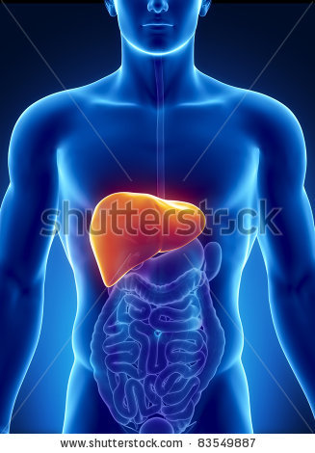
The liver is a large, important organ. It is located in the upper right of the abdominal cavity, next to the stomach. During digestion, nutrients are released. These are carried to the liver through the blood.
You can compare the liver to a ‘chemical plant’. It has three main functions:
1. The liver processes nutrients and converts them to building materials. The building materials ensure that you have enough energy.
2. The liver neutralizes certain harmful substances in our body. Your urine and faeces dispose of any harmful substances that the liver can’t neutralize.
3. The liver produces bile. We need bile to digest fats properly.
Interesting fact!
Your liver is the largest internal organ. It weighs about 1.5 kilograms.

No drivel in the pancreas and liver!
What does the pancreas do for your digestion?
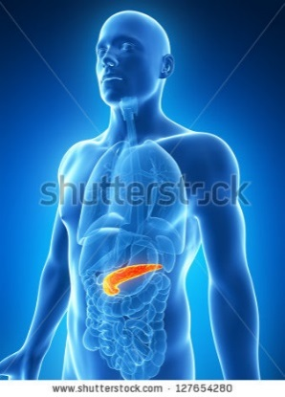
The pancreas is a long, narrow gland. It is located in the back of the abdomen, behind the duodenum and the stomach.

The pancreas produces more than one litre of pancreatic juice every day. This juice contains various enzymes. We need these to digest sugars, proteins and fats.
The pancreatic juice from the pancreas and the bile from the liver are added in the small intestine to the food coming from the stomach. These juices are an important aid to the small intestine during the digestive process. The pancreatic juice from the pancreas is secreted only when we see, smell, taste or swallow food. Then the brain receives a signal, and that’s how it knows food is on its way.

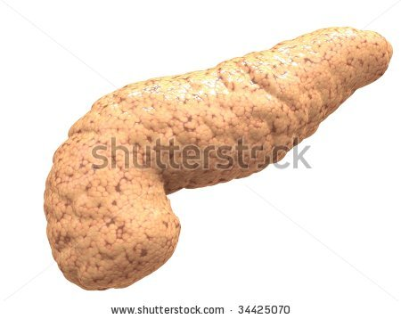

No drivel in the pancreas and liver!
Now you know the entire digestive system: well done!
Mouth (1) Oesophagus (2) Stomach (3)(5) Small intestine (7)(6) Appendix (9)(11)
Large intestine (8)(10) Rectum (9)(12) Anus (11)(13) Liver (12)(3) Pancreas (13)(4)
(andere afbeelding met andere nummers in webversie)
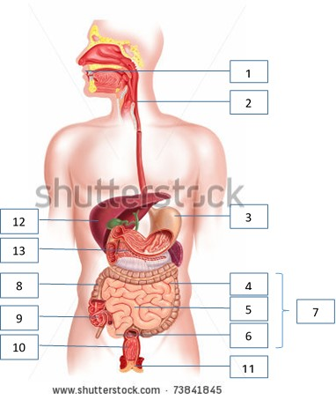
Application phase 4 (application 1): No drivel in the pancreas and liver!

No drivel in the pancreas and liver!
Do you remember what exactly the pancreas and the liver do? Drag the characteristics to the correct column.
Located behind the duodenum and the stomach
Produces pancreatic juice

Located in the upper right of the abdominal cavity, next to the stomach.
Receives a signal if we see or swallow food
Converts nutrients into building materials
Is a long, narrow gland
Neutralizes harmful substances
Is just like a chemical plant

Pancreas | Liver

Solution

Pancreas | Liver
Located behind the duodenum and the stomach | Located in the upper right of the abdominal cavity, next to the stomach
Produces pancreatic juice | Is just like a chemical plant
Is a long, narrow gland | Converts nutrients into building materials
Receives a signal if we see, smell, taste or swallow food | Neutralizes harmful substances

You deserve a medal!
Try again. Read all the possible answers carefully. Does your notebook help?
Too bad, you did your best!

Evaluation phase
Let us take a look what you remember about the digestive system. Good luck!
Question 1

Why are enzymes so important for digestion?

- They make the food slippery, so that it can easily pass through the organs.
- They divide the food up into tiny particles.
- They remove waste materials from our food.
- They make sure that our food cannot travel backwards into the previous organ during digestion.

Very good! You're off to a good start!
Sorry. Enzymes divide the food up into tiny particles.

Question 2

Which organ transports the food by means of peristaltic movements? This is the alternating contraction and relaxation of an organ.

- The oesophagus
- The mouth
- The liver
- The pancreas

Correct! Keep going, you're almost there!
The correct answer is the oesophagus.
Question 3

Which of these is not a function of the liver?
- Producing bile
- Neutralizing harmful substances
- Digesting sugars, proteins and fats
- Converting nutrients into building materials

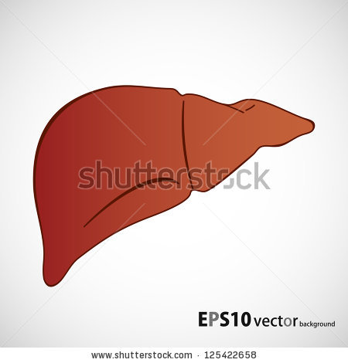

Excellent job. You did that very well!
Sorry. This is indeed one of the functions of the liver. The liver doesn’t digest sugars, proteins or fats.

Question 4

Why is the sphincter at the entrance to the stomach so important?
- It prevents large pieces of food from entering the stomach.
- It prevents food from entering the large intestine too quickly.
- It prevents food from re-entering the oesophagus.
- It prevents food from entering the small intestine too quickly.

Bravo! Now we’ll move on to the last question...
The right answer was c: the sphincter prevents food from re-entering the oesophagus.
Question 5

Can you name the organs below? Look carefully at where the lines point, and choose the correct combination.
1

111111
3

111111
2
- 1 = anus, 2 = mouth, 3 = pancreas
- 1 = mouth, 2 = pancreas, 3 = anus
- 1 = mouth, 2 = anus, 3 = pancreas
- 1 = pancreas, 2 = anus, 3 = mouth

You did a great job!
Better luck next time. Take a good look at the solution!

