TOPIC: Body
Subtopic 1: The Circulatory System
Pre-test
Teaching phase 1: The heart, the centre of your circulatory system
Application phase 1: The heart, the centre of your circulatory system
Teaching phase 2: Veins and arteries: the blood’s motorways
Application phase 2: Veins and arteries: the blood’s motorways
Teaching phase 3: Mirror, mirror on the wall, why is our blood so interesting?
Application phase 3: Mirror, mirror on the wall, why is our blood so interesting?
Evaluation phase

Pre-test

Hey there! Do you know what’s going on in our body? By answering these questions, you can find out what you already know!
Question 1

How many litres of blood flow through the body of an adult?
- 3 litres
- 5 litres
- 10 litres
- 15 litres
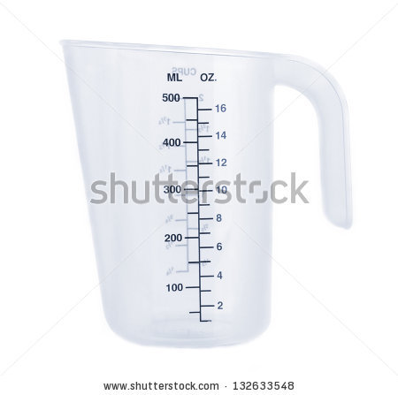

Question 2

What are the most important parts of the circulatory system?
- Heart and blood vessels
- Heart and lungs
- Lungs and the liver
- Liver and intestines

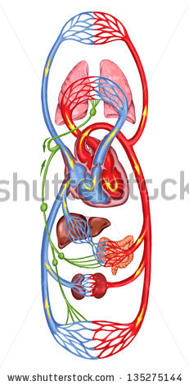

Question 3

What are the two types of blood cells?
- Large and small blood cells
- Thick and thin blood cells
- White and red blood cells
- Black and red blood cells

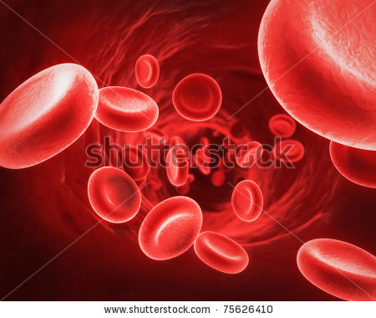

Question 4

What is a microscope?
- An apparatus for listening to your heart
- An apparatus for examining things that are too small to see with the naked eye
- An apparatus for testing hearing
- An apparatus for measuring your temperature



Question 5

What are the two types of blood vessels?
- Red and white blood vessels
- Veins and varicose veins
- Veins and arteries
- Capillaries and varicose veins

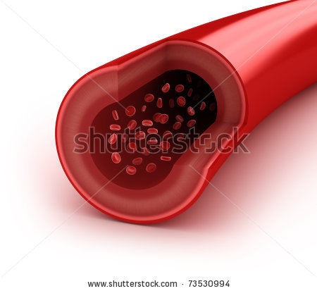

Teaching phase 1: The heart, the centre of your circulatory system

The heart, the centre of your circulatory system

Do you know which part of our body is essential to circulation? What do you feel beating, or what sometimes beats faster? Our heart, of course!
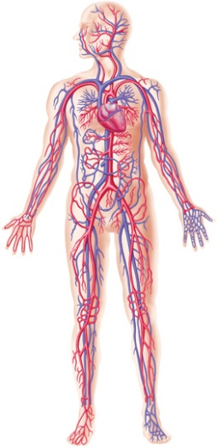
The circulatory system consists of the heart and the blood vessels. You can find your heart on the left side of your body, under your ribcage.

The heart consists of a right side and a left side. The right and the left side each has a ventricle (2 and 4) and an atrium (1 and 3), that are linked by a heart valve (5 and 6). These ventricles and atria ensure that the blood continually flows all through our body. The heart is a type of pump that constantly contracts and relaxes.
The alternating contracting and relaxing of the heart muscle is what we call the heartbeat. When you are resting, your heart rate slows down and when you exert yourself, you can feel your heartbeat speed up. The easiest place to feel it is in your neck, but you can feel it on your wrist or your ribcage too.
Children have an average heart rate of 130 beats per minute, and adult hearts beat an average of 70 beats per minute.
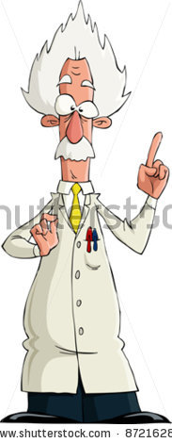
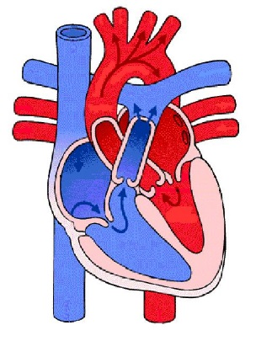
1
3
2
4
5
6
AMAZING FACT!
Later, when you are an adult, your heart will weigh as much as a large potato.

The heart, the centre of your circulatory system

Now we are going to look at how the heart and blood circulation work together! Make a note of the most important material in your notebook.

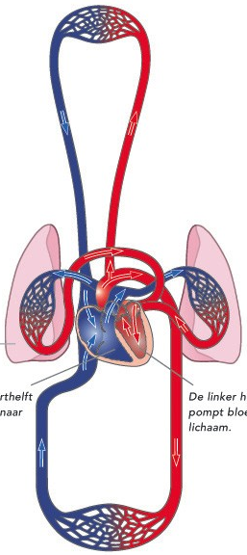
Oxygen-rich blood
Oxygen-poor blood
There are 2 circulatory systems in your body: the greater and the lesser circulatory system.

The lesser circulatory system carries the blood from your heart to your lungs and back. The right atrium receives oxygen-poor blood from the body. When the atria contract, this blood is pumped into the right ventricle through the heart valve. When the ventricles contract, the oxygen-poor blood enters the pulmonary artery. The pulmonary artery pumps this blood into the lungs. There it is transformed into oxygen-rich blood.

The greater circulatory system takes much longer, considering that the blood travels from the heart to all of the cells in your whole body and back. That is the reason for the term ‘greater’ circulatory system. The oxygen-rich blood from your lungs travels in the pulmonary artery to the left heart atrium. When the atria contract, this blood is pumped into the left ventricle through the heart valve. When the ventricles contract, this oxygen-rich blood enters your main artery. This artery is also called the aorta. The oxygen-rich blood is pumped through your whole body via the aorta.

The heart, the centre of your circulatory system
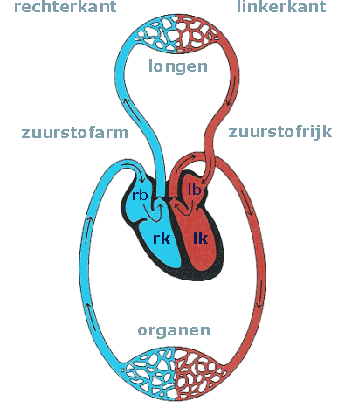
Have you noticed that the left side carries oxygen-rich blood (in red), while the right side of the heart is responsible for the oxygen-poor blood (in blue)? Let’s go over the functions of the various parts of the heart. Take a good look at the figure!
1
2
3
4
6
5
10
11
7
8
9

1 | Lungs
2 | Organs
3 | Right atrium | This atrium takes oxygen-poor blood from the body and pumps it into the right ventricle through the heart valve.
4 | Left atrium | This atrium gets oxygen-rich blood from the lungs.
5 | Right ventricle | This ventricle pumps oxygen-poor blood to the lungs through the pulmonary artery.
6 | Left ventricle | This ventricle pumps oxygen-rich blood via the aorta to all the cells in our body.
7 | Pulmonary artery | This artery carries oxygen-poor blood from the right ventricle to the lungs. There the blood absorbs the oxygen and releases carbon dioxide.
8 | Pulmonary vein | This vein pumps the oxygen-rich blood from the lungs to the heart, namely the left atrium.
9 | Aorta (main artery) | This is the largest artery, which takes oxygen-rich blood from the left ventricle of the heart and carries it to the organs.
10 | Lesser circulatory system
11 | Greater circulatory system

Oxygen | Oxygen is an odourless, colourless gas that we breathe in constantly. Without oxygen we cannot survive. Our body is made up of 65% oxygen, especially in the form of water.
Oxygen-rich blood | Blood that contains oxygen
Oxygen-poor blood | Blood that does not contain oxygen
Carbon dioxide | Waste that the lungs remove from our blood and is exhaled.
Application phase 1 (application 1): The heart, the centre of your circulatory system

The heart, the centre of your circulatory system

Now you know that each part of the heart has an important role in the circulatory system. Can you match the right parts with their function?

Main artery or aorta
This ventricle pumps oxygen-rich blood via the aorta to all the cells in our body.

Pulmonary artery
This atrium takes oxygen-poor blood from the body and pumps it into the right ventricle through the heart valve.

Right atrium

This is the largest artery, which takes oxygen-rich blood from the left ventricle of the heart and carries it to the organs.

Left atrium

This ventricle pumps oxygen-poor blood to the lungs through the pulmonary artery.

Left ventricle
This atrium gets oxygen-rich blood from the lungs.

This artery carries oxygen-poor blood from the right ventricle to the lungs. There the blood absorbs the oxygen and releases carbon dioxide.

Right ventricle

Pulmonary vein
This vein pumps the oxygen-rich blood from the lungs to the heart, namely the left atrium.

Good job!
Try again. You can do it!
Sorry, you've made a few errors. Better luck next time!

Solution

Main artery or aorta
Pulmonary artery
Right atrium

Left ventricle
Left atrium

Right ventricle
This atrium takes oxygen-poor blood from the body and pumps it into the right ventricle through the heart valve.
Pulmonary vein
This is the largest artery, which takes oxygen-rich blood from the left ventricle of the heart and carries it to the organs.

This ventricle pumps oxygen-poor blood to the lungs through the pulmonary artery.

This atrium gets oxygen-rich blood from the lungs.

This artery carries oxygen-poor blood from the right ventricle to the lungs. There the blood absorbs the oxygen and releases carbon dioxide.

This ventricle pumps oxygen-rich blood via the aorta to all the cells in our body.

This vein pumps the oxygen-rich blood from the lungs to the heart, namely the left atrium.

Teaching phase 2: Veins and arteries: the blood’s motorways

Veins and arteries: the blood’s motorways

What ensures that blood can flow through your entire body? Aside from the heart, the blood vessels are very important for your circulation.

There are two major groups of blood vessels: veins and arteries. We have already seen two examples of arteries: the aorta and the pulmonary artery. We have also been introduced to a vein: the pulmonary vein.

But what is the difference between an artery (1) and a vein (2)?
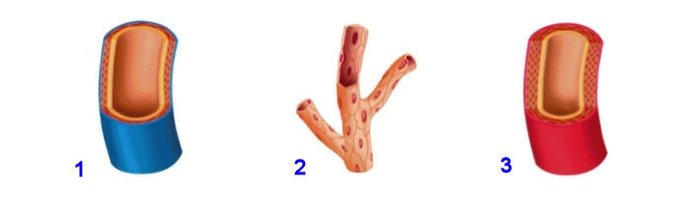
Heart
In arteries (1) the blood flows away from the heart. Arteries have a thick wall. The thick wall is necessary for pumping the blood from your heart through the rest of your body. Some parts of the body need more blood than others. That's why there are capillaries (3). These are tiny blood vessels that branch off from the arteries. They make it possible for blood to flow through our entire body, from top to toe.

Veins (2) carry blood back to the heart. Veins have thin walls. Veins contain valves that keep the blood flowing to the heart and prevent it from flowing away from the heart.

1
2
3
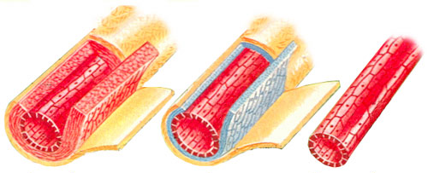

Veins and arteries: the blood’s motorways

Do you know the difference between veins and arteries? Here is a summary.

Vein | Artery
Thin wall | Thick wall
Has valves | Has no valves
Carries blood to the heart | Carries blood away from the heart

AMAZING FACT!
If you placed all your blood vessels end-to-end, they would reach around the world twice!

Application phase 2 (application 1): Veins and arteries: the blood’s motorways

Veins and arteries: the blood’s motorways

Is the following statement about veins and arteries true or false?

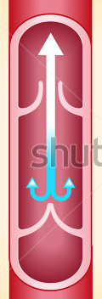
Heart

Arteries have valves. Therefore blood can only flow to the heart. It cannot flow away from the heart.



False.
Well done! Only veins have valves, because the veins carry the blood to the heart. The valves prevent the blood from flowing away from the heart.

Veins and arteries: the blood’s motorways

Is the following statement about veins and arteries true or false?

Arteries have thicker walls than veins.

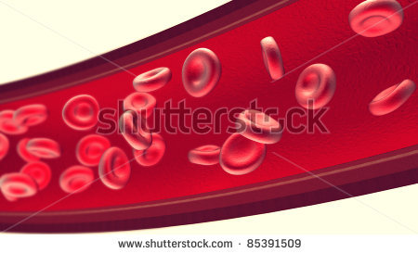

True
Good job! Arteries do indeed have a thicker wall. The thick wall is necessary for pumping the blood from your heart through the rest of your body.
Sorry, but that is true. Arteries have a thicker wall. The thick wall is necessary for pumping the blood from your heart through the rest of your body.

Veins and arteries: the blood’s motorways

Is the following statement about veins and arteries true or false?

In veins, the blood flows away from the heart. In arteries, the blood flows to the heart.

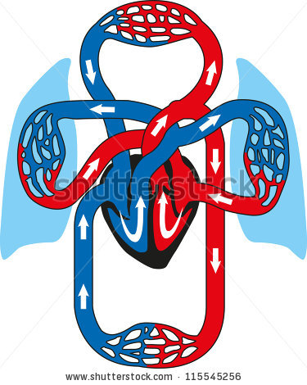

False.
That's right!
Incorrect. It's the other way around: In arteries, the blood flows away from the heart. In veins, the blood flows to the heart.

Application phase 2 (application 2): Veins and arteries: the blood’s motorways

Veins and arteries: the blood’s motorways

What are the characteristics of veins and arteries? Do you remember the differences? Move the characteristics to the right column.
Thin wall

Carries blood to the heart

Has valves

Has no valves

Thick wall

Carries blood away from the heart

Vein | Artery

Solution

Vein | Artery
Thin wall | Thick wall
Has valves | Has no valves
Carries blood to the heart | Carries blood away from the heart

Good job!
Try again. Maybe your notebook can help.

Teaching phase 3: Mirror, mirror on the wall, why is our blood so interesting?

Mirror, mirror on the wall, why is our blood so interesting?
You already know that blood flows through every part of our body. But what exactly is it made up of and why is it so important?
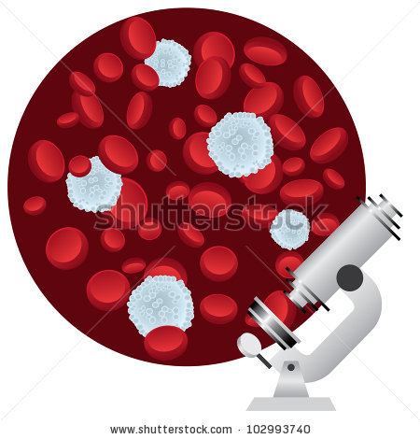
As you can see in the image, blood is not just a liquid. Blood consists of many tiny particles. These particles are invisible to the naked eye. That is why we need a microscope.
- Over than half of our blood consists of plasma. This is a red, sticky substance. This substance consists of water and chemicals, such as salt and proteins.

- The rest of our blood is made up of a solid substance. These consist of platelets and blood cells.

  - Platelets are very tiny cells that float in the plasma. They produce the scab on your wound if you hurt yourself. Otherwise you would keep bleeding.

  - Blood cells float in the plasma too. There are two types of blood cells:

    - The white blood cells make sure we get sick less often. They fight all kinds of bacteria that enter our body daily.

    - The red blood cells bring the oxygen in our blood to our whole body.

Mirror, mirror on the wall, why is our blood so interesting?
Is everything not yet quite clear? Maybe this flow chart will help!
The chart below gives you an overview of the composition of our blood.
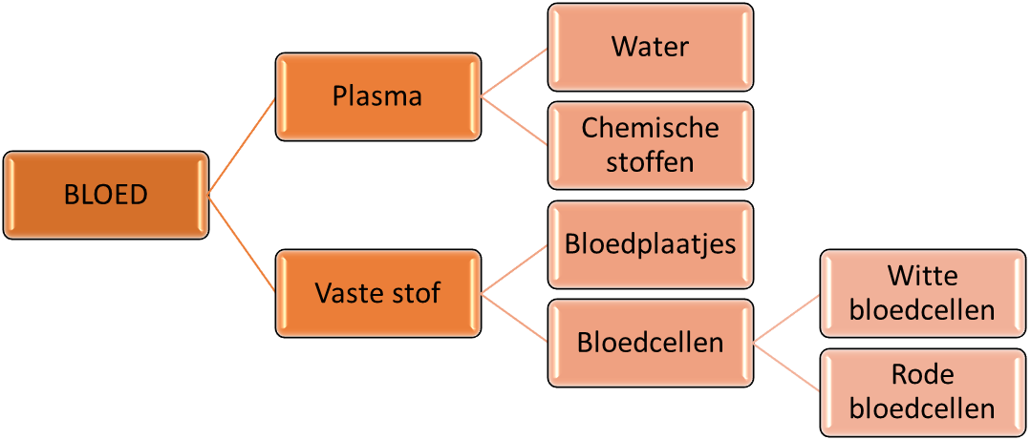
 |  |  |  | Water
 |  | Plasma |  | Chemicals
BLOOD
 |  | Solids |  | Platelets
 |  |  |  | Blood cells |  | White blood cells
 |  |  |  |  |  | Red blood cells

AMAZING FACT!
In every drop of blood there are approximately 2 million red blood cells, 5,000 white blood cells and 250,000 platelets
AMAZING FACT!
If you placed all your blood vessels end-to-end, they would reach around the world twice!

Application phase 3 (application 1): Mirror, mirror on the wall, why is our blood so interesting?

Mirror, mirror on the wall, why is our blood so interesting?

What would you see if you looked at blood with your naked eye? Click on the right figure.

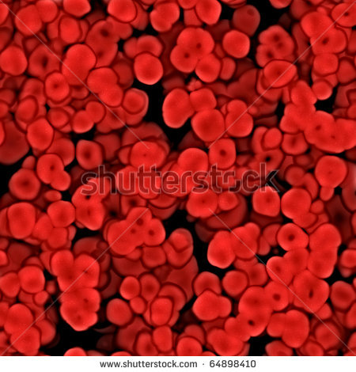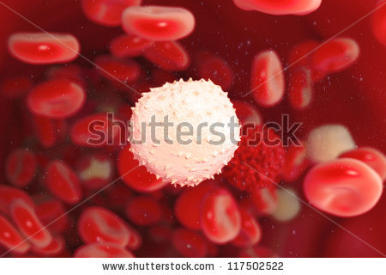

Solution

Well done, congratulations!
Try again. Think about the last time you hurt yourself and you were bleeding. What did it look like?
Oops, it was the second photo. The tiny components of blood are only visible when you use a microscope.

Application phase 3 (application 2): Mirror, mirror on the wall, why is our blood so interesting?

Mirror, mirror on the wall, why is our blood so interesting?
Do you remember what blood is made of? Take a good look at the diagram. Connect the name of the missing component to the matching letter.

Plasma
Platelets
Chemicals
Red blood cells

 |  |  |  | Water
BLOOD
 |  | Solids
 |  |  |  | Blood cells |  | White blood cells

Solution

 |  |  |  | Water
 |  | Plasma |  | Chemicals
BLOOD
 |  | Solids |  | Platelets
 |  |  |  | Blood cells |  | White blood cells
 |  |  |  |  |  | Red blood cells

You were really paying attention; keep it up!
Try again. Everything is not quite in the right place.
Sorry, check the answer carefully, and you won’t forget next time!

Application phase 3 (application 1): Mirror, mirror on the wall, why is our blood so interesting?

Mirror, mirror on the wall, why is our blood so interesting?
Every component of our blood has an important function. Which part does what? Make the right connection.

Plasma
Red blood cells
Fights bacteria

Prevents us from losing too much blood

White blood cells
Carries oxygen

Solution

Plasma
Red blood cells
Fights bacteria
Prevents us losing too much blood
White blood cells
Carries oxygen

Fantastic. You've got it!
Try again.
Oops, your answer isn’t quite right. Better luck next time!

Evaluation phase
Let's take a look now at what you remember about the circulatory system... good luck!
Question 1

Where can you find the heart in your body?
- Under your ribcage on the left
- Under your ribcage on the right
- On the left in your abdominal cavity
- On the right in your abdominal cavity

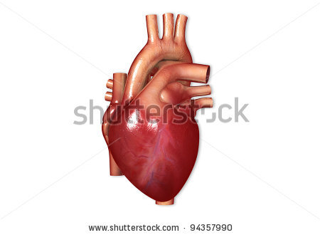

Good start! Now on to the next one...
Oops! The heart is under your ribcage on the left. Try to find it, you'll feel it beating.

Question 2

What is the heartbeat?
- The alternating contraction and relaxation of the arteries
- The contraction of the ventricles and the relaxation of the atria
- The alternating contraction and relaxation of the heart muscle
- The contraction of the atria and the relaxation of the ventricles



Great! Keep up the good work.
Oops! Your heartbeat is the alternating contraction and relaxation of your heart muscle.

Question 3

Which statement is false?
- The aorta transports oxygen-rich blood from the left ventricle away from the heart.
- The right ventricle pumps OXYGEN-RICH blood to the lungs through the pulmonary artery.
- The right atrium receives oxygen-poor blood from the body.
- The left atrium gets oxygen-rich blood from the lungs.

A. right side
B. left side
C. lungs
D. oxygen-poor
E. oxygen rich
F. organs

Excellent job!
Sorry, read every sentence very carefully. The right ventricle pumps oxygen-poor blood to the lungs through the pulmonary artery.

Question 4

What are the characteristics of an artery?
- Thin wall, no valves, blood flows away from the heart
- Thick wall, valves, blood flows away from the heart
- Thick wall, valves, blood flows to the heart
- Thick wall, no valves, blood flows away from the heart

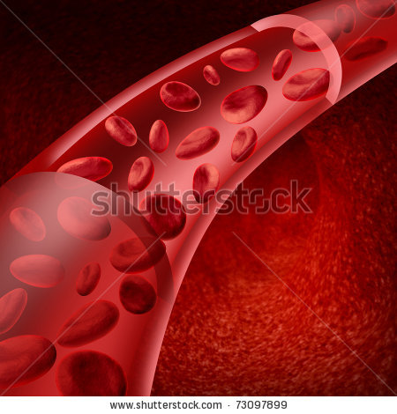

You’re doing well, keep it up!
Sorry… An artery has the following characteristics: a thick wall, no valves and blood flows away from the heart.

Question 5

What is the function of white blood cells in our blood?
- They fight bacteria
- They carry oxygen
- They prevent us from losing too much blood
- They control our body temperature.

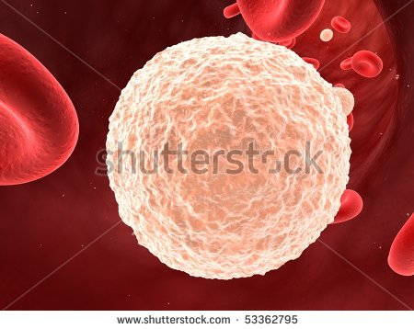

You did really well!
Better luck next time! The white blood cells fight bacteria to ensure that we stay healthy.

