**SOS!**

Hello! Today you are going to learn about health and safety. You already know something about it? Great, then you will be able to answer these three questions. If you don't know the answer, don't worry. You will learn all about it today!

1. What does this drawing mean?

|  |  |  |
| --- | --- | --- |
| verzamelpunt.png | 0 | Waiting room |
| 0 | Bird observation post |
| 0 | Watch out! Stay close together! |
| 0 | Assembly point |

2. What does this drawing mean?

|  |  |  |
| --- | --- | --- |
| giftig.png | 0 | Watch out for pirates! |
| 0 | Poisonous |
| 0 | Watch out for broken legs! |
| 0 | Burial place |

3. Everyone has an immune system but what does it do?

0 It protects against illnesses.  
0 It protects against burns.  
0 It protects against thieves.  
0 It protects against lightning.

To the doctor?!

Everyone gets ill from time to time. Do you remember the last time you were ill? Do you know exactly what that is, 'being ill'?   
You will discover the answer to these questions today!

**Being ill = bugs in your body!**

Everyone has a system that protects them against illnesses: an **immune system**.

It tracks down all the intruders in your body and destroys them. The intruders that want to make you ill are small bugs that you cannot see with the naked eye. We call those small bugs **bacteria** and **viruses**. They are in our blood and they try to multiply there. Your immune system does not give the intruders a chance. It sends lots of **white blood cells** to the bacteria and viruses. Those blood cells are the soldiers that defend your body.

A fever is not always bad: it is a sign that your body is fighting against intruders. Fever becomes dangerous if it lasts too long or gets too high. In that case you should go to the doctor.



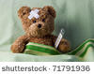

**To the doctor?!**

**No!**

You do not go to the doctor for *small ailments* such as a scrape or a bruise. Your body can *repair them on its own*. For bruises your cells clean up the blood under your skin. The bruise changes colour from blue to brown, yellow and green. For small wounds, a scab forms to plug the hole in your body: that way you cannot bleed to death. A new skin forms under the scab. That can itch sometimes!

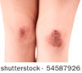

**YES!**

If you are in a *lot of pain* or are *really ill* then of course you should go to the doctor.

Do you have to cough and sneeze, does your nose run, or do your legs itch when you go outside? Then you probably have an allergy. Your body thinks it is being attacked by viruses or bacteria and it tries to defend you. Your body does not know that grass pollen or house dust mite are harmless. If you suffer from an allergy you should go to the doctor for some medicine.

When you go to the doctor, you go for a *consultation*. You should always make an appointment or look up the consultation hours before going to the doctor. During the consultation hours you can walk in without an appointment.

Can you read this table?  
Look up when you can see the doctor without an appointment.

|  |  |  |  |
| --- | --- | --- | --- |
|  | Morning | Afternoon | Evening |
| Monday | 8.30-10.30 | by appointment | 16.30-18.30 |
| Tuesday | 8.30-10.30 | by appointment | by appointment |
| Wednesday | 8.30-10.30 | by appointment | 16.30-18.30 |
| Thursday | 8.30-10.30 | by appointment | 16.30-18.30 |
| Friday | 8.30-10.30 | by appointment | 16.30-18.30 |
| Saturday | 9.00-12.00 |  |  |

You can get medical assistance from other people too:

|  |  |  |  |
| --- | --- | --- | --- |
| ehbo.pngrode kruis.jpg  Have you ever heard of First Aid? | You can find these symbols in places where you can get medical assistance. You see them on First Aid kits, medicine cabinets, ambulances, chemist signs, etc. | arts apotheek.pngslang voor apotheek.jpg | This symbol tells you that you are dealing with a doctor, pharmacist or hospital. The snake wrapped around a staff is an ancient symbol for the Greek god of medicine called Asclepius. |
|  | Belgium has a poisons advice centre that you can phone if you have eaten or drunk a poisonous product (bleach, rat poison, etc.). The phone number of the poisons advice centre is 070/ 245 245. | Brandweer Antwerpen Mercedes Sprinter ambulance | For really urgent cases you can call an ambulance on the number **112** or **100.** |

To the doctor?!

Your throat is really sore and you want to see your doctor. When can you visit the doctor?

|  |  |  |  |
| --- | --- | --- | --- |
|  | Morning | Afternoon | Evening |
| Monday | 8.30-10 |  | 17-19 |
| Tuesday | 8.30-10 |  | 17-19 |
| Wednesday | 8.30-10 | 15-16 | by appointment only |
| Thursday | by appointment only |  | 17-19 |
| Friday | 8.30-10 |  | 17-19 |
| Saturday | 9-11: make an appointment during the week! |  |  |

|  |  |  |
| --- | --- | --- |
|  | True | False |
| 1. I can make an appointment on Wednesday afternoon at 15.30. | 0 | 0 |
| 2. I can see the doctor on Monday afternoon at 16.00 if I have an appointment. | 0 | 0 |
| 3. I can see the doctor without an appointment on Thursday evening at 18.45. | 0 | 0 |
| 4. I can phone on Monday morning to make an appointment. | 0 | 0 |
| 5. I can see the doctor on Sunday morning if I have an appointment. | 0 | 0 |
| 6. If I phone on Friday for an appointment on Saturday then I can see the doctor. | 0 | 0 |

Als juist: Correct!

Als fout: This answer is incorrect.

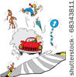You see a traffic accident: a car hits someone on a bicycle. The cyclist looks like he is badly hurt and needs urgent medical assistance. You want to phone an ambulance. Which number should you phone?

Do you remember which number to phone? **100** or **112**!

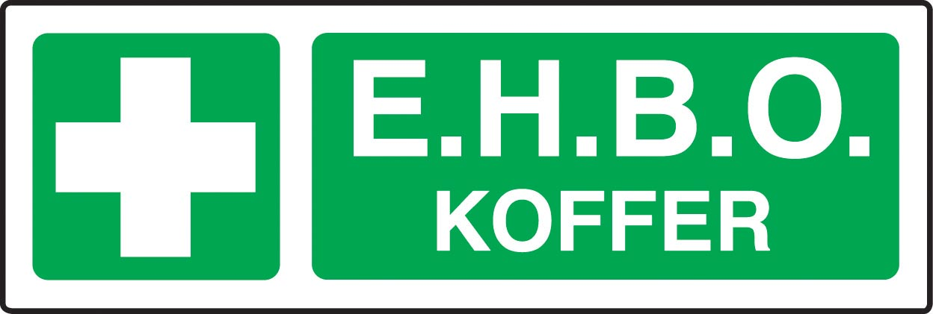What does the Dutch word EHBO stand for?

Thanks for solving this question. The correct answer is "**E**erste **H**ulp **B**ij **O**ngevallen" or "**E**erste **H**ulp **B**ij **O**ngelukken".

Which sentence is NOT true?

|  |  |  |
| --- | --- | --- |
| arts apotheek.png | 0 | 1. This symbol shows that you are dealing with a doctor. |
| 0 | 2. This symbol can be found on the door of a chemist. |
| 0 | 3. You can see this symbol in a hospital. |
| 0 | 4. This symbol shows that there is a zoo with snakes in the area. |

Als juist: Correct!

Als fout eerste keer: This sentence is correct. Try to find the incorrect sentence.

Als fout tweede keer: This sentence is correct. Sentence 4 'This symbol shows that there is a zoo with snakes in the area' is incorrect.

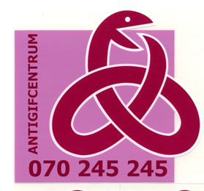Jasmine is 5 years old. She was playing in the kitchen when she saw washing powder. That powder smelled nice so Jasmine wanted to taste it. She ate a big spoonful of washing powder and does not feel so good now. To help her you phone the number 070/245 245. Who or what are you phoning?

0 The pharmacist  
0 The hospital  
0 The poisons advice centre  
0 The doctor

Als juist: Great! You are phoning the poisons advice centre!

Als fout eerste keer: This is not correct. Try again.

Als fout tweede keer: Incorrect. If you phone 070/ 245 245 then you reach the poisons advice centre.

Fire! Fire!

Fire! Fire! What should you do if there is a fire?

|  |  |
| --- | --- |
| stock photo : Fire alarm break glass alarm trigger | Step 1:  If you notice the fire yourself, break the glass of the fire alarm pull station. This will make the fire alarm go off. That way everyone will know that there is a fire in the building.  https://encrypted-tbn0.google.com/images?q=tbn:ANd9GcRAlDcRnMXhIBD9lWjy5oHgutFqD4IiQFJElsz9R8iIqf5a1nd- Pictogram branddeken For a small fire you can use a fire blanket to cover the flames. Leave it on the flames until the firemen arrive and remove it. |
| stock vector : Firefighter with a fire hose against a fire | Step 2: Call the fire brigade on the number **100** or **112**. |
| uitgang.png | Step 3: Go outside as quickly as possible via the normal exit or one of the building's emergency exits. All exist are indicated with this green sign. Do **not** use the lift.  stock vector : Set prohibited signs - elevatorIf you do not notice the fire but you do hear the fire alarm then you must go outside as quickly as possible. Do **not** use the lift.  Tips:  Do not waste time by putting things away. Walk outside right away. |
| verzamelpunt.png | Step 4: Once you are outside, go to the assembly point. Wait there for instructions from the firemen or the headmaster/headmistress.  NEVER go back inside before the firemen, teachers or headmaster/headmistress say it is safe to go back inside. |

Fire! Fire! What should you do if someone gets burned?

One simple rule applies: **'Water first, the rest comes later!'**. A burn must be put under cool water (not ice-cold water!) as quickly as possible, for at least 15 minutes. In three cases you must go to a doctor or the hospital:  
1. The burn is large.  
2. The burn is on the face.   
3. There are large blisters on the burn.  
Small, less serious burns can be treated with an ointment for burns from the chemist.

Fire! Fire!

Do you know what to do if you notice a small fire? Put the following steps in the correct order!

|  |  |  |  |
| --- | --- | --- | --- |
| verzamelpunt.png | stock photo : Fire alarm break glass alarm trigger | uitgang.png | stock photo : The Sign of phone isolated on white background112 |
| Step 1 | Step 2 | Step 3 | Step 4 |

Als juist: Good job! Those are the correct steps.

Als fout eerste keer: You haven't put all the steps in the correct order yet. Try again.

Als fout tweede keer: That is not completely correct. Compare your answer to the correct steps.

Prevention is better than cure!

Here are the top six tips to prevent you from becoming ill!

You have learned what to do in certain situations that threaten the health or safety of people. But it is better not to be in such a situation: 'Prevention is better than cure!'

1. Eat healthy food.
2. Get enough exercise.
3. Listen to your body: if you are tired, go to sleep. If you feel sick, do not eat too much, etc.
4. Do not drink water from rivers, pools, lakes, etc.   
   That water - especially *stagnant* water - is often full of germs and other harmful things.
5. 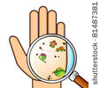Wash your hands often.   
     
   There are lots of bacteria and viruses on your hands. To avoid spreading them around it is important to wash your hands often and to wash them well. Sometimes you see step-by-step instructions that explain how to wash your hands:

|  |  |  |  |
| --- | --- | --- | --- |
| **Stop the spread of colds and the flu!** | | | |
| DSCN3757.JPG | | | |
| Step 1 | Step 2 | Step 3 | Step 4 |

1. Get yourself vaccinated.  
   If a virus enters your body then your body will recognise that virus as a foreign intruder. Your body sends out soldiers - white blood cells. They make weapons we call **antibodies**. The fight between a virus and the antibodies of the white blood cells can take a while and make you feel ill.   
   Every type of virus is different. That's why your body may have trouble recognising a virus and then making antibodies. That's why there are **vaccines**. The doctor injects a small amount of the virus into your body. The amount is so small that it does not make you ill. But the amount is big enough that the next time the virus wants to attack your body, it will be recognised as a virus. That saves a lot of time: your body makes the correct antibodies right away and the virus cannot grow and make you ill.

**Follow warnings**

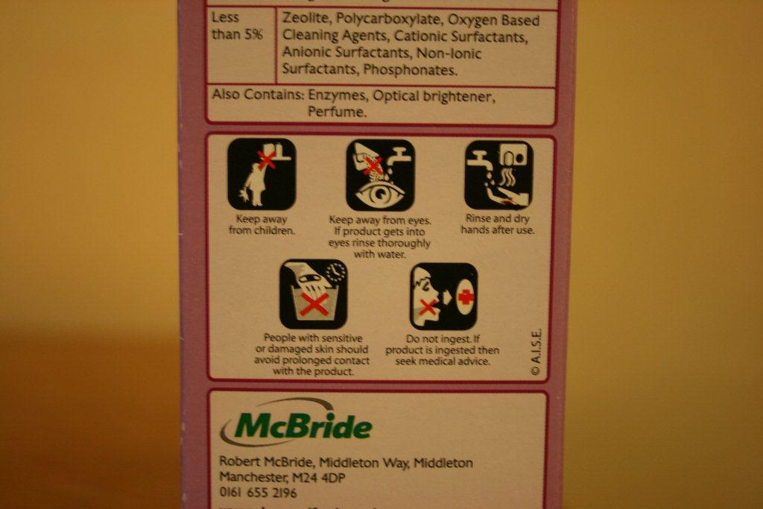Many products such as paint, bleach, etc. have warnings about health and safety on their packaging. Here is a photo of a washing powder label. You can read which ingredients are in the washing powder and you also see some warnings. To make it clear for everyone, these warnings are shown as drawings. We call such drawings **pictograms**.

Did you know that these pictograms have the same meaning in every country? They are one language that everyone understands!

Here are a few important pictograms and their meaning:

|  |  |  |  |
| --- | --- | --- | --- |
| risico.png | Watch out: irritating and harmful substances! | giftig.png | Watch out: poisonous!  This symbol is shown on products that can cause death if they are breathed in, swallowed, etc. |
| ontvlambaar.png | Watch out: flammable! This product can burst into flames. | ontploffingsgevaar.png | Watch out: explosive! |
| oogcontact vermijden.jpg | Avoid eye contact. In the event of eye contact rinse eyes thoroughly with water. | buiten het bereik van kinderen bewaren.jpg | Keep out of reach of children. |
| niet inslikken.jpg | Do not swallow. If swallowed consult a doctor. | hoog voltage.jpg | Danger: high voltage.  This symbol is placed on electricity cabinets. If you open that cabinet you might get a strong surge of electricity that could kill you. Do not touch! |
| geen toegang.png | Stop! No running here! |  |  |

Prevention is better than cure!

Washing your hands often and well is an important way to prevent the spread of viruses and bacteria. Can you draw up a step-by-step plan? Put the photos in the correct order!

|  |  |  |  |  |  |
| --- | --- | --- | --- | --- | --- |
| http://jerrymahoney.files.wordpress.com/2011/12/how-to-wash-hands.gif | http://jerrymahoney.files.wordpress.com/2011/12/how-to-wash-hands.gif | http://jerrymahoney.files.wordpress.com/2011/12/how-to-wash-hands.gif | http://jerrymahoney.files.wordpress.com/2011/12/how-to-wash-hands.gif | http://jerrymahoney.files.wordpress.com/2011/12/how-to-wash-hands.gif | http://jerrymahoney.files.wordpress.com/2011/12/how-to-wash-hands.gif |
| Step 1 | Step 2 | Step 3 | Step 4 | Step 5 | Step 6 |

Als juist: Good job! You know how to wash your hands!

Als fout eerste keer: That's not quite right. Try again.

Als fout tweede keer: That is not completely correct. The correct order is: step 4 - step 3 - step 2 - step 6 - step 5 - step 1.

Are these sentences true or false?

|  |  |  |  |
| --- | --- | --- | --- |
|  | True | False |  |
| 1. When you get vaccinated the doctor injects a small amount of a virus into your body. | 0 | 0 | stock photo : syringe |
| 2. Every type of virus is different. | 0 | 0 |  |
| 3. You can drink water from pools. | 0 | 0 |  |
| 4. There are bacteria on your hands. That is why you must wash your hands. | 0 | 0 | germs on hands.jpg |

Als juist: Correct!

Als fout: This answer is incorrect.

Do you know these safety pictograms? Connect the pictograms to the correct explanation!

|  |  |
| --- | --- |
| risico.png | Stop! No running here! |
| ontvlambaar.png | Danger: high voltage. |
| ontploffingsgevaar.png | Watch out: poisonous! |
| giftig.png | Avoid eye contact. In the event of eye contact rinse eyes thoroughly with water. |
| oogcontact vermijden.jpg | Watch out: explosive! |
| geen toegang.png | Watch out: irritating and harmful substances! |
| hoog voltage.jpg | This product can burst into flames.  Als juist: Great! You know all the pictograms.  Als fout eerste keer: Take another look at your answer. Something is not correct.  Als fout tweede keer: Unfortunately that's not completely correct. Take a careful look at the correct answer again. |

1. Which sentence is **wrong**?

0 A vaccine contains a small amount of a virus.  
0 White blood cells attack viruses and bacteria.   
0 If you have an allergy your white blood cells not only attack viruses and bacteria, they also attack harmless intruders.  
0 Pictograms attack viruses and bacteria.

Als juist: Correct!

Als fout: Incorrect. Pictograms are drawings with warnings about health and safety.

2. What does this drawing mean?

|  |  |  |
| --- | --- | --- |
| uitgang.png | 0 | Exit |
| 0 | Watch out: run through here quickly! |
| 0 | Athletics Club |
| 0 | Watch out: do not fall out of the window! |

Als juist: Correct!

Als fout: Incorrect. This drawing shows the exit.

3. What does this drawing mean?

|  |  |  |
| --- | --- | --- |
| hoog voltage.jpg | 0 | Watch out: danger of lightning! |
| 0 | Watch out: sharp turn! |
| 0 | Danger: high voltage |
| 0 | Assemble here |

Als juist: Correct!

Als fout: Wrong. This drawing shows a danger of high voltage. You see this warning on electricity cabinets, near railways, etc.