**To your health!**

1. Which drink do you need the most?

Hello! Today you are going to learn about food. You already know something about food? Great, then you will be able to answer these three questions. If you don't know the answer, don't worry. You will learn all about it today!

1. water
2. soft drinks
3. milk
4. fruit juice

1. Which sentence is **not true**?
2. People eat to stay healthy.
3. People eat to have energy at the beginning of a new day.
4. People eat in order to concentrate.
5. People eat in order to be able to buy new clothes.

3. Which sentence is **not true**?

1. People need a lot of exercise in order to stay healthy.
2. Not eating breakfast in the morning is healthy.
3. Eating fruit and vegetables is healthy.
4. Drinking lots of water is healthy.

'When and why do we eat?'

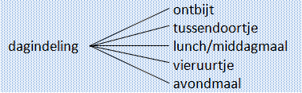**When do you eat?**



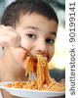

You eat at different times during the day.   
1. You start the day with **breakfast**,  
2. You eat **lunch** around noon,   
3. You eat **supper** at the end of the day.  
Between these three meals you can eat a piece of fruit or a biscuit as **a morning** or **afternoon snack**.

Timetable

- breakfast

- morning snack

- lunch/dinner

- afternoon snack

- supper

You eat quite a lot in one day. But why do we have to eat? Can you think of three reasons? Write these reasons down in the notebook. This notebook is on the right side of your screen!



TIP:

Take time to eat breakfast. Do not skip breakfast!





Why do people eat? Read all about it on this page!

To grow

Why do you have to eat? The blue circles give a few reasons. Do you see reasons that you had written down?

To be able to concentrate

Not only do you have to eat three meals a day, it is also important that you eat **healthy** food. It is best to choose a **variety** of meals and snacks. Eating a variety of foods means that you change often: you do not only eat chips, you also eat mashed potatoes, rice, pasta, lentils, etc.

To be able to run fast

EAT

To be fit all day long





To be able to play sports

To be able to think

So that you do not get ill

To keep your body warm

'When and why do we eat?'

We eat at different times of the day. Can you link the meals with the correct times of the day?

|  |  |
| --- | --- |
| stock photo : Twelve O`Clock | Lunch  Als juist: Good job! You connected everything correctly!  Als fout eerste keer: Something is not quite right. Try again.  Als fout tweede keer: That is not completely correct. Compare your own answer to the correct answer. |
| stock photo : High Detail Alarm Clock isolated on white | Snack |
| stock photo : A stylish wall clock showing 6 o'clock, isolated on white with clipping path | Afternoon snack |
| stock photo : Four O'Clock | Supper |
| stock photo : Ten O'Clock | Breakfast |

Can you put these meals in the correct order? What do you start the day with? What do you end the day with?

|  |  |
| --- | --- |
| Lunch | stock photo : Two cute boys laying on ground in nature and happily eating healthy food  1. 2. 3. 4. 5.  Start of the day End of the day |
| Breakfast | stock photo : Girl holding bowl of muesli isolated on white background |
| Supper | stock photo : Tasty food, messy child eating spaghetti |
| Afternoon snack | Als juist: Good job! You put all the meals in the correct order!  Als fout eerste keer: You haven't put everything in the correct order yet. Try again.  Als fout tweede keer: That is not completely correct. Compare your own answer to the correct answer.  stock photo : Child eating ice cream. Little girl at home |
| Snack | stock photo : Smiling children with a glass of milk |

To eat healthily you must eat a variety of foods. Look at the suppers that Annabel ate this week. Did she eat a variety of foods?

Als juist: That’s right. Annabel eats pasta too often at night.

Als fout: That's not correct. Annabel does not eat a variety of foods, because she eats pasta every night.



|  |  |
| --- | --- |
| Monday | Spaghetti  0 Annabel eats a variety of foods.  0 Annabel does not eat a variety of foods. |
| Tuesday | Macaroni |
| Wednesday | Pasta with tomato and courgette |
| Thursday | Lasagne |

To eat healthily you must eat a variety of foods. Look at the suppers that Farid ate this week. Did he eat a variety of foods?

|  |  |
| --- | --- |
| Monday | Lasagne  0 Farid eats a variety of foods.  0 Farid does not eat a variety of foods. |
| Tuesday | Lentils with courgette, tomato and aubergine |
| Wednesday | Sausage, potatoes and apple sauce |
| Thursday | Couscous with lamb and carrots |

Als juist: That’s right. Farid eats lots of different kinds of food.

Als fout: That's not correct. Farid eats lots of different kinds of food.



|  |  |
| --- | --- |
| Monday | Macaroni |
| Tuesday | Salmon with broccoli and potatoes |
| Wednesday | Pizza |
| Thursday | Chicken with mushrooms and rice |

To eat healthily you must eat a variety of foods. Look at the suppers that David ate this week. Did he eat a variety of foods?

Als juist: That’s right. David eats lots of different kinds of food.

Als fout: That's not correct. David eats lots of different kinds of food.

0 David eats a variety of foods.

0 David does not eat a variety of foods.



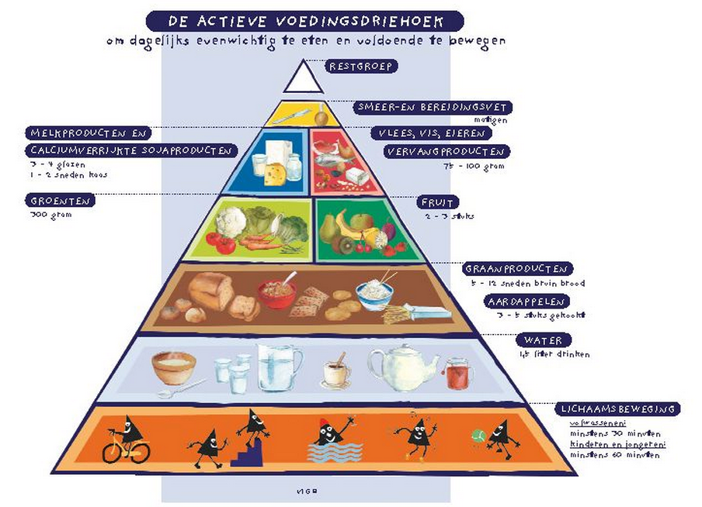'What do we eat?'

9

To help you choose healthy foods and a variety of foods, researchers have made this food pyramid.

Take a good look at the pyramid. Then click through to the next page to get an explanation of the pyramid.

8

7

6

4

5

3

2

1

DAIRY PRODUCTS AND CALCIUM-ENRICHED SOYA PRODUCTS

3-4 glasses

1-2 slices of cheese

VEGETABLES

300 grams

REMAINING GROUP

SPREADABLE FAT AND COOKING FAT

moderate

MEAT, FISH, EGGS

SUBSTITUTES

75-100 grams

FRUIT

2-3 pieces

GRAIN PRODUCTS

5-12 slices of brown bread

POTATOES

3-5 cooked potatoes

WATER

drink 1.5 litres

EXERCISE

adults:

at least 30 minutes

children and young people:

at least 60 minutes



The active food pyramid shows what **kind** of food you must eat in order to stay healthy.

***Kind***  
The pyramid sorts food into nine kinds of foodstuffs. These nine kinds each form a large group.

Take a good look at the drawings in the pyramid to see where the food belongs. Under ‘grain products’, for example, you see rice and muesli. Under 'water' you also see tea and coffee.

There are no drawings in the remaining group. We do not need the foods and drinks under the 'remaining group' but they can be delicious. Sweets and soft drinks are good examples of these.



The active food pyramid also shows the **quantity** of food you must eat in order to be healthy.

* The areas at the bottom of the pyramid are the largest because you need the most of those food groups.
* The areas are smaller at the top because you should only eat or drink a small quantity of these groups per day.
* The largest area of the pyramid shows that you must get enough exercise in order to remain healthy.

'Get started with the food pyramid!'

Oops! This food pyramid is not complete. The names of the foodstuffs have been left off. Can you put them in the correct place?

Exercise; Water; Grain products and Potatoes; Fruit; Vegetables; Meat, fish, eggs; Dairy products; Spreadable fat and cooking fat; Remaining group

Als juist: Great! You completed the pyramid correctly.

Als fout eerste keer: You haven't put all the names in the right places yet. Try again.

Als fout tweede keer: Your answer is not completely correct. Compare your own answer to the correct answer.



|  |  |
| --- | --- |
| 1. | Als juist: Correct!  Als fout: Incorrect. Lemonade belongs at the top of the pyramid under 'remaining group'. You should not eat or drink much of this. You should drink more water than lemonade. |
| 2. | Als juist: Correct!  Als fout: Incorrect. |
| 3. | Als juist: Correct!  Als fout: Incorrect. |
| 4. | Als juist: Correct!  Als fout: Incorrect. Butter belongs in the 'spreadable fat and cooking fat' group. That group only has a small area. That means you should not eat much of it. Cheese is in a larger area. You can eat more cheese than butter. |
| 5. | Als juist: Correct!  Als fout: Incorrect. Chocolate belongs at the top of the pyramid under 'remaining group'. You should not eat or drink much of this. |

**Lots, very little, more, less...**Take a good look at the food pyramid and touch the correct answer!

|  |  |  |
| --- | --- | --- |
|  | True | False |
| 1. I should drink more water than lemonade. | 0 | 0 |
| 2. I should eat less cheese than vegetables. | 0 | 0 |
| 3. I should eat more grain products than I should drink water. | 0 | 0 |
| 4. I should eat more butter than cheese. | 0 | 0 |
| 5. I can eat lots of chocolate. | 0 | 0 |

You will see several words below. They need to be placed in the food pyramid. Can you put them in the correct group? Drag the words to the right area.

Walking (1), muesli (3), bar of chocolate (9), tomatoes (5), cheese (7), whipping cream (7), potato croquettes (3), shrimps (6), swimming (1), Fanta (9), bun (9), building a tree house (1), bread (3), banana (4), camomile tea (2), chips (3), steak (6), egg (6)

Als juist: Good job! You found the correct place for all the products!

Als fout eerste keer: You haven't put all the products in the right place yet. Try again.

Als fout tweede keer: This is not completely correct. Compare your own answer to the correct answer.

**Fill your own lunch box!**

Tomorrow you and your class are going to the seaside. Your teacher asks the pupils to bring their own lunch. You have to fill your own lunch box. Can you fill it with **healthy** items and a **variety** of food? Put the food and drinks that you will take along into your lunch box.

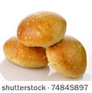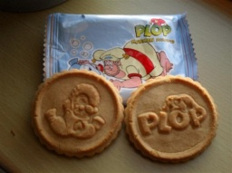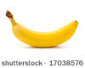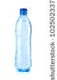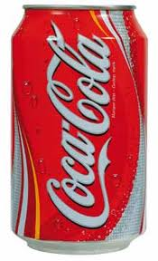   
Make sure you choose healthy products and a variety of foods!

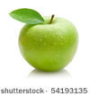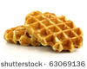

stock photo : Sliced sausage isolated on white background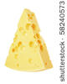 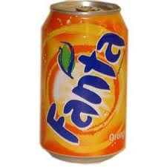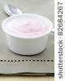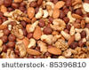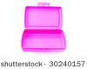

*can of coke, bottle of water, waffle, apple, banana, sandwiches, yoghurt, nuts, plop biscuit, pasta salad, marshmallows, can of lemonade, sandwich with vegetables, piece of cheese, sausage*

Don't forget, you should only choose **1** item from the top of the food pyramid (the remaining group). So you should only choose one can of coke OR one can of lemonade OR a waffle OR a plop biscuit OR sweets. One of these products is OK but two is too much!

**Mathis' weekly menu**

Use what you learned about the food pyramid to complete this exercise!

Mathis is in the fourth year at school. His teacher asked him to write down everything that he ate and drank during one school week. Mathis wrote down his weekly menu in a notebook:

|  |  |  |
| --- | --- | --- |
| Monday | Breakfast: bread with chocolate spread, chocolate milk Morning snack: apple  Lunch: sausage, apple sauce and mashed potatoes, water  Afternoon snack: biscuit with chocolate  Supper: bread with cheese and salami, water | Look carefully at Mathis' weekly menu. Write down two good, positive points about his weekly menu. Write down two less good, negative points as well.    Two positive points:  1.  2.  Two negative points:  1.  2. |
| Tuesday | Breakfast: none  Morning snack: waffle  Lunch: cheese sandwiches, can of coke  Afternoon snack: waffle  Supper: macaroni with cheese and ham, can of coke  While watching TV: bag of crisps |
| Wednesday | Breakfast: muesli, yoghurt, one cup of milk  Snack: none  Lunch: beef stew with chips, water  Afternoon snack: banana  Supper: bread with cheese and ham, bottle of water |
| Thursday | Breakfast: none  Snack: can of lemonade  Lunch: leek soup with two hard rolls  Afternoon snack: Mars bar and can of coke  Supper: toasted ham and cheese sandwiches with raw vegetables, coke |
| Friday | Breakfast: bread with chocolate spread, tea  Snack: two tangerines  Lunch: cheese sandwiches, cherry tomatoes, bottle of water  Afternoon snack: glass of fruit juice and two speculoos biscuits  Supper: spaghetti Bolognese, water |

Did you notice that Mathis ate a variety of healthy foods on Monday, Wednesday and Friday?   
On Tuesday and Thursday he did not: he skipped breakfast, drank soft drinks and ate lots of biscuits. On Thursday he did a few positive things. He ate leek soup and vegetables!

Have you learned a lot about healthy food? Answer the following questions to see how much you have learned!

1. This food pyramid is not complete. Which names belong to which numbers? Touch the correct answer!

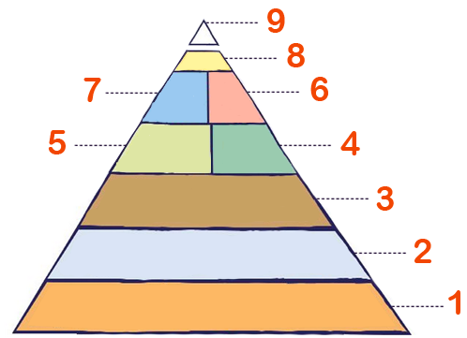

Als juist: Correct!

Als fout: No, the correct answer was ' 1 = exercise, 2 = water, 9 = remaining group'.

0 1 = remaining group, 2 = water, 9 = exercise

0 1 = exercise, 2 = water, 9 = remaining group

0 1 = water, 2 = exercise, 9 = remaining group

0 1 = water, 2 = remaining group, 9 = exercise

2. Which sentence is true?

1. Walking, cycling and swimming are all important in order to remain healthy.
2. You can eat as many sweets as you want because they are part of the remaining group.
3. Dairy products are more important than fruit and vegetables.
4. The food pyramid has seven kinds of food.

Als juist: Correct!

Als fout: Oops! The correct answer was 'Walking, cycling and swimming are all important in order to remain healthy.'

3. Which sentence is **not** true?

A. You should eat more vegetables than cheese.  
B. You should eat less butter than cheese.  
C. You should eat more bread than cheese.  
C. You should eat more cheese than fruit.

Als juist: Correct!

Als fout: No, this sentence is not true: 'You should eat more cheese than fruit.'