**What are you up to?**

Hello, we are going to start by asking you to complete a ‘test’. Don't worry if you don't know the answers yet. You will learn all about it in this topic.

1. What is not on a birthday calendar?

Select the right answer.

1. The days of the week
2. The months of the year
3. The date
4. Different calendars are used for different things.

Can you find the right calendar for writing down the menu of the week?

**A birthday calendar**

This includes all months of the year and all days of the week.

There is also room to write something down every day.

You can reuse it every year and continue to add new birthdays.

**A monthly calendar**

We use this calendar in the classroom to show which corners we have already worked in. Each month we get a new monthly calendar from our teacher.

**A pocket diary**

This is an annual calendar. For each day you can write down something that you do not want to forget. All days and months of the year are in the diary. It is small so it is easy to put into your handbag or your trouser pocket. You have to buy a new one every year.

**A week calendar**

The days of the week are shown on each sheet of this calendar. There is room to write something next to each day. You can tear off the sheets. After a year all the sheets are gone and you have to buy a new one.

1. What is missing?

Select the right answer.



1. The date
2. The name of the month
3. The year
4. What is this?

Select the right answer.



1. A carnival mask
2. A sundial
3. A calendar
4. A mural
5. Why are some days in the month of January coloured grey?

|  |  |  |  |  |  |  |
| --- | --- | --- | --- | --- | --- | --- |
| **January 2012** | | | | | | |
| **Monday** | **Tuesday** | **Wednesday** | **Thursday** | **Friday** | **Saturday** | **Sunday** |
| **26**  Christmas holiday | **27**  Christmas holiday | **28**  Christmas holiday | **29**  Christmas holiday | **30**  Christmas holiday | **31**  Christmas holiday | **1**  New Year's Day |
| **2**  Christmas holiday | **3**  Christmas holiday | **4**  Christmas holiday | **5**  Christmas holiday | **6**  Christmas holiday | **7**  Christmas holiday | **8**  Christmas holiday |
| **9** | **10** | **11** | **12** | **13** | **14** | **15** |
| **16** | **17** | **18** | **19** | **20** | **21** | **22** |
| **23** | **24** | **25** | **26** | **27** | **28** | **29** |
| **30** | **31** | **1** | **2** | **3** | **4** | **5** |

1. Because it is weekend.
2. Because it is a school holiday.
3. Because those days are holidays.
4. 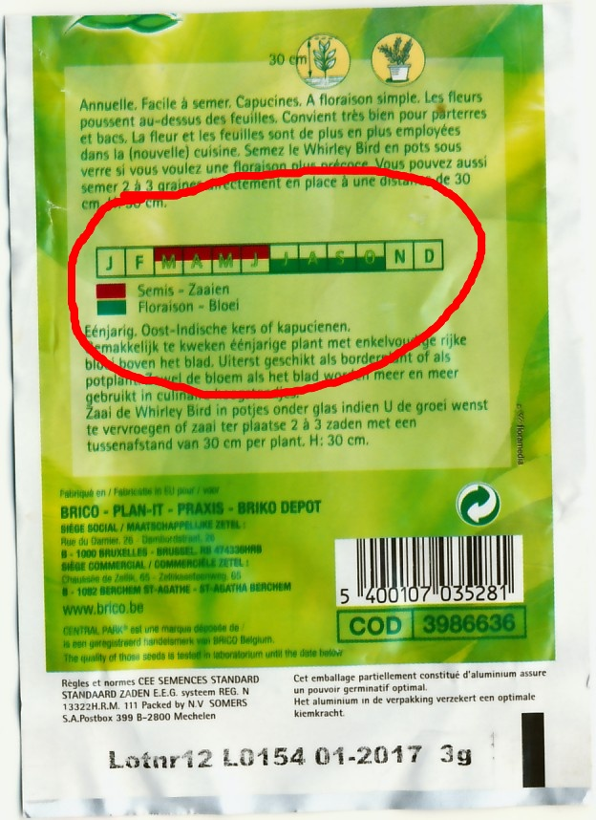When should I plant these flowers?

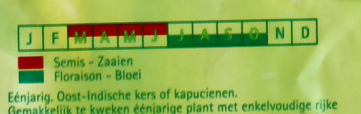

*Plant*

*In bloom*

1. In the months March, April, May and June
2. In the months July, August, September and October
3. In the months January and February
4. In the months November and December
5. What is a leap year?

Select the right answer.

1. That is the new year of the Chinese calendar.
2. That is a year in which there are fewer holidays.
3. That is the year in which we add a day to the month of February.
4. That is the year in which we subtract a day from the month of February.

**Calendar time**

*Calendars come in all shapes and sizes. You see them in many places. A calendar helps us divide the time into years, months, weeks or days. Without calendars we would forget lots of things or we would not know what day it is. There are year calendars, monthly calendars and block-calendars, birthday calendars, calendars for garden chores, to write down holidays, etc. All these calendars are used for something else.*

The names of the days

of the week

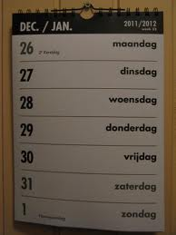

The year

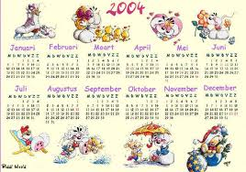

*What do you usually find on a calendar?*

The name of the month

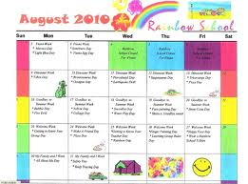

The date

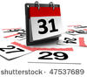

**What should you choose?**

*Some calendars are not suited for a certain purpose. You have to choose the correct calendar. Can you help make the right decision?*



*“We have a very big family so I cannot remember all the birthdays throughout the year. Can you point to the calendar that I should use?”*

|  |  |
| --- | --- |
| **A birthday calendar**  This includes all months of the year and all days of the week.  There is also room to write something down every day.  You can reuse it every year and continue to add new birthdays. | verjaardagskalender.jpg |
| **A week calendar**  This calendar includes all the days of the week and a symbol. It is easy to see what day it is today, it was yesterday and will be tomorrow. | weekkalender1.jpg |

Als juist: **Excellent!**

Als fout: Oops**, too bad. Birthdays are spread over an entire year. The correct answer is a birthday calendar.**



*“At home my dad always makes a weekly menu. Can you point to the calendar that he should use?”*

|  |  |
| --- | --- |
| **A week calendar**  The days of the week are shown on each sheet of this calendar. There is room to write something next to each day. You can tear off the sheets. After a year all the sheets are gone and you have to buy a new one. | weekkalender.jpg |
| **A monthly calendar**  We use this calendar in the classroom to show which corners we have already worked in. Each month we get a new monthly calendar from our teacher. | maandkalender school.jpg |

Als juist: **Excellent!**

Als fout: **Oops! The correct answer is a week calendar.**



*“It is my teacher's birthday and I want to give her a present. She likes jokes and is a bit of a scatterbrain. Sometimes she forgets what day it is. Which calendar would help her? Can you point to it?”*

|  |  |
| --- | --- |
| **A birthday calendar**  All the months of the year are on this calendar.  The days of the week are also shown.  There is room to write something down every day.  You must replace this calendar every year. | jaarkalender.jpg |
| **A block-calendar**  There is often a fact or a joke on the back of this calendar. You rip off a sheet every day and can see what day it is. You must buy a new one every year. | dagkalender.jpg |

Als juist: **Good job!**

Als fout: **Oops! The correct answer is a block-calendar. You can see what day it is and the teacher learns a new joke.**

*Some calendars are not suited for a certain purpose. You have to choose the correct calendar. Can you help?*



*“My granny is a forgetful person. She makes appointments with everyone but forgets which day she has to be where and at what time. Chan you choose a good calendar for her? Point to it.”*

|  |  |
| --- | --- |
| **A calendar**  All the months of the year are on this calendar.  The days of the week are also shown.  There is no room to write something down every day.  You must replace this calendar every year. | jaarkalender 1.jpg |
| **A pocket diary**  This is an annual calendar. For each day you can write down something that you do not want to forget. All days and months of the year are in the diary. It is small so it is easy to put into your handbag or your trouser pocket. You have to buy a new one every year. | zakagenda.jpg… |

Als juist: **Good job!**

Als fout: **Oops! A year calendar is not very handy in this situation. The correct answer is a pocket diary.**

**What is missing?**

*A calendar is used to divide up time. A calendar shows the days, months and the year. Something very important is missing from the following calendars. Click on the correct answer.*



What is missing?

1. the months of the year
2. the days of the week
3. the year

Als juist: **That’s great!**

Als fout eerste keer: **No. This is a year calendar. Try again.**

Als fout tweede keer: **No, that is not the correct answer. The year is missing.**

*Click on the right answer.*



What is missing?

1. the year
2. the month of the year
3. the days of the week

Als juist: **Good job!**

Als fout eerste keer: **No. This is one month of a calendar. Try again.**

Als fout tweede keer: **No, that is not the correct answer. The month of the year is missing.**

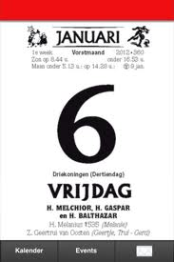What is missing?

1. the year
2. the month of the year
3. the name of the day

Als juist: **Great!**

Als fout eerste keer: **No. This is a block-calendar. Try again.**

Als fout tweede keer: **No, that is not the correct answer. The name of the day is missing.**

**Calendar time, something from the past?**

*In the old days people already tried to divide up time. They looked at the sun, which rose and set, and knew that it was day or night. They saw the different shapes of the moon, could tell the difference between the different seasons, etc. But who eventually invented the calendar?*

**

*Read everything very carefully and use your notebook.*

*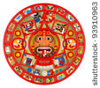It is not possible to find out who made the very first calendar. What we do know is that people already tried to make an accurate calendar a very long time ago.*

*The Mayan people were the first to invent an accurate calendar. Unfortunately much of their knowledge was lost because they fought so many wars.*

*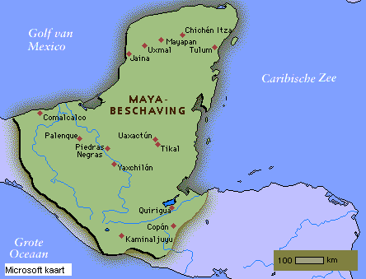Calendars have been found from around the period 300 AD. The Mayan people lived in Honduras, Guatemala and southern Mexico. You can still find people living in those areas who descend from the ancient Mayas. The calendar was round and it was painted on an enormous stone that was 4 metres in diameter. The Mayan people were very clever with numbers! Even back then they could calculate that a year lasts about 365 days. It takes the earth about 365 days to revolve around the sun.*

*The ancient Mayas used their calendar for different things. For example, to know when it was time to plant seeds or harvest crops, and to predict the future.*

*Read everything very carefully and use your notebook.*

*The calendar used by the Ancient Egyptians also had 365 days.*

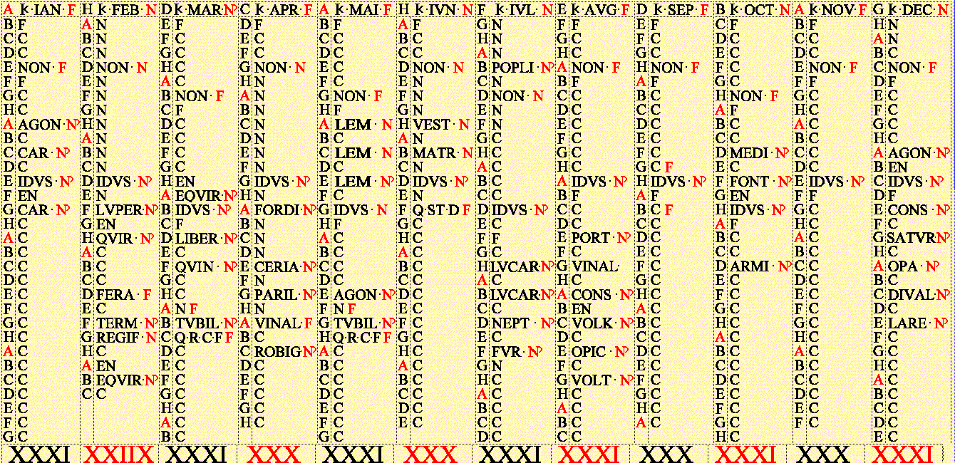

*Julius Caesar made some improvements to this calendar. Julius Caesar was one of the most powerful men in Ancient Rome. His calendar was called the Julian calendar.*

*He decided that the first month of every new year should be called ‘January’. The name comes from the Roman god ‘Janus’. Janus is always shown with two faces.*

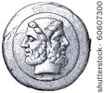

*He also decided that February is the month that receives an extra day every four years. We call this day a leap day.*

**

*The Julian calendar was improved later on by Pope Gregory. We call his improved version the Gregorian calendar. This calendar is now used all over the world.*

**A few questions**

*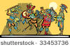Time for a few questions! You can use what you wrote down in your notebook.*

*The Mayas were the first people with an accurate calendar.*

*Do you remember how many days they had in one year?*

*Select the right answer.*

1. 355
2. 354
3. 365

Als juist: **You remembered that very well.**

Als fout: **No, the correct answer is 365 days. That is how long it takes the earth to revolve around the sun.**

*Time for a few questions! You can use what you wrote down in your notebook.*

*Can you make a drawing of the earth revolving around the sun? I want to see which direction the earth is spinning.*

**Good job!**

*Time for a few questions! You can use what you wrote down in your notebook.*

*The following key words belong to whom or what? Drag them to the right drawing.*

Pope Gregory

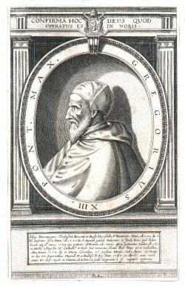

The Mayas



Julius Caesar



|  |  |  |  |
| --- | --- | --- | --- |
| Janus | current calendar | January first month | leap day |
| a round calendar | South America | the whole world | First accurate calendar |

Als juist:  **It is fantastic that you know all of this.**

Als fout eerste keer: **Try to improve your answer.**

Als fout tweede keer: **Perhaps you should reread the texts under "Calendar time, something from the past?".**

**Have you lost count?**

*You probably know that the months of the year do not have the same number of days. There are months with 30 days and months with 31 days. February always has 28 days unless it is a leap year. In leap years February has 29 days.*

*That is one day extra. Do you know why we do that?*

*Read everything very carefully and use your notebook.*

**

*The earth revolves around the sun in an orbit.*

*It takes 365 days, 5 hours, 48 minutes and 45.1814 seconds to do this.*

*That means that when we celebrate New Year's Day (on January 1) the earth has not completed its entire journey around the sun.*

*It needs another 6 hours to complete the journey.*

*Read everything very carefully and use your notebook.*

**

*If we left things this way then after one year we would be missing six hours to match the seasons to the time that the earth needs to revolve around the sun.*

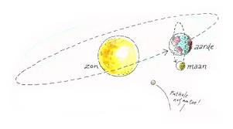

*After four years this would become 4 x 6 hours = 24 hours. That is exactly one day short.*

*To avoid problems such as incorrect planting and harvesting times, we add one day to our year every four years.*

**

*It is Julius Caesar who decided that we do this in February.*

*So for three years February has 28 days and in the leap year it has 29 days.*

*The names of the months of the year were not chosen randomly. The decision to give months 28, 30 or 31 days was random, however. It was decided by Julius Caesar.*

*He was a very important and powerful man in Ancient Rome. All the names have a meaning.*

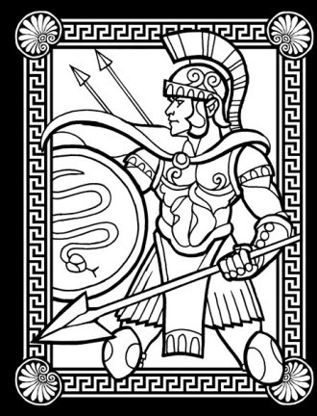

*January is the first month of the year. This month was named after Janus, a Roman god.*

*January has 31 days.*

*March is the third month and it is named after Mars, also a Roman god. March also has 31 days.*

*June is named after Juno, the Roman goddess of marriage. June has 30 days.*

*Do you find it difficult to remember how many days are in each month?*

|  |  |  |
| --- | --- | --- |
| 1. January 31 days 2. February 28 or 29 days 3. March 31 days 4. April 30 days | 1. May 31 days 2. June 30 days 3. July 31 days 4. August 31 days | 1. September 30 days 2. October 31 days 3. November 30 days 4. December 31 days |

*A useful trick:*

*First you have to learn the months of the year by heart: January, February, March, April, May, June, July, August, September, October, November, December. Then there's a trick* you can do with your *knuckles.*

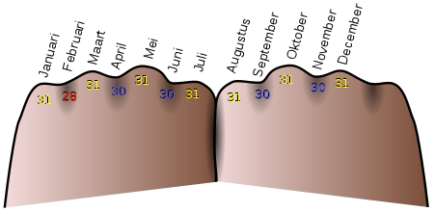

*Make two fists and place them next to each other just like in the picture. The first knuckle of your left hand (little finger) is January, which has 31 days. Every month on a knuckle has 31 days (January, March, May, July, August, October, December). Every month between the knuckles has 30 days (April, June, September, November). February has 28 or 29 days.*

**You are allowed to count with your fingers!**

Do you remember the trick? Drag the correct number to the months.



Als juist: **You remembered that very well.**

**Making plans!**

*Almost every calendar looks like a table showing all kinds of things, often with room for writing things down. On a monthly calendar you see the name of the month and all the days of the month. On a year calendar you see the year and all the months of the year. On a week calendar, like your school diary, you see the days of the week. On most calendars you can write things down, this makes them a handy tool for making plans.*



*People who make a lot of plans or have to remember a lot of things often use a pocket diary. That is a small book where you can write down all the things that you should not forget throughout the year.*

**

*Lots of people do not use a paper calendar any more. They use their computer, laptop or tablet PC. To make plans you can also use a mobile phone or a smartphone.*

**Time to celebrate!**

*Every month, someone's celebrating their birthday and that includes a few famous Belgians.*

*Can you put them in the correct order? From young to old.*

Niels Destadsbader

19 August 1988



Lady Gaga

20 March 1986



Brahim Attaeb

24 February 1984



Charlotte

21 December 1987

Als juist: **Excellent!**

Als fout eerste keer: **Try one more time. Take a good look at the year of birth.**

Als fout tweede keer: **Oops! Look at the correct answer.**

Charlotte

21 December 1987

She will be 26 years old this year.



Niels Destadsbader

19 August 1988

He will be 25 years old this year.



Romelu Lukaku

13 May 1993

He will be 20 years old this year.



Justin Bieber 1 March 1994

He will be 19 years old this year.



**Niels Destadsbader**

Brahim Attaeb

24 February 1984

He will be 29 years old this year.



Lady Gaga

20 March 1986

She will be 27 years old this year.



**Write it down!** *You can see all kinds of things on a calendar. On this calendar page for January you can see grey, white and black numbers. The white numbers are from December, the black are from January and the grey numbers are from February. Do you know why some days are coloured orange?*

|  |  |  |  |  |  |  |
| --- | --- | --- | --- | --- | --- | --- |
| **January 2012** | | | | | | |
| **Monday** | **Tuesday** | **Wednesday** | **Thursday** | **Friday** | **Saturday** | **Sunday** |
| **26**  Christmas holiday | **27**  Christmas holiday | **28**  Christmas holiday | **29**  Christmas holiday | **30**  Christmas holiday | **31**  Christmas holiday | **1**  New Year's Day |
| **2**  Christmas holiday | **3**  Christmas holiday | **4**  Christmas holiday | **5**  Christmas holiday | **6**  Christmas holiday | **7**  Christmas holiday | **8**  Christmas holiday |
| **9** | **10** | **11** | **12** | **13** | **14** | **15** |
| **16** | **17** | **18** | **19** | **20** | **21** | **22** |
| **23** | **24** | **25** | **26** | **27** | **28** | **29** |
| **30** | **31** | **1** | **2** | **3** | **4** | **5** |

1. *Because there is no school on these days.*
2. *Because those are the days of the weekend.*
3. *Because there is a celebration on those days.*

*Als juist:* ***Very good!***

*Als fout eerste keer:* ***Take a good look at the calendar. There is a colour for holidays and there is a colour for the weekend.***

*Als fout tweede keer:* ***No. That is not the correct answer. The grey days are the days of the weekend.***

*Some families have a common family calendar.*

*Can you put this family's symbols in the right place?*

**

*birthday garage theatre swimming*

|  |  |  |  |  |  |  |
| --- | --- | --- | --- | --- | --- | --- |
| **January 2012** | | | | | | |
| **Monday** | **Tuesday** | **Wednesday** | **Thursday** | **Friday** | **Saturday** | **Sunday** |
| **26**  Christmas holiday | **27**  Christmas holiday | **28**  Christmas holiday | **29**  Christmas holiday | **30**  **Travel to the Ardennes** | **31**  Christmas holiday | **1**  New Year's Day |
| **2**  Christmas holiday | **3**  Christmas holiday | **4**  Christmas holiday | **5**  Christmas holiday | **6**  Christmas holiday | **7**  Christmas holiday | **8**  Christmas holiday |
| **9** | **10** | **11** | **12** | **13** | **14** | **15**  **Arne 7 years old!** |
| **16** | **17**  **Swimming lessons Malo** | **18** | **19** | **20** | **21** | **22** |
| **23**  **Get car repaired** | **24** | **25** | **26** | **27**  **School play** | **28** | **29** |
| **30** | **31** | **1** | **2** | **3** | **4** | **5** |

Als juist: **That was not hard.**

Als fout eerste keer: **Look at the pictograms and what is written on the calendar.**

Als fout tweede keer: **Better luck next time.**

**Make sure you are on time!**

*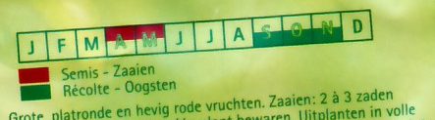On a vegetable calendar you can see when it is best to eat certain vegetables. The boxes are coloured in at the moments when the vegetables are cheapest. Of course you must plant and harvest them first.*

*On a packet of seeds you can see on the back when is the best time to plant and harvest.*

*You must plant the pumpkin in the months March, April and May. That is in the spring. You can harvest the pumpkins in the months September, October and November. That is in the autumn.*

*Can you colour in the calendar correctly?*

|  |  |  |  |  |  |  |  |  |  |  |  |
| --- | --- | --- | --- | --- | --- | --- | --- | --- | --- | --- | --- |
| *March* | *April* | *May* | *June* | *July* | *Aug* | *Sep* | *Oct* | *Nov* | *Dec* | *Jan* | *Feb* |
|  |  |  |  |  |  |  |  |  |  |  |  |
| ***SPRING*** | | | ***SUMMER*** | | | ***AUTUMN*** | | | ***WINTER*** | | |

*Plant Harvest*

Als juist: **Good job!**

Als fout eerste keer: **Reread the text.**

Als fout tweede keer: **You plant in the spring and harvest in the autumn**.

*Doing homework, learning lessons, meeting up with friends, going to a football game, watching TV… or doing something else. Everything must be planned.*

*School finishes at 4 p.m. and Marie stays in the after school club every day except Tuesdays and Wednesdays.*

*Marie must do some maths homework and needs one hour for this. The homework must be finished by Thursday.*

*She also has some French homework and must go to the library to complete it. The library is open on Wednesdays from 2 to 4 p.m.*

*Marie goes to basketball practice on Tuesdays from 5 to 6 p.m.*

*Marie wants to watch her favourite programme on the Disney channel every day at 7 p.m. The show lasts half an hour.*

*Can you help Marie plan her week? Drag the pictograms to the correct place.*



after school club homework library basketball watch TV

|  |  |  |  |  |  |  |  |
| --- | --- | --- | --- | --- | --- | --- | --- |
| hours | **Monday** | **Tuesday** | **Wednesday** | **Thursday** | **Friday** | **Saturday** | **Sunday** |
| 8 a.m. to 12 noon | **SCHOOL** | | | | | | |
| 12 noon to 4 p.m. | **SCHOOL** | |  | **SCHOOL** | |  |  |
| 4 to 5 p.m. |  |  |  |  |  |  |  |
| 5 to 6 p.m. |  |  |  |  |  |  |  |
| 7 to 8 p.m. |  |  |  |  |  |  |  |

**Good try.**

Good job, you finished this topic. Let's see what you learned with a short test.

1. Why are the days not written on a birthday calendar?

Select the right answer.

1. Because the days of the week fall on a different date every year.
2. Because you have to buy a new calendar every year.
3. Because the months change every year.
4. Because there is no room for the days.

Als juist: **Excellent! Keep up the good work.**

Als fout: **No, that is not correct. There are no days on a birthday calendar because the days of the week shift every year. 15 January is not always a Sunday. In 2009 it was a Thursday and in 2013 it will be a Tuesday. In 2040 it will again be a Sunday, however.**

1. 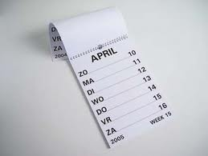What is missing on this calendar?

Select the right answer.

1. The days of the week and the year.
2. The name of the month and the date.
3. The year and the date.
4. Nothing is missing.

Als juist: **Great! Keep up the good work.**

Als fout: **Oops! We tricked you. Nothing is missing.**

1. Why are there white numbers on this calendar?

|  |  |  |  |  |  |  |
| --- | --- | --- | --- | --- | --- | --- |
| **January 2012** | | | | | | |
| **Monday** | **Tuesday** | **Wednesday** | **Thursday** | **Friday** | **Saturday** | **Sunday** |
| **26**  Christmas holiday | **27**  Christmas holiday | **28**  Christmas holiday | **29**  Christmas holiday | **30** | **31**  Christmas holiday | **1**  New Year's Day |
| **2**  Christmas holiday | **3**  Christmas holiday | **4**  Christmas holiday | **5**  Christmas holiday | **6**  Christmas holiday | **7**  Christmas holiday | **8**  Christmas holiday |
| **9** | **10** | **11** | **12** | **13** | **14** | **15** |
| **16** | **17** | **18** | **19** | **20** | **21** | **22** |
| **23** | **24** | **25** | **26** | **27** | **28** | **29** |
| **30** | **31** | **1** | **2** | **3** | **4** | **5** |

1. Because these are days of the next month.
2. Because these are holidays.
3. Because these are days from the previous month.
4. Because these are holiday days.

Als juist: **That is correct.**

Als fout: **No, the white days are days from the previous month.**

1. Different calendars are used for different things.

Can you find the correct calendar for this boy?

*“My sister is an electronics wiz and is especially good with computers. But she is very bad when it comes to planning and organising. She has so much to do and forgets that she needs to take me to gymnastics. She always loses her pocket diary and I am tired of phoning her every time. I am running out of calling credit! What would be a good tool for planning her activities?”*

1. A block-calendar
2. A tablet PC
3. A telephone
4. A year calendar

Als juist: **Great!**

Als fout: **No, the best tool would be a tablet PC.**

1. What is this?

Select the right answer.



1. This is a book for people with poor vision.
2. This is a computer screen.
3. This is the Julian calendar.
4. This is a game.

Als juist: **Wow, good job remembering that!**

Als fout: **No, it is the calendar that Julius Caesar made. It is called a Julian calendar.**

1. 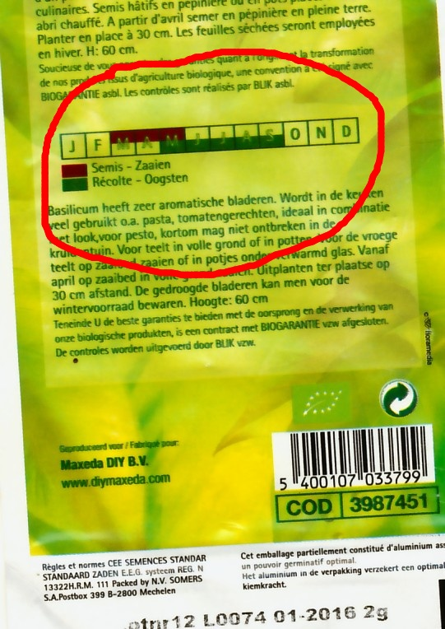When can I harvest these herbs?
2. In September
3. In the winter
4. In the summer
5. In March

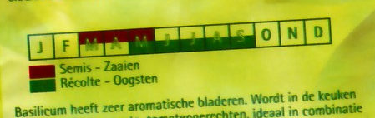

*Plant*

*Harvest*

Als juist: **Excellent!**

Als fout: **No, that is not correct. You can harvest these herbs from May to September and that is in the summer.**

1. How many days are in the month of May?
2. 30
3. 31
4. 29
5. 28

Als juist: **Good guess! Or did you use the knuckle trick?**

Als fout: **Oops! That is not correct. May has 31 days. Don't forget that you can use the knuckle trick.**