**Time flies**

Hello, we are going to start by asking you to complete a ‘test’. Don't worry if you don't know the answers yet. You will learn all about it in this topic.

1. Who or what turns day into night?

Select the right answer.

1. the sun
2. the stars
3. the sun and the moon
4. the earth, the sun and the moon
5. What is this?

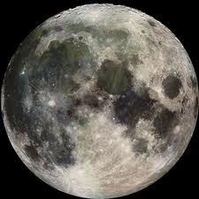Select the right answer.

1. the sun
2. the moon
3. a star
4. the earth

1. What is correct?

Select the right answer.

1. The sun revolves around the earth.
2. The earth revolves around the sun.
3. The earth revolves around the moon.
4. What is a natural day?

Select the right answer.

1. That is a day and a night and it includes a morning, an afternoon, an evening and a night. Together this is 24 hours.
2. That is a sunny day.
3. That is a day that you spend in nature.
4. That is part of the night.
5. Which statement is true?

Select the right answer.

1. You can only see the moon at night.
2. The moon is a large star.
3. Sunlight is reflected on the moon.

**Spinning around.**

*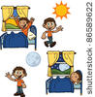What wakes you up every morning? Your alarm clock? The crow of a rooster? Or do you stay in bed until someone wakes you up?*

*When you get out of bed, the day is usually well under way. That is because of the sun. As soon as the sun appears, the night is over and day has begun. The sun gives off light all day long. In the evening, when you go to bed, the sun disappears on the horizon and day is done. It becomes dark and night begins.*

*Day and night follow each other. Our planet earth and the sun make this possible. You probably already know that the earth is round.*

*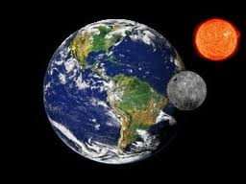Did you also know that the earth spins on its own axis all the time? Did you know that the earth revolves around the sun? Did you know that the moon spins around itself and revolves around the earth?*

*Does all of this make you a bit dizzy?*

**THE SUN**

*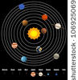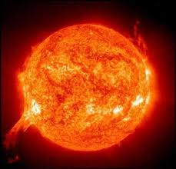Our solar system consists of eight planets and one star, the sun. The sun is in the middle of our solar system.*

*The sun is an enormous ball of hot gases. It warms up and lights up the planets. Without the sun there would be no life on our planet. The sun gives us light, heat and energy.*

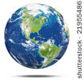**THE EARTH**

*Earth is one of the planets in our solar system. The earth is round and has lots of water. On this photo earth looks like it is standing still but it actually spins on its own axis all the time. Each time earth has spun around its axis, 24 hours have passed.*

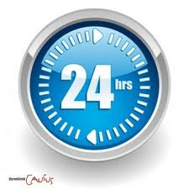

*It takes 24 hours for the earth to spin around once. We call this a natural day.*

**THE EARTH**

**

*A natural day has four parts: morning, afternoon, evening and night. A day is not the same as a natural day. When people talk about a day they often mean the time between sunrise and sunset.*

|  |  |  |  |  |  |  |  |  |  |  |  |  |  |  |  |  |  |  |  |  |  |  |  |
| --- | --- | --- | --- | --- | --- | --- | --- | --- | --- | --- | --- | --- | --- | --- | --- | --- | --- | --- | --- | --- | --- | --- | --- |
| *1 a.m.* | *2 a.m.* | *3 a.m.* | *4 a.m.* | *5 a.m.* | *6 a.m.* | *7 a.m.* | *8 a.m.* | *9 a.m.* | *10 a.m.* | *11 a.m.* | *12 noon* | *1 p.m.* | *2 p.m.* | *3 p.m.* | *4 p.m.* | *5 p.m.* | *6 p.m.* | *7 p.m.* | *8 p.m.* | *9 p.m.* | *10 p.m.* | *11 p.m.* | *12 midnight* |
| ***night*** | | | | ***morning*** | | | | | | | ***afternoon*** | | | | | | ***evening*** | | | | | | ***night*** |
| *nacht.jpg* | | | | *ochtend.jpg* | | | | | | | *menu.jpg*  *speelplaats.jpg* | | | | | | *gaan slapen.jpghuiswerk.jpg* | | | | | | *nacht.jpg* |

**THE EARTH**

*The earth does even more. It also revolves around the sun in an orbit. It does this non-stop. The earth needs one year to travel all the way around the sun.*

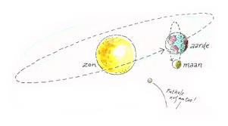

**THE MOON**

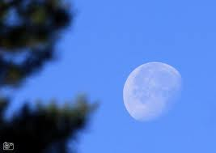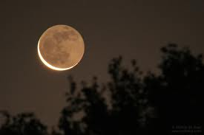

*We mostly see the moon at night. The moon is not gone during the day, it is just harder to see it. The moonlight that we see at night is actually sunlight that reflects on the moon.*

**

*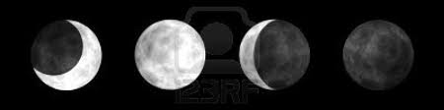The moon is round. However, you often see it in all kinds of other shapes. Sometimes you can see the entire moon, sometimes you only see a crescent or half of the moon.*

**THE MOON**

*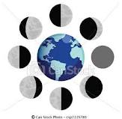That is because the moon does not stand still. The moon travels around the earth in an orbit, just like the earth travels around the sun. From earth, we always see the sunlight falling on the moon in a different way. Therefore, we always see a different part of the moon.*

*When the moon is on the same side as the sun, we cannot see it from the earth. That is called a new moon.*

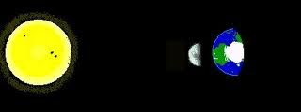

**THE MOON**

*A few days later you can see a crescent moon just like on the image below. This crescent slowly becomes bigger until you see half of the moon.*

*Then it takes about a week before you can see the entire moon. We call this a full moon.*

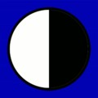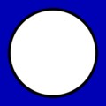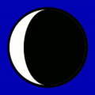

*One week later the moon slowly becomes smaller again until it seems to ‘disappear’. Then a new crescent moon appears once again, but the crescent is on the other side.*

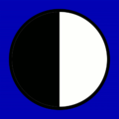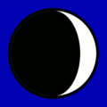

*It takes approximately a full month before we see all the phases of the moon.*

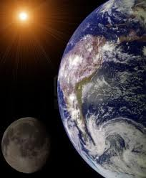**Who turns off the light?**

*Light and dark, day and night. What causes this change? Three important celestial objects.*

*Which one are we talking about? Click on the correct object.*

*You get three tips:*

1. *I am there, but you can't always see me.*
2. *I am a star.*
3. *I produce energy and light.*

*Who am I?*

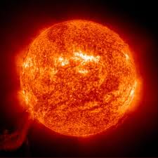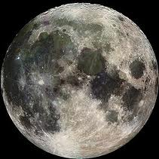

*the earth the moon the sun*

*Als juist:* ***Good job! Keep up the good work!***

*Als fout eerste keer:* ***No, that is not correct. Try again.***

*Als fout tweede keer:* ***Oops! The correct answer is: "the sun", because you cannot see it at night. This star produces lots of heat, light and energy.***

**Who turns off the light?**

*Light and dark, day and night. What causes this change? Three important celestial objects.*

*Which one are we talking about? Click on the correct object.*

*You get three tips:*

1. *I am there, but you can't always see me.*
2. *I revolve around the earth.*
3. *I always look a bit different.*

*Who am I?*



*the earth the moon the sun*

*The moon is the correct answer.*

*Als juist:* ***Yes, that's correct.***

*Als fout eerste keer:* ***No, that is not correct. Try again. You can go back and read the explanation again.***

*Als fout tweede keer:* ***Oops! The correct answer is: "the moon". This celestial object revolves around the earth and changes shape. You can't always see the moon during the day, but you can see it at night.***



**Who turns off the light?**

*Light and dark, day and night. What causes this change? Three important celestial objects.*

*Which one are we talking about? Click on the correct object.*

*You get three tips:*

1. *I spin on my own axis and I revolve around the sun.*
2. *I am a planet.*
3. *I am covered by a lot of water.*

*Who am I?*



*the earth the moon the sun*

*The earth is the correct answer.*

*Als juist:* ***Good job!***

*Als fout eerste keer:* ***No, that is not correct. Try again. Did you write anything down in your notebook?***

*Als fout tweede keer:* ***Oops! The correct answer is: “the earth", because it is one of the planets in our solar system that revolves around the sun. You can recognise the earth by the blue colour of the water.***

**Getting dizzy?**

*Day and night, dark and light… the moon spins, the earth spins, and the sun? Help! Do you still remember how it works?*

*Drag the celestial objects to the correct location on the picture.*

 the solar system



*Als juist:* ***Excellent! You solved this correctly.***

*Als fout eerste keer:* ***Go back to the previous screen. Read, listen to and look at everything very carefully.***

*Als fout tweede keer:* ***Oops! Let me help you. The sun is in the middle. The earth travels in an orbit around the sun and the moon revolves around the earth.***

Good job, you finished this topic. Let's see what you learned with a short test.

1. Do you know this celestial object?

Select the right answer.

A. the sun

B. the moon

C. a star

D. the earth

*Als juist:* ***Excellent! Keep up the good work.***

*Als fout:* ***That's not correct. This planet is the earth. You can recognise it by the blue colour of the water.***

1. Day and night are created by:
2. the stars
3. the earth, the sun and the moon
4. sun
5. the sun and the moon

*Als juist:* ***Excellent! Keep up the good work.***

*Als fout:* ***That's not correct. The earth, the sun and the moon cause day to turn to night and vice-versa.***

1. Which statement is true?

Select the right answer.

1. The sun revolves around the earth.
2. The sun spins around itself.
3. The moon revolves around the earth.
4. The earth revolves around the moon.

*Als juist:* ***Excellent! Keep up the good work.***

*Als fout:* ***That's not correct. The moon revolves around the earth, while the earth spins on its own axis and revolves around the sun.***

1. How long does it take the earth to revolve around the sun?

Select the right answer.

1. A day
2. A month
3. A week
4. A year

*Als juist:* ***Excellent! Keep up the good work.***

*Als fout:* ***That's not correct. The earth revolves around the sun and it needs one year to do that.***

1. What is a natural day?

Select the right answer.

1. 12 hours
2. 24 hours
3. 36 hours

*Als juist:* ***Excellent! Keep up the good work.***

*Als fout:* ***That's not correct. A night lasts 12 hours and day also lasts 12 hours. Together that makes 24 hours.***

1. Which statement is true?

Select the right answer.

1. The moon gives light.
2. The moon reflects sunlight.
3. You can only see the moon at night.

*Als juist:* ***Good job! Keep up the good work.***

*Als fout:* ***That's not correct. The moon does not give light. The sun shines on the moon and the moon reflects that sunlight. You can also see the moon during the day, but not very easily.***