**Time flies.**

Hello, we are going to start by asking you to complete a ‘test’. Don't worry if you don't know the answer to some of these questions, as you will learn all about it in this topic.

1. We don't have to explain what a clock or a watch is. That was different in the old days. Back then people were not familiar with instruments that tell time.

Can you point to the first instrument that was used to measure time?

Shadow indicator

Clock

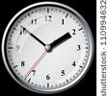

Clock radio

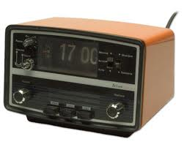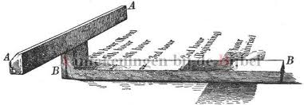

1. Below you see the names of four measuring instruments.

Which instrument cannot be used to measure time?

Select the right answer.

1. Sundial
2. Hourglass
3. Heart rate monitor
4. Water clock
5. What is an obelisk?
6. That is the name of a star.
7. That is the friend of Asterix.
8. That is a sundial.
9. That is the name of a planet.
10. A sundial is an old instrument used to measure time.

What are the disadvantages of this instrument?

Select the right answer.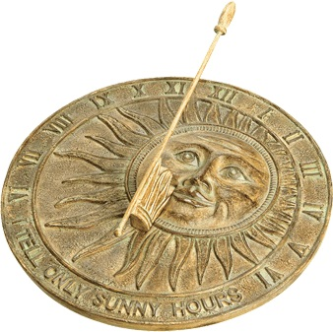

1. Sundials are very expensive.
2. Sundials use a lot of energy.
3. Sundials do not work in bad weather.
4. You cannot make your own sundial.

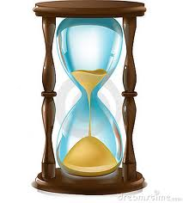

1. What do you need to make an hourglass?

Select the right answer.

1. sand from a sand box
2. a long stick
3. finely ground eggshells
4. water

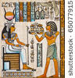**The first timekeepers**

*Time instruments have changed over the years. They got a bit better each time. The Ancient Egyptians were the first people to invent an instrument that could measure time. They noticed that the shadows of the sun moved during the day because the sun moves during the day. To measure how slow or fast this went, the Ancient Egyptians made the first clock.*

*Read everything very carefully and write a few words in your notebook.*

***THE SHADOW CLOCK***

*The* ***first clock*** *was the shadow clock. The shadow clock was* ***shaped like a T****. The shadow of the clock fell on the longest part of the T. By looking at how far the shadow reached on the longest part of the T and then* ***drawing*** *a* ***thin line****, they were able to determine the time.*

**

*Read everything very carefully and write a few words in your notebook.*

***THE SUNDIAL***

*The sundial was invented after the shadow clock.*

*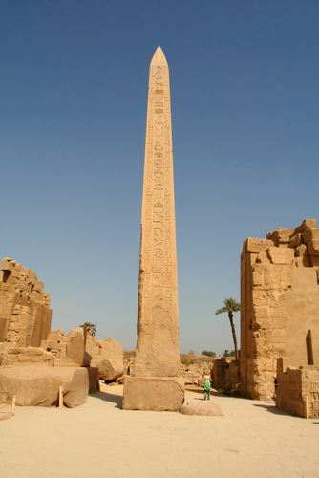A sundial consists of* ***a flat area or a disc with lines*** *drawn on it. Each line corresponds with a* ***time of the day****. On the disc there is also* ***a slanted rod or stick*** *so that a* ***shadow*** *can fall on the lines. As the sun moves during the day, the rod's shadow also changes. There are really big, awkward sundials. They are called* ***obelisks.***

*On this photo you see an obelisk from Karnak in Egypt.*

***THE SUNDIAL***

*Sundials in the shape of an obelisk can be found in many countries and cities all over the world, as you can see on the photos.*

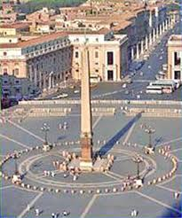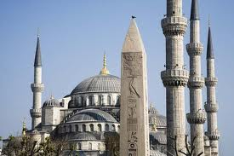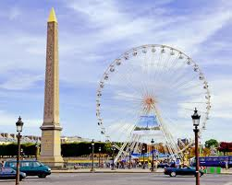

*Paris, France Istanbul, Turkey Rome, Italy*

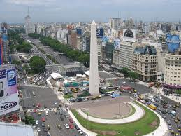

*Buenos Aires, Argentina*

*Perhaps you can look for a few other examples?*

*Read everything very carefully and write a few words in your notebook.*

***THE SUNDIAL***

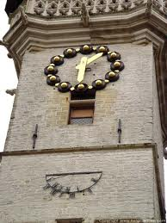

*There are no obelisks in Belgium. What you can find in many places in Belgium are* ***sundials*** *in the form of a flat disc. You usually see these sundials* ***on high buildings and churches****. There is one on this picture. It is a sundial on the town hall of Alost.*

*You can even admire a very modern sundial in Brussels that was made in 2003.*

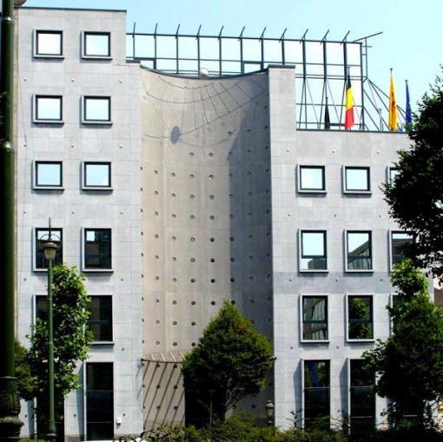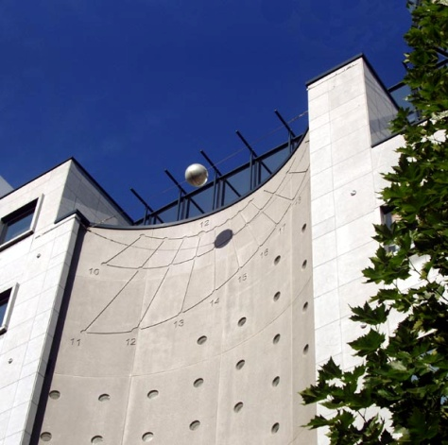

*Brussels, Avenue Boudewijn I*

*Read everything very carefully and write a few words in your notebook.*

***THE WATER CLOCK***

*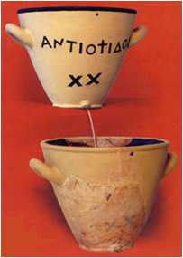 There were* ***many different forms*** *of water clocks.*

*The water clock was no more than* ***a vase or a pot with a hole at the bottom****. The water clock was filled with water. The water slowly dripped through the small opening and fell into a vessel. In the vessel there was an hour scale. Based on the height of the water in that vessel you could read how much time had passed. The higher the water in the vessel, the more time that had passed. The lower the water in the vessel, the less time that had passed.*

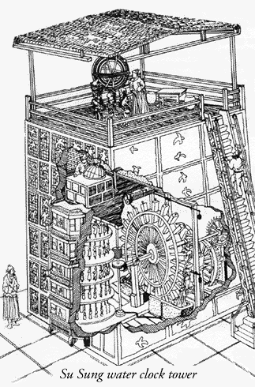

*These clocks were often used to measure* ***the amount of time that a lawyer could speak in court****. Many examples of water clocks come from Ancient Egypt and Greece, but Iraq and China also had water clocks. One of the most famous water clocks is the one from Beijing in China that you can see in this picture.*

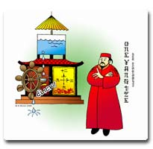

*Read everything very carefully and write a few words in your notebook.*

**THE CANDLE CLOCK**

*Before the hourglass was invented, people used a candle clock. The candle clock was a* ***very simple instrument*** *for reading time. All people needed was a candle. There were* ***thin lines*** *on the candle. Each time the candle became a line shorter, about one hour had passed. When the candle was completely burnt up the next candle was used. Sometimes one candle burned faster than another, so the candle clock was* ***not an accurate instrument****.*

**THE HOURGLASS**

*The hourglass consists of* ***2 glass chambers*** *that are connected at their necks. The sand is in the top chamber. The sand slowly falls down into the bottom chamber. When the top chamber is empty then a certain amount of time has passed. ‘Hourglass’ is actually not a well-chosen word because it did not always measure an hour. As real sand was too coarse and could not slide through the neck, hourglasses were usually filled with* ***ground eggshells****.*

*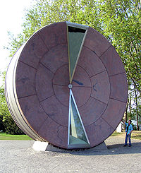We still use hourglasses in different ways. When playing a game, cooking an egg, as a symbol on the computer, to brush your teeth, in the sauna, etc.*

*In Budapest, the capital of Hungary, you can admire a very large timewheel (see picture).*

*This timewheel is* ***the largest hourglass in the world****! It is 8 metres in diameter. It takes exactly one year for the sand to flow from the upper to the lower chamber. On New Year's Eve the hourglass is turned over. That must be quite a job!*

**Is it 1, 2, 3 or…?**

*Have you understood everything? Did you write some things down in your notebook? Well then let's start the next assignment.*

*Which words belong to which time instruments? Drag the words to the time instruments. You'll notice that there is a time instrument that you have not read about yet. But you can find this instrument if you look carefully and think hard.*

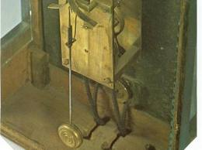

|  |
| --- |
| *stick - flat disc* |
| *awkwardly large - shadow* |
| *can freeze – different shapes* |
| *fire – not accurate* |
| *eggshells – game* |
| *hands – mechanic* |

**

**

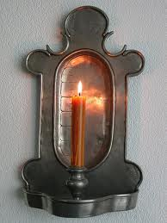

Als juist: **Great job!**

Als fout eerste keer: **That's not completely correct. Try again.**

Als fout tweede keer: **Don't worry if you don't know all of the answers yet.**

**Time to make something.**

1. *Later you will be asked to choose a time instrument. You will get all you need for each instrument. That means all the things that you need to make this instrument. You can choose from:*
2. *A water clock*
3. *A sundial*
4. *An hourglass*

***Requirements:***

*A long stick, a disc or surface to draw the hours of the day on (this can be on the ground of the playground), some chalk to draw the hours*

*Which time instrument can you make with these items?*

1. *A water clock*
2. *A sundial*
3. *An hourglass*

*Als juist:* ***Good thinking!***

*Als fout:* ***No, these items are used to make a sundial.***

***Requirements:***

*Two bottles with caps, strong tape to connect the bottles, a nail to make thin holes in the caps, a hammer to hit the nail through the caps, fine sand, a chronometer or a watch with a seconds hand*

*Which time instrument can you make with these items?*

1. *A water clock*
2. *A sundial*
3. *An hourglass*

*Als juist:* ***Good job!***

*Als fout:* ***Oops, these items are used to make an hourglass.***

***Requirements:***

*An empty tin can with a hole in it, a glass jar to collect the water, a hammer and a nail to make a hole in the tin can, a marker to draw the hours on the glass jar, water, a watch to calculate the time*

*Which time instrument can you make with these items?*

1. *A water clock*
2. *A sundial*
3. *An hourglass*

*Als juist:* ***Yes, that's correct.***

*Als fout:* ***Oops, that is not correct. The correct answer is a water clock.***

1. Now choose one of the three time instruments and write the name of the chosen instrument in your text box.

Can you write in the text box how you would make this instrument? Write down what you must do.

***Good try. Perhaps you can test your time instrument at home or in the classroom to see if it really works.***

Good job, you finished this topic. Let's see what you learned with a short test.



1. What is this used for?

Select the right answer.

1. To decorate your house.
2. This used to be used as lighting.
3. This is a clock for measuring time.

*Als juist:* ***Great! Keep up the good work.***

*Als fout:* ***Too bad, but this is a candle clock. It was used to measure time.***

1. Below you see the names of four measuring instruments.

With which instrument can you measure time?

Select the right answer.

1. Sundial
2. Thermometer
3. Heart rate monitor
4. Rain gauge

*Als juist:* ***Excellent! Keep up the good work.***

*Als fout:* ***Oops! The correct answer is* "A sundial". All the other instruments do not measure time.**

1. What are the disadvantages of the water clock?

Select the right answer.

1. Water clocks are very complicated instruments.
2. Water clocks can freeze in wintry weather.
3. Water clocks measure more precisely than sundials.
4. Water clocks are expensive.

*Als juist:* ***Excellent! Keep up the good work.***

*Als fout:* ***Oops! The correct answer is* "Water clocks can freeze in wintry weather."**

1. What do you need to make a REAL hourglass?

Select the right answer.

1. sand from a sand box
2. a long stick
3. finely ground eggshells
4. water

*Als juist:* ***Good job.***

*Als fout:* ***Oops! The correct answer is* "Finely ground eggshells".**

1. What is this?
2. An apartment building
3. A rocket
4. A cemetery
5. A sundial

*Als juist:* ***Good job! This was the last question.***

*Als fout:* ***Oops! The correct answer is* "A sundial". These large sundials are called obelisks. They are found in many places in the world.**