**It is time.**

Hello, we are going to start by asking you to complete a ‘test’. Don't worry if you don't know the answer to some of these questions, as you will learn all about it.

1. What would happen if we didn't know what time it is or what day it is?

Select the right answer.

1. The sun would never set.
2. People and animals would not get tired.
3. There would be chaos.
4. It would always be vacation.

In the past people did not have clocks.

Yet they were still able to tell time.

How do you think they did that?

Select the right answer.

1. They stuck their finger in the air to feel which direction the wind came from.
2. They looked at the clouds.
3. They looked at the position of the sun and the shape of the moon.
4. They asked each other.
5. Below you see the names of four measuring instruments.

With which instrument is it impossible to measure time?

Select the right answer.

1. Sundial
2. Hourglass
3. Heart rate monitor
4. Water clock
5. Do you know where the sun rises in the morning?

Select the right answer.

1. In the east
2. In the south
3. In the north
4. In the west

**Can we really measure time?**

**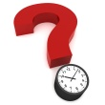***Time is very important. You must wake up on time because you have to be at school on time. You have to catch the bus, train or tram on time too. You have to start doing your homework on time because you want to save some time for playing games. Perhaps you want to catch a TV programme on time or you have to be on time for a football match, drawing-lessons, a family visit or dancing classes. And, whether you like it or not, sometimes you have to go to bed on time. To see what time it is, or to know how much time you have left, you can look at a clock or a watch.*

*That was different in the old days, when time was measured with other instruments.*

**A world without a clock?**

*Imagine that there were no clocks, watches or other instruments that tell time. What might happen?*

*Write the number and your answer in the textbox.*

**

1. *With the trains, buses, trams, metro?*
2. *With shops?*
3. *In school?*
4. *….*

*Good job! Can you think of anything else that is not on the list?*

*Write it down in your textbox.*

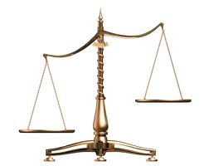**Do all clocks have hands?**

*Can you help? Where should these instruments be?*

*Take a good look at the images and drag them to the correct place.*

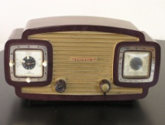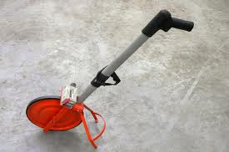

*meetlat.jpg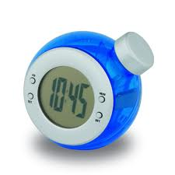*

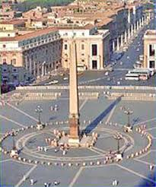

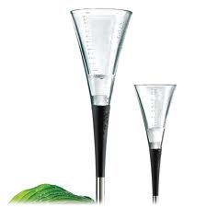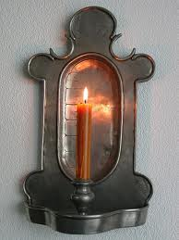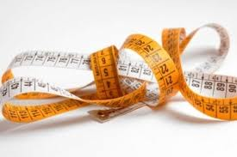

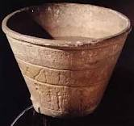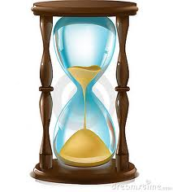

|  |  |
| --- | --- |
| *instruments to measure time* | *other measuring instruments* |
|  |  |

Als juist:  **Wow! You did a really good job!**

Als fout eerste keer: **Oops, that's not completely correct.**

Als fout tweede keer**: After this topic you will know all the answers.**

**All in good time**

*A long time ago people started looking for ways to measure time. The very first method was very simple. People used natural elements like the sun, the moon and the stars.*

*When the sun rises in the morning, it is day. Look at the parasol on the beach. Do you see where the sun is? Correct. You do not see the sun on this photo. What you do see is the parasol's shadow. The shadow is on the left side of the photo. That means the sun is on the right side. That is east. The sun rises in the east every morning.*

*The sun rises in the* ***east*** *in the* ***morning.***

*zon schaduw zuiden.jpg*

*Take a good look at this photo. Do you see the sun now? No, but you do see that the shadow surrounds the parasol. The sun is now high in the sky. The sun is in the south. That's where it always is around noon.*

*The sun is in the* ***south*** *around* ***noon.***

**

*You still cannot see the sun on the photo, but you can see the shadow. It is on the right side. That means the sun is on the left side. It is evening and the sun is setting in the west.*

*The sun* ***sets*** *in the* ***west.***

**Any idea what time it is?**

*People used to tell time by looking at the sun. But they didn't know the hours and minutes. Nowadays we can tell time much more precisely.*

*Can you find the right time for each drawing or photo?*

*Look at the images carefully and read the sentences. Select the correct sentence.*

*Don't forget! The sun rises in the* ***east*** *in the morning and this is on the* ***right side*** *of the images.*

|  |  |
| --- | --- |
| *middag.jpgWhat is the correct time?*  *A. It is summer and seven o'clock in the morning.*  *B. It is summer and it is about 12 noon.*  *C. It is summer and eleven o'clock at night.*  *D. It is night.* | *nacht.jpgWhat is the correct time?*  *A. It is summer and seven o'clock in the morning.*  *B. It is summer and it is about 12 noon.*  *C. It is summer and eleven o'clock at night.*  *D. It is night.* |
| *avond106459166.jpg*  *What is the correct time?*  *A. It is summer and seven o'clock in the morning.*  *B. It is summer and it is about 12 noon.*  *C. It is summer and eleven o'clock at night.*  *D. It is night.* | *opkomende zon.jpg*  *What is the correct time?*  *A. It is summer and seven o'clock in the morning.*  *B. It is summer and it is about 12 noon.*  *C. It is summer and eleven o'clock at night.*  *D. It is night.* |

|  |  |
| --- | --- |
| *Als juist:* ***Good job!***  *Als fout eerste keer:* ***This is not the correct answer. Try again.***  *Als fout tweede keer:* ***No, if you look at the picture then you will see that the sun shines brightly and it is high in the sky. It is noon and the sun is in the south.*** | *Als juist:* ***Good job!***  *Als fout eerste keer:* ***This is not the correct answer. Try again.***  *Als fout tweede keer:* ***No, it is obviously night. You can see that the sun is gone and the stars and moon are visible****.* |
| *Als juist:* ***Good job!***  *Als fout eerste keer:* ***This is not the correct answer. Try again.***  *Als fout tweede keer:* ***Oops, this is a picture of joggers with the evening sun in the background. It is evening and the sun is slowly******setting.*** | *Als juist:*  ***Wow! Excellent job! Big thumbs up!***  *Als fout eerste keer:* ***This is not the correct answer. Try again.***  *Als fout tweede keer:* ***This was a tough one. The sun rises in the east and that is on the right side. Therefore it is morning.*** |

**Where is the sun?**

west

east

*Now you know that the sun rises in the east, is in the south at noon*

*and sets in the west in the evening. Can you put the sun in the right place in the garden?*

*Pay attention to the different times!*

south

north

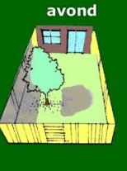

south

north

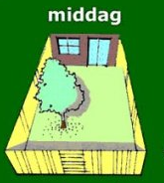

south

north

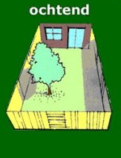

south

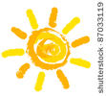



Good job, you finished this topic. Let's see what you learned with a short test.

1. People think measuring time is very important.

Do you know why?

Select the right answer.

1. Because people like measuring time.
2. Because if people don't know the time they cannot go to sleep.
3. Because it is important to know when you have to be somewhere (what time the bus, tram or train leaves, when it is someone's birthday, etc.).
4. Because otherwise it would be night all the time.

*Als juist:* ***Great! Keep up the good work.***

*Als fout:* ***Too bad! The correct answer is "*Because it is important to know when you have to be somewhere (what time the bus, tram or train leaves, when it is someone's birthday, etc.)".**

1. In the past people did not have any instruments to tell time.

north

west  east

south

They were able to tell time by looking at the sun or

the moon.

What time would it be on this picture?

1. Noon
2. Evening
3. Morning

Als juist: **Fantastic!**

Als fout: **No, that is not correct. The sun is** **setting.**

**The sun always sets in the west.**



1. What is this used for?

Select the right answer.

1. To decorate your house.
2. This used to be used as lighting.
3. This is a clock for measuring time.

Als juist: **That's great!**

Als fout: **No, this is a candle clock.**

1. What is explained in this picture?

Select the right answer.

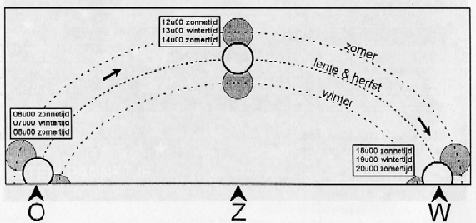

1. The picture shows that a day consists of 24 hours.
2. The picture shows that the sun rises in the east in the morning, is in the south at noon and sets in the west in the evening.
3. This picture shows that the sun rises in the west and sets in the east.
4. The picture explains the different phases of the moon.

*Als juist:* ***Very good. This was the last question.***

*Als fout:* ***What a pity.* The picture shows that the sun rises in the east in the morning, is in the south at noon** **and sets in the west in the evening. There is a trick to help you remember this. The sun is like bread: it rises in the yeast and it sets behind the vest.**