**TOPIC: ORIENTATION**

**Subtopic 4: Lost?!**

Teaching phase 1: Aids in the air

Application phase 1: Aids in the air

Teaching phase 2: Aids on the ground

Application phase 2: Aids on the ground

Teaching phase 3: Find your way with a map and compass

Application phase 3: Find your way with a map and compass

Teaching phase 4: I always find my way!

Application phase 4: I always find my way!

**Pre-test**

Welcome! Are you always able to find your way? Do you know which aids you can use? Today you will learn more about this. First answer these questions to see what you already know.

1. In which direction do you find moss?
2. north
3. east
4. south
5. west
6. Which statement about the North Star is true?
7. The North Star is located in the south.
8. The North Star is part of the Big Dipper constellation.
9. The North Star is the only star in the sky that never changes place.
10. The North Star is not visible all year round.
11. Which statement about aids for orienting yourself is false?
12. A GPS can always help you find your way.
13. The main entrance of a church usually points west.
14. The farther your follow a river downstream, the greater the chance that you will find a village.
15. To orient a map properly, you must hold it so that north on the map agrees with the north that is shown on your compass.
16. Which aid should you use if you are lost in the desert?
17. a GPS
18. the sun
19. moss
20. a river

**Teaching phase 1: Aids in the air**

A map, a compass, a GPS... They are all handy tools to orient yourself or to find your way. We call them orientation tools. Have you ever thought about what you should do if you do not have any of these tools to orient yourself? Will you be hopelessly lost? Of course not: you can find things in nature that will help you find your way. Here are a few tips to get to your destination without using technical devices. If you take a good look in nature, you will see phenomena that provide clues on directions.

The sun is a good example. You probably already noticed that the sun does not stay in the same place all day long. It does not even go to some places. The sun can help us orient ourselves. Let's give it a try:

**E S W**







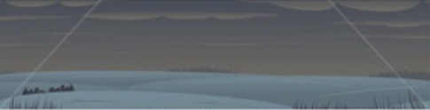

The sun comes up in the east in the morning.

At noon the sun is in the south, at its highest point.

In the evening, the sun sets in the west.

The sun is never in the north.

At night is is more difficult to orient yourself with the sun. But the stars can help us. The North Star is a very handy helper. It is the only star in the sky that never changes place. It is always in the north above the horizon. To orient yourself based on the North Star you need good eyes, a large open area and a clear, cloud-free night sky.

|  |  |
| --- | --- |
| 1. You look at the starry sky and search for the Big Dipper constellation. It is easy to spot because it looks like a saucepan. It has seven stars. This constellation is visible all year long. | E:\Oriëntatie - Evelien\Illustraties\Poolster\128551785.jpg  Big Dipper |
| 1. To find the North Star you start out at the two stars on the side of the saucepan. You expand the distance between those two stars five times. There you will find the North Star. | Big Dipper  North Star |
| 1. The North Star is also part of a constellation. Did you notice that it is almost the same shape as the Big Dipper constellation? It is only a bit smaller. You have found the Little Dipper! | Big Dipper  North Star  Little Dipper |
| 1. To know where north is, point your finger at the North Star. If you pull your finger straight down to the horizon, you have found north. Behind you lies south, to your right is east and to your left is west. | North Star  Big Dipper |

**Application phase 1 (application 1): Aids in the air**

Can you orient yourself using the sun? Put everything in the right place.

|  |  |  |  |
| --- | --- | --- | --- |
| night | morning | noon | evening |
|  |  |  |  |

west

6:20 p.m.

north

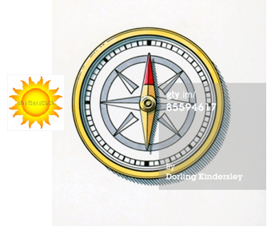 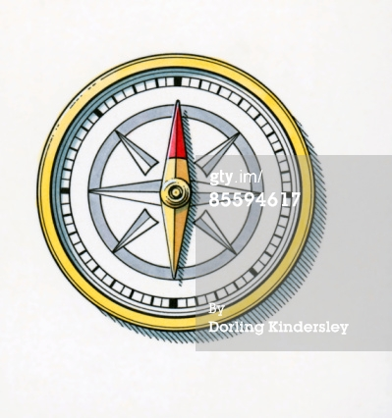 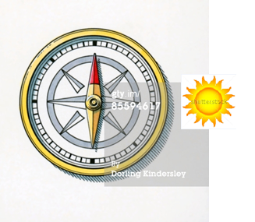 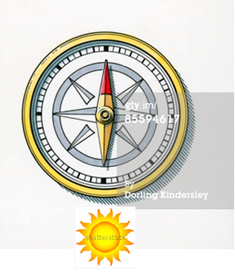

7:30 a.m.

00:40 a.m.

south

east

11:55 a.m.

**Als juist: Good job!**

**Als fout eerste keer: Try again. Do you remember the compass rose?**

**Als fout tweede keer: Oops, better luck next time. Try to remember the compass rose.**

**Application phase 1 (application 2): Aids in the air**

Where is the sun? Select the right answer.

* south
* west
* east
* north

Emmeline is going to eat at her grandma's house tomorrow at 12 noon.

**Als juist: Congratulations!**

**Als fout eerste keer: Try again.**

**Als fout tweede keer: Better luck next time! The sun is in the south at noon.**

* south
* west
* east
* north

Katya has music lessons every Tuesday at 6 p.m.

**Als juist: Congratulations!**

**Als fout eerste keer: Try again.**

**Als fout tweede keer: Better luck next time! The sun is in the west in the evening.**

* south
* west
* east
* north

Zenep gets up early every morning. She is always awake at 6:15 a.m.

**Als juist: Congratulations!**

**Als fout eerste keer: Try again.**

**Als fout tweede keer: Better luck next time! The sun is in the east in the morning.**

* northwest
* southeast
* northeast
* southwest

Marco has an appointment at the vet's office at 4 p.m. His dog is sick.

**Als juist: Congratulations!**

**Als fout eerste keer: Try again.**

**Als fout tweede keer: Better luck next time! The sun is between the south and the west in the afternoon, so it is in the southwest.**

* northwest
* southeast
* northeast
* southwest

Oliver is going to the seaside with some friends. They need to catch the train at 10:10 a.m.

**Als juist: Congratulations!**

**Als fout eerste keer: Try again.**

**Als fout tweede keer: Better luck next time! The sun is between the east and the south in the morning, so it is in the southeast.**

**Application phase 1 (application 3): Aids in the air**

I am looking for the North Star. Can you find it? Click on it now!

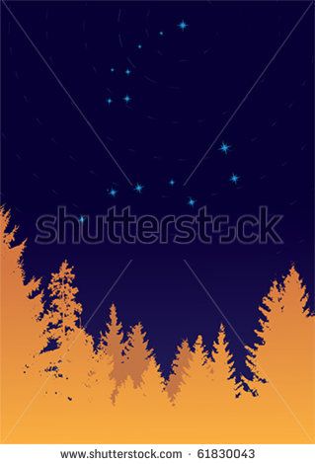

**Als juist: Good job!**

**Als fout eerste keer: Try again. First look for the Big Dipper. That is the biggest of the two constellations.**

**Als fout tweede keer: Better luck next time! If you expand the side of the Big Dipper five times you will find the North Star.**

I am looking for the North Star. Can you find it? Click on it now!



**Als juist: Good job!**

**Als fout eerste keer: Try again. First look for the Big Dipper. That is the biggest of the two constellations.**

**Als fout tweede keer: Better luck next time! If you expand the side of the saucepan of the Big Dipper five times you will find the North Star.**

I am looking for the North Star. Can you find it? Click on it now!

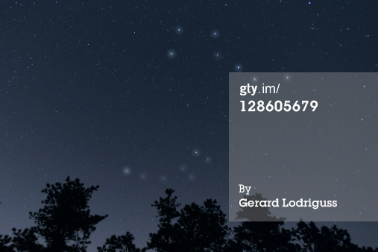

**Als juist: Good job!**

**Als fout eerste keer: Try again. The Big Dipper is at the top of this picture.**

**Als fout tweede keer: Better luck next time! If you expand the side of the saucepan of the Big Dipper five times you will find the North Star.**

**Teaching phase 2: Aids on the ground**

You can also find lots of things on the ground to orient yourself if you do not have any other tools. Take a look!

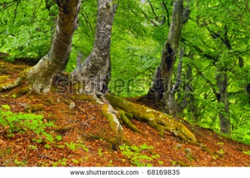

Did you notice that moss usually grows on the same side of trees and roofs? You can find most moss in the west. Why is that? Moss needs water and light to grow, just like all other plants. Moss gets its water from the rain. Most rain comes from the west. It is carried by the west wind. That's why it is very damp in those places. The combination with the sun enables moss to grow there. So the green side of trees always points to the west.

Buildings can also help you find directions. Did you know that the main entrance of a church is usually oriented to the west? Then you know the other directions.

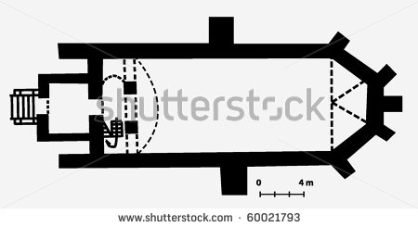

**E**

**W**

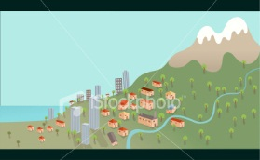

If you are really lost, you can always look for a river. Every river flows from its source downstream to the sea. Rivers get wider as they get closer to the sea. A long time ago people settled next to rivers, mainly for food and trade. If you come across a river it is good to follow that river downstream. That way you have a good chance of finding a village. If you follow the river upstream then you are going back to the source. You might not find any people there.

**Application phase 2 (application 1): Aids on the ground**

We are standing on the red dot. We want to walk in the direction of the arrow. Can you say if we are walking in the right direction to reach the closest village as quickly as possible?

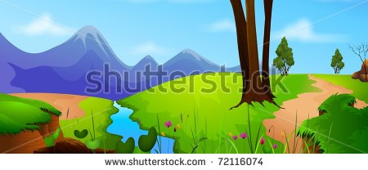

 

**Als juist: That's right! You must follow the river downstream to reach the closest village. The source of a river is usually in the mountains so the river flows from the mountains to the sea.**

**Als fout: No, you must follow the river downstream to reach the closest village. The source of a river is usually in the mountains so the river flows from the mountains to the sea.**

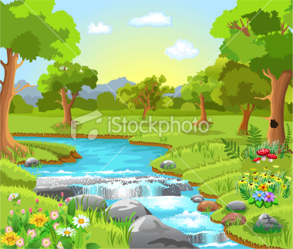

 

**Als juist: That's right! You must follow the river downstream to reach the closest village.**

**Als fout: No, you must follow the river downstream to reach the closest village.**

[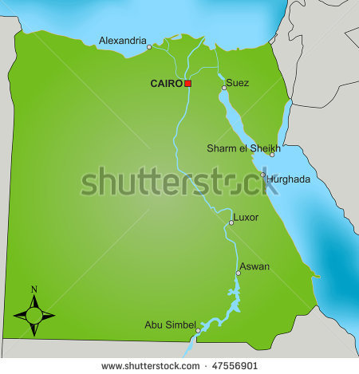](http://www.shutterstock.com/subscribe.mhtml)

 

**Als juist: That's right! You must follow the river downstream towards the sea to reach the closest village.**

**Als fout: No, you must follow the river downstream towards the sea to reach the closest village.**

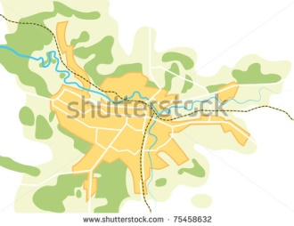

 

**Als juist: That's right! You must follow the river downstream to reach the closest village. The river gets wider near the sea.**

**Als fout: No, you must follow the river downstream to reach the closest village. The river gets wider near the sea.**

**Teaching phase 3: Find your way with a map and compass**

Imagine that you find a village along the river and you get a map and compass to orient yourself. Do you know how to use them? The top of the map usually corresponds with north. Many maps also show a compass rose with north at the top, south at the bottom, east to the right and west to the left. Hold the map so that the arrow on the map pointing north also points to the real north. You can find the real north using the compass. There, now you will be able to find your way!

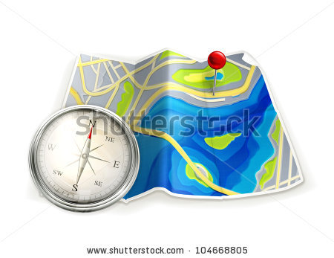

**N**

**W**

**E**

**S**

**Application phase 3 (application 1): Find your way with a map and compass**

Can you tell me if this map is placed correctly to orient ourselves? Remember, the north on the map's compass rose must correspond with the north on the compass. The red arrowhead of this compass shows that north is at the top.

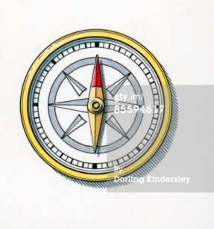



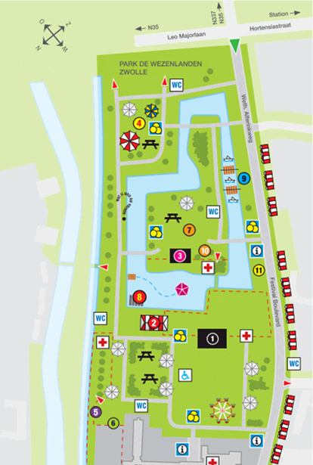





**Als juist: That's right! The map is in the wrong position!**

**Als fout: Oops! The map is in the wrong position. North on the map's compass rose does not correspond with the north on the compass.**







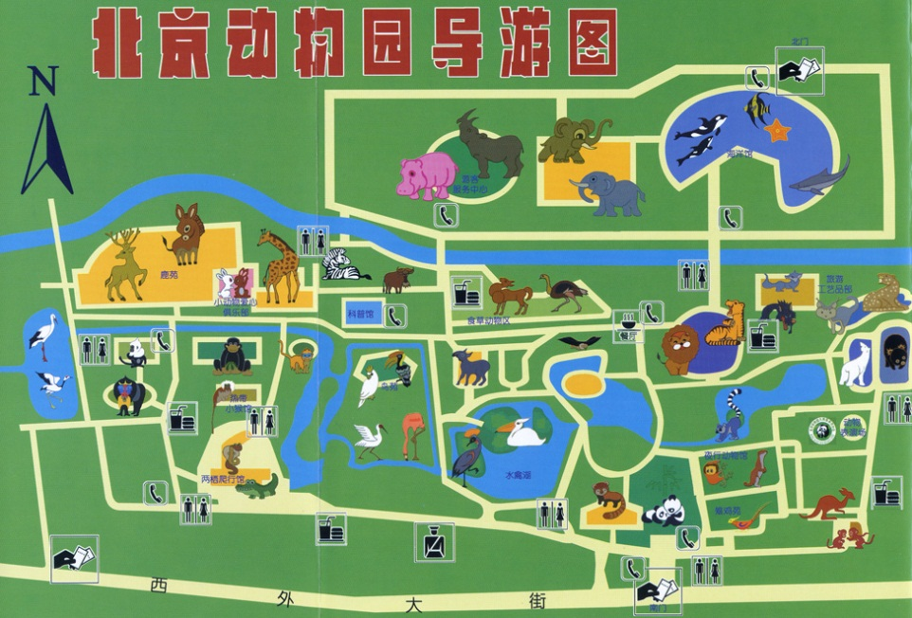

**Als juist: That's right!**

**Als fout: Too bad! The map is positioned correctly. North on the map's compass rose corresponds with the north on the compass.**



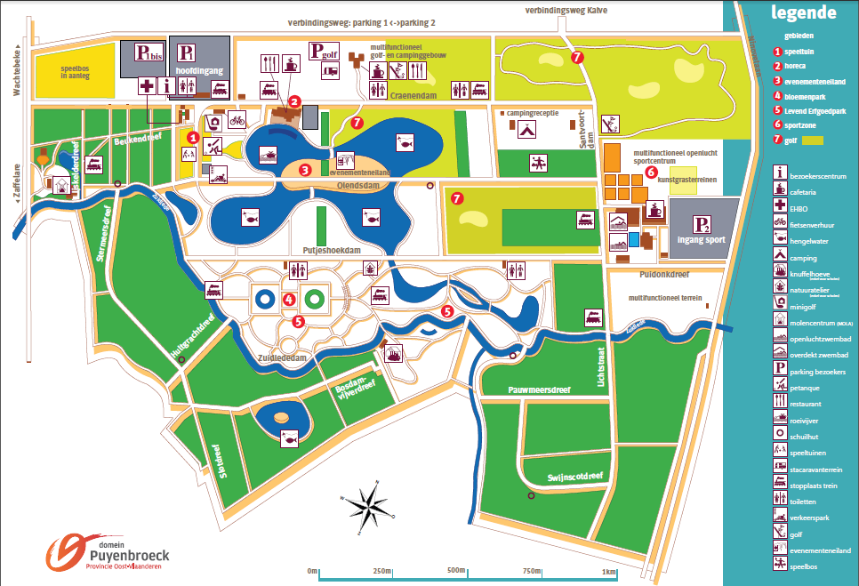





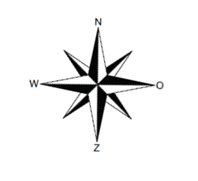

**Als juist: That's right!**

**Als fout: Too bad! The map is positioned correctly. North on the map's compass rose corresponds with the north on the compass.**

**Teaching phase 4: I always find my way!**

Now we know different ways to orient ourselves. From the sun to the GPS, from the compass to the North Star. Does that mean you will never get lost again? Well, it is a question of using the right tool in the right situation. A GPS will not help you if the batteries are dead. You cannot orient yourself using the North Star if there are so many streetlamps that you cannot see any stars. That's why it is good to know how different orientation tools work. That way you can make the right choice about what to take in your backpack on your next trip, and you will never get lost again!

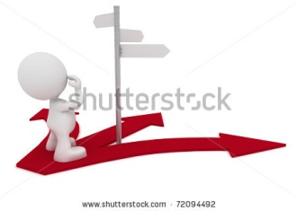

**Application phase 4 (application 1): I always find my way!**

What are the advantages of the following orientation tools?

|  |  |  |
| --- | --- | --- |
|  | **ADVANTAGE** | This tool allows you to determine your route from your departure to your destination.  This helps you during the day to know which direction is east, south, west and north.  This accurately tells you the route you need to follow and how long it will take you.  This makes it very easy to find north.  This is a good means of orienting yourself at night. |
| Compass |  |
| North Star |  |
| GPS |  |
| Sun  E:\Oriëntatie - Evelien\Illustraties\Zon\stock-vector-vector-illustration-of-abstract-sun-with-flames-jpg-file-has-clipping-path-84929914.jpg |  |
| Map |  |

**Als juist: Well done! You know the advantages of every orientation tool!**

**Als fout eerste keer: Try again. Read the sentences carefully.**

**Als fout tweede keer: Oops, better luck next time. Take a good look at the advantages for each orientation tool before you continue.**

**Application phase 4 (application 2): I always find my way!**

What are the disadvantages of the following orientation tools?

|  |  |
| --- | --- |
|  | You cannot use this if it is cloudy at night.  **DISADVANTAGE** |
| Compass | You are very dependent on technology: you do not look for your own route but allow yourself to be guided. |
| North Star | This tool gets old quickly: some traffic situations might have changed due to road works. |
| GPS | You cannot use this if it is cloudy or stormy during the day. |
| Sun  E:\Oriëntatie - Evelien\Illustraties\Zon\stock-vector-vector-illustration-of-abstract-sun-with-flames-jpg-file-has-clipping-path-84929914.jpg | If you hold this near metal it will not work. |
| Map |  |

**Als juist: Well done! You know the disadvantages of every orientation tool!**

**Als fout eerste keer: Try again. Read the sentences carefully.**

**Als fout tweede keer: Oops, better luck next time. Take a good look at the disadvantages for each orientation tool before you continue.**

**Application phase 4 (application 3): I always find my way!**

Which other advantages and disadvantages can you think of for orientation tools? For each of the following orientation tools, write down an advantage or disadvantage that is different than the examples you already saw.

What is an advantage of this orientation tool?

GPS

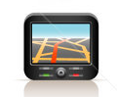

Text box



**Good thinking!**

What is a disadvantage of this orientation tool?

compass

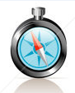

Text box

**Thanks for thinking of that!**

What is an advantage of this orientation tool?

river

[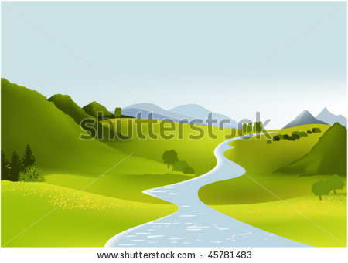](http://www.shutterstock.com/subscribe.mhtml)



Text box

**Thanks for thinking about that!**

What is an advantage of this orientation tool?

map

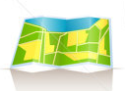

Text box

**Thanks for thinking of that!**

moss

[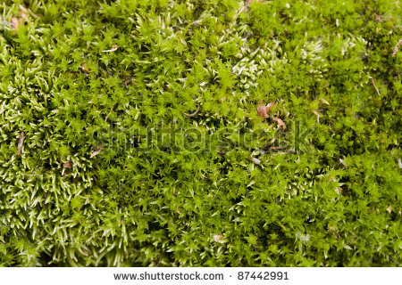](http://www.shutterstock.com/subscribe.mhtml)



Text box

**Good thinking!**

What is an advantage of this orientation tool?

North Star



Text box

**As you can see, each orientation tool has advantages and disadvantages. Use them wisely and you will always find your way!**

**Application phase 4 (application 4): I always find my way!**

Which orientation tool is best used in the following situations? You have a few things on hand. Choose what will help the best:

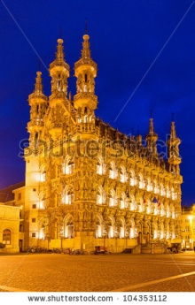

You and your family are taking an evening walk through Leuven. To determine your route you use:

* the North Star
* a GPS
* a political map
* a compass

**Als juist: Good job!**

**Als fout eerste keer: Try again. Remember, you are in a city.**

**Als fout tweede keer: Better luck next time! It is best to use a GPS in the city. You probably cannot see the North Star because of all the streetlamps. A political map does not give detailed information about streets. A compass only shows you where north is, it does not say which street to take.**



You and a group of friends are cycling through the fields. All of a sudden one of your friends falls and hurts himself. You do not have any orientation tools with you. To find the closest village for help you should orient yourself with:

* the sun
* moss
* the North Star
* the river nearby

**Als juist: Good job!**

**Als fout eerste keer: Try again. Remember, it is daytime.**

**Als fout tweede keer: Better luck next time! You have the best chance of finding a village if you follow the river downstream.**

[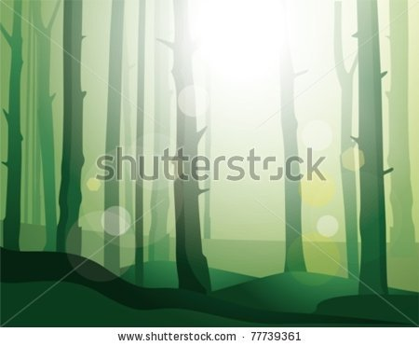](http://www.shutterstock.com/subscribe.mhtml)

You go on a quest in the forest during the day. You received an orientation kit with a GPS, a compass and a map. What should you use to orient yourself?

* a GPS that cannot catch a signal
* a compass that points east
* moss
* the North Star

**Als juist: Good job!**

**Als fout eerste keer: Try again. Remember, it is daytime.**

**Als fout tweede keer: Better luck next time! To orient yourself using the map , look for some moss. A compass must point north and a GPS must pick up satellite signals.**

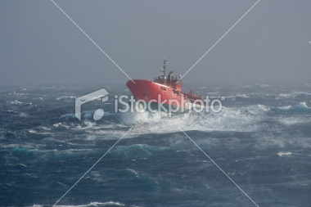

You are sailing on the ocean. In the middle of the day a storm breaks. There is thunder and lightning above your boat. All your electric devices refuse to work. How can you find the way to the harbour?

* with a compass
* with the North Star
* with the sun
* with moss

**Als juist: Good job!**

**Als fout eerste keer: Try again.**

**Als fout tweede keer: Better luck next time! To find you way to the harbour it is best to use a compass. It is daytime so you cannot use the North Star. The sun has disappeared behind the clouds. You cannot find moss at sea.**

**Evaluation phase**

We are almost done! Can you answer the following questions to show that you really know your stuff?

1. Which drawing is incorrect?
2. 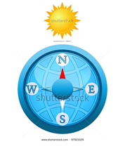
3. 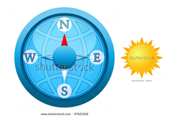
4. 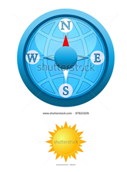
5. 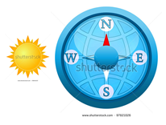

**Als juist: Good job!**

**Als fout: No, the sun is never in the north.**

1. Which statement is false?
2. The North Star is always located in the north.
3. - A river always flows to the source.
4. The sun is in the south at noon.
5. You find moss in the west.

**Als juist: Good job!**

**Als fout: No, a river always flows to the sea, not to the source.**

1. Which statement about reading maps is true?
2. The top of the map usually corresponds with north.
3. The right side of the map usually corresponds with north.
4. The bottom of the map usually corresponds with north.
5. The left side of the map usually corresponds with north.

**Als juist: Good job!**

**Als fout: No, the top of the map usually corresponds with north.**

1. Which orientation tool should you use if you are lost in the woods on a cloudy day?
2. the sun
3. the North Star
4. a church
5. moss

**Als juist: Good job!**

**Als fout: No, you can orient yourself best using moss. It is daytime so you cannot use the North Star You cannot see the sun because it is cloudy. You do not often find a church in the woods.**