**TOPIC: ORIENTATION**

**Subtopic 3: Let's go**

Teaching phase 1: A range of maps

Application phase 1: A range of maps

Teaching phase 2: Let someone else drive!

Application phase 2: Let someone else drive!

Teaching phase 3: How does a GPS work?

Application phase 3: How does a GPS work?

**Pre-test**

Welcome! Today you will learn more about all kinds of maps. Do you already know something about maps? Try to answer these questions. You will learn the things that you don't know later.

1. What cannot be found on a physical map?
2. streets
3. rivers
4. mountains
5. oceans
6. Which map do you use if you want to know how to travel from Brussels to Paris?
7. a political map
8. a tube map
9. a road map
10. a map
11. You want to take the tram from Wondelgem to Flanders Expo. Which tram line do you need to take?
12. Red tram line 1
13. Green tram line 4
14. Yellow tram line 21
15. Yellow tram line 22

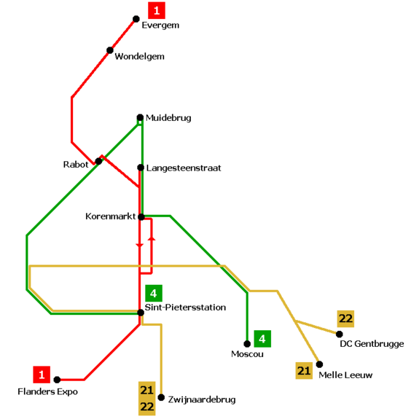

1. A GPS is a navigation system. Which of the items below does NOT belong?
2. sun
3. satellite
4. receiver
5. maps

**Teaching phase 1: A range of maps**

Maps come in all shapes and sizes. And they offer lots of information. Do you know these maps?

A **road map** does not show all the streets. Only roads that connect villages, municipalities or cities are shown on a road map. Different colours are used for motorways than for smaller roads.

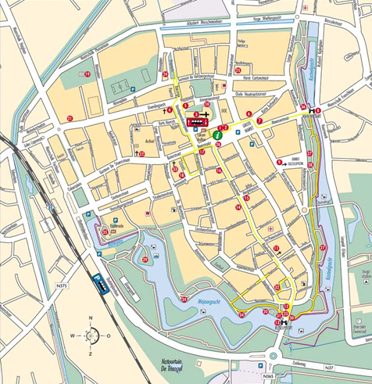

A **political map** shows the borders between countries. Borders can be straight lines, sometimes they follow rivers or mountains. Political maps may be changed due to political events.

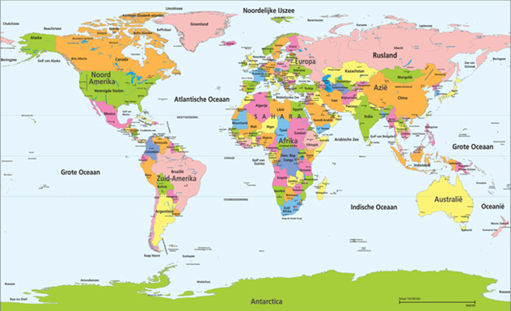

There is a **street map** for every city. Street maps show all streets (small and large), buildings and parks so that you do not get lost. These maps can be very useful if you are cycling or walking through a city.

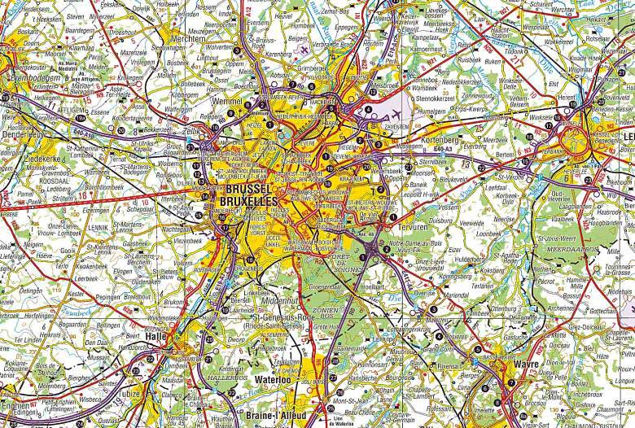

A **transit map** is a special map that shows the lines, stops and numbers of the public transport system. Every bus, tram or metro line has its own colour.

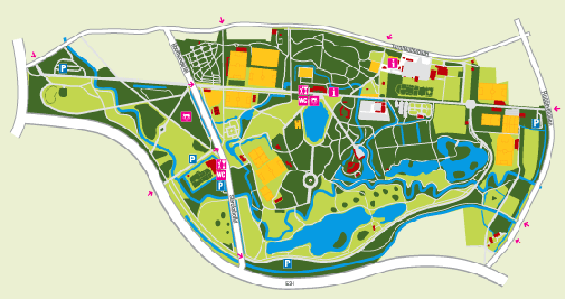

A **map** can be handy if you walk through an amusement park or follow trails. This type of map shows in detail all paths, buildings and places of interest in a small area.

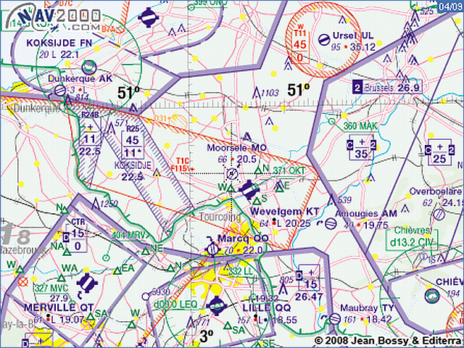

An **aerial map** is a map for pilots. It shows the flight paths and airports. The height of obstacles (like mountains) and natural phenomenon (such as lakes and rivers) are also shown on aerial maps.

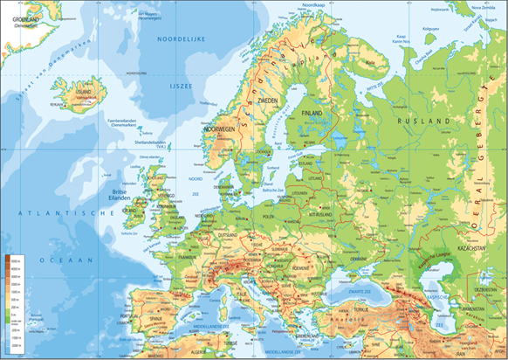

A **physical map** provides information about the landscape of an area, such as rivers, lakes, mountains, deserts and other natural phenomena. Sometimes cities and national borders are also shown.

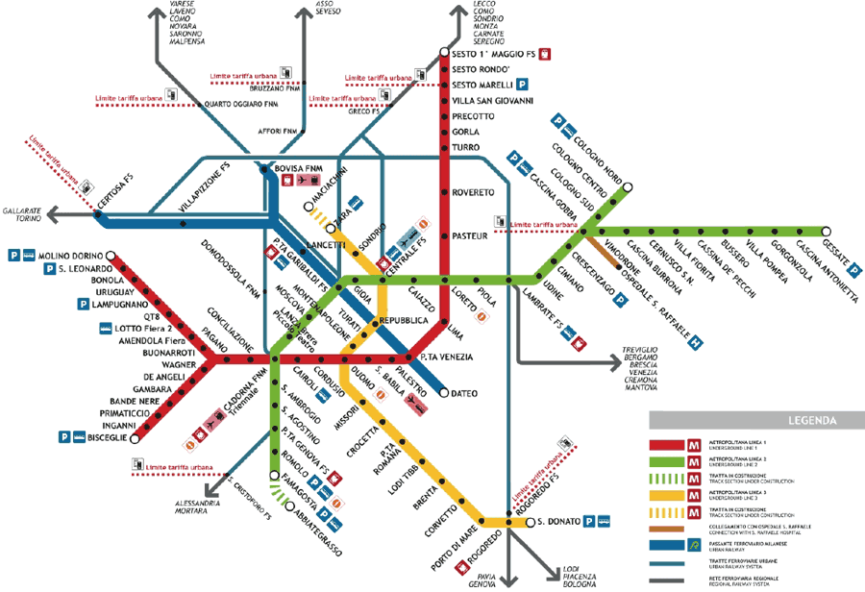

**Application phase 1 (application 1): A range of maps**

You are your class are planning an outing to Tournai in Henegouwen. Can you say what kind of map you should use for each situation? Put the maps in the right place.

|  |  |  |
| --- | --- | --- |
| You are sightseeing in Tournai. How can you find your way around? |  | Physical map |
| A river runs through Tournai. Which river is that? |  | Road map |
| The animal park Pairi Daiza is located near Tournai. How can you learn where the different animals are housed in the park? |  | Street map |
| Tournai is located in Henegouwen. You want to know where that province is and which country it borders. |  | Political map |
| You are travelling to Tournai by bus. How can you know which roads the bus takes to get to the city? |  | Map |

**Als juist: Well done!**

**Als fout eerste keer: Try again. Try to think about which map is best used for which situation.**

**Als fout tweede keer: That is not quite right. Better luck next time.**

**Teaching phase 2: Let someone else drive!**

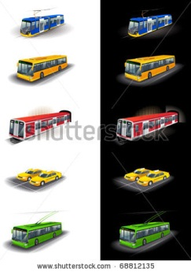

The bus, tram, metro and train are all forms of public transport. Public means that everyone who wants to use it can use it.

You usually choose the train to travel long distances. It is the fastest and easiest way to travel from one large city to another. The bus, tram and metro are mainly used to move around in a city or to travel a short distance. To be able to use public transport it is important to know how it works. If you want to take the bus or tram, for example, you must keep a few things in mind.

I need to go from point A to point B. What should I keep in mind when I take the bus, tram or metro?



1. Where is the closest stop near point A to get on?
2. Where is the closest stop near point B to get off?
3. Which bus, tram or metro is the fastest way of getting to point B?
4. Which directions does the bus, tram or metro that I need ride?

Let's practice a bit. Here is a timetable of the metro and tram network in Brussels.



legend

terminus

terminus

**Application phase 2 (application 1): Let someone else drive!**

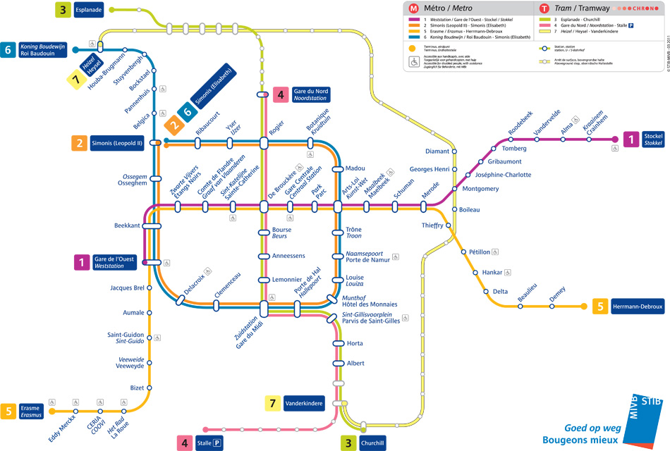

**Destination:** Belgian Comic Strip Center

**Address:** Zandstraat 20 rue des sables, 1000 Brussels

**Metro stop where you must get off:** De Brouckère

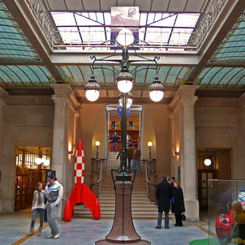

You want to visit the Belgian Comic Strip Center. Which metro do you need to take if you get on at the stop ‘Beaulieu’? This stop is shown with a red circle.

* Purple metro line 1
* Green metro line 3
* Pink metro line 4
* Yellow metro line 5

**Als juist: Good job!**

**Als fout eerste keer: Try again. First look for the stop ‘Beaulieu’, which is where you must get on. Then look for the stop ‘De Brouckère’, which is where you must get off. Then see which metro line rides between these two stops.**

**Als fout tweede keer: Better luck next time! To get to the Belgian Comic Strip Center you take the yellow metro line 5. That line rides between the stop ‘Beaulieu’ and the stop ‘De Brouckère'. Look at the map once again before you continue.**

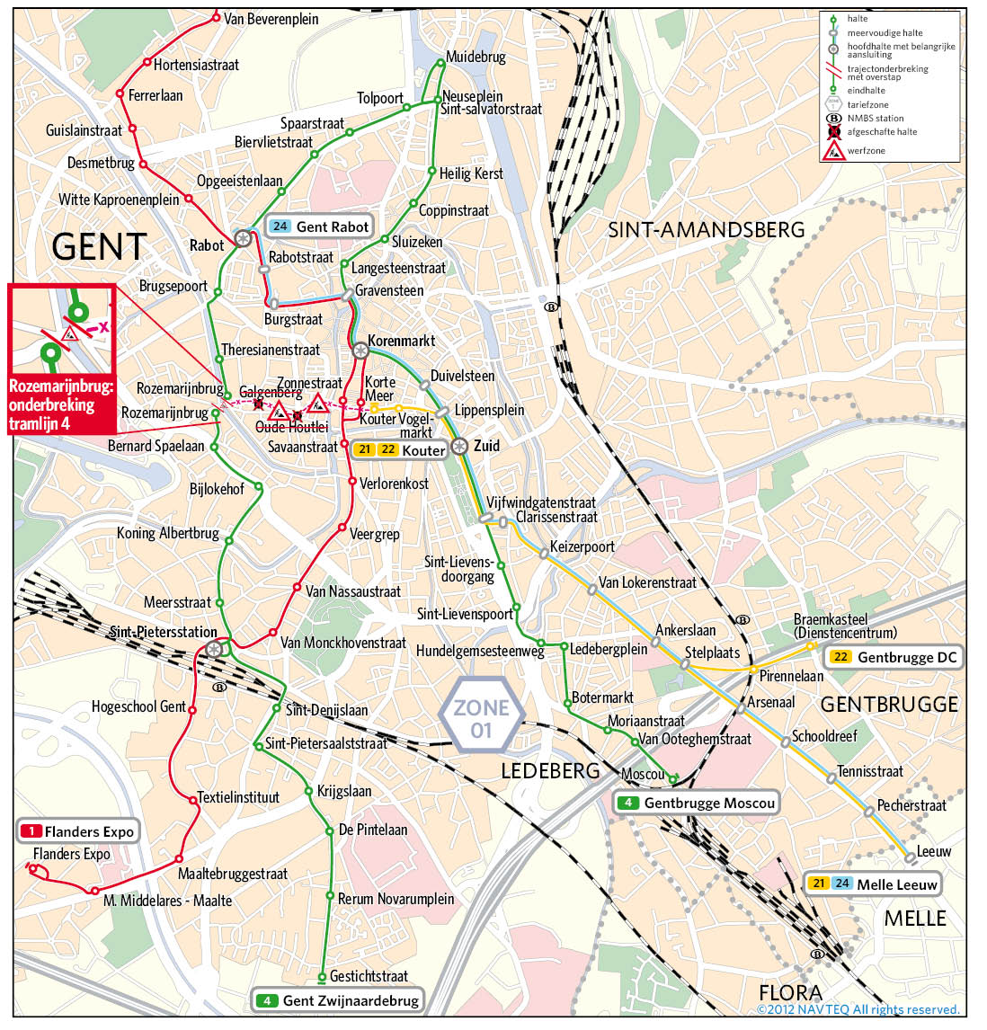

**Destination:** De Centrale

**Address:** Kraankinderstraat 2, 9000 Ghent

**Tram stop where you must get off:** Heilig Kerst

[](http://www.decentrale.be/default.aspx)

You signed up for a world music course at ‘De Centrale’. Which tram should you take if you get on at the stop ‘Botermarkt’? This stop is shown with a red circle.

* Red tram line 1
* Green tram line 4
* Yellow tram line 22
* Blue tram line 24

**Als juist: Good job!**

**Als fout eerste keer: Try again. First look for the stop ‘Botermarkt’, which is where you must get on. Then look for the stop ‘Heilig Kerst’, which is where you must get off. Then see which tram line rides between these two stops.**

**Als fout tweede keer: Better luck next time! To go to ‘De Centrale’ you take the green tram line 4. That line rides between the stop ‘Botermarkt’ and the stop ‘Heilig Kerst'. Look at the map once again before you continue.**

**Destination:** Thai Festival

**Address:** Groenplaats, 2000 Antwerp

**Tram stop where you must get off:** Groenplaats

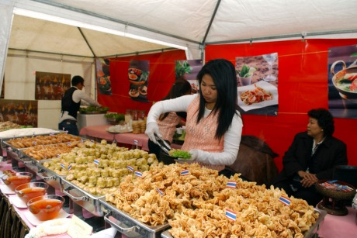

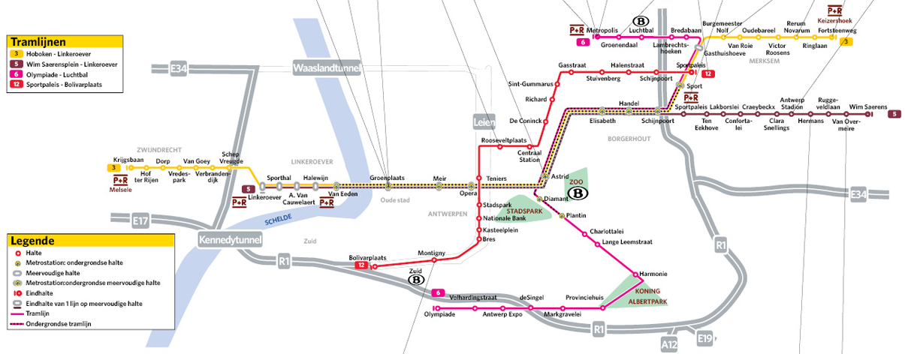

Your class plans to visit the Thai Festival, a festival where you can learn about Thai food and desserts, Thai dance and music. Which tram should you take if you get on at the stop ‘Oudebareel’? This stop is shown with a red circle.

* Yellow tram line 3
* Brown tram line 5
* Pink tram line 6
* Red tram line 12

**Als juist: Good job!**

**Als fout eerste keer: Try again. First look for the stop ‘Oudebareel’, which is where you must get on. Then look for the stop ‘Groenplaats’, which is where you must get off. Then see which tram line rides between these two stops.**

**Als fout tweede keer: Better luck next time! To get to the Groenplaats you take the yellow tram line 3. That line rides between the stop ‘Oudebareel’ and the stop ‘Groenplaats'. Look at the map once again before you continue.**

**Application phase 2 (application 2): Let someone else drive!**

Do you know which transportation companies ride in which part of Belgium?

|  |  |  |
| --- | --- | --- |
| http://www.google.be/url?source=imglanding&ct=img&q=http://www.scotty.be/media/21360/logo_tec.png&sa=X&ei=U_b2T5zhMMmA8wPY5oSVBw&ved=0CAsQ8wc&usg=AFQjCNECMr2mSp8x8qHJEfJTHnn0JzusEw |  | The buses and trams of this transportation company ride in Flanders. |
| http://www.google.be/url?source=imglanding&ct=img&q=http://www.aquariologie.be/images/Logos/Logo%20NMBS.jpg&sa=X&ei=Svf2T__YMYTT8QOziKmqBw&ved=0CAsQ8wc&usg=AFQjCNF3c1wQohFlw9oOMXb2htbKKMG0eg |  | The buses, trams and metros of this transportation company ride in Brussels. |
| http://www.google.be/url?source=imglanding&ct=img&q=http://www.exp-networks.be/wp-content/uploads/2009/04/logo-stib.png&sa=X&ei=rPb2T4bFD9P78QOI-JmaBw&ved=0CAsQ8wc&usg=AFQjCNEGWVP_ln6HXQoCuHedvxmThfyTtQ |  | The trains of this transportation company ride all over Belgium. |
|  |  | The buses and trams of this transportation company ride in Wallonia. |

**Als juist: Good job! You've got the right answer!**

**Als fout eerste keer: Try again.**

**Als fout tweede keer: Oops, better luck next time.**

**Application phase 2 (application 3): Let someone else drive!**

With which form of transport will you reach your destination fastest? Can you help? Select the right answer.

* tram 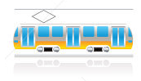
* bus 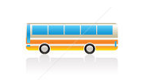
* train 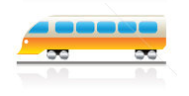
* metro 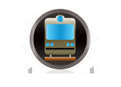

Maya lives in Antwerp. She want to go to Ostend for the day and make sandcastles on the beach. Which form of transport do you recommend?

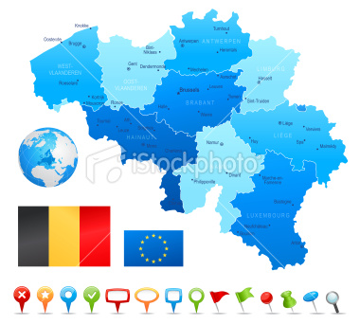

**Als juist: Good job!**

**Als fout eerste keer: Try again. Did you know that the distance between Ostend and Antwerp is about 120 km?**

**Als fout tweede keer: Better luck next time! To travel from Antwerp to Ostend, it is best to take the train. The train is the best way to travel long distances between two cities.**

* tram 
* bus 
* train 
* metro 

Lots of hot air balloons depart from the Grote Markt of Sint-Niklaas every year. Rudolf wants to go see the spectacle. He is at the Sint-Niklaas train station and wants to go to the Grote Markt in Sint-Niklaas. Which form of transport do you recommend?

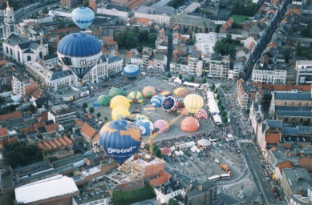

**Als juist: Good job!**

**Als fout eerste keer: Try again. Did you know that no trams ride through the centre of Sint-Niklaas?**

**Als fout tweede keer: Better luck next time! The Sint-Niklaas train station and the Grote Markt in Sint-Niklaas are not far from each other, only 2 km. That's why it is best to take the bus.**

* tram 
* bus 
* train 
* metro 

Yassin has been staying with his best friend David in Bredene for a few days. Today they want to visit the Sea Life Center in Blankenberge. Which form of transport do you recommend?

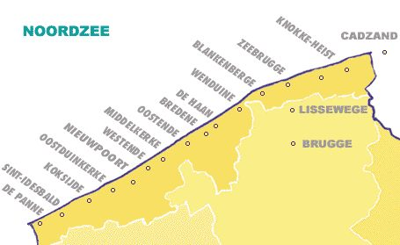

**Als juist: Good job!**

**Als fout eerste keer: Try again. Did you know that the distance between Bredene and Blankenberge is about 20 km?**

**Als fout tweede keer: Better luck next time! Yassin and David should take the Coast Tram from Bredene to Blankenberge because the distance is not too far.**

**Teaching phase 3: How does a GPS work?**

These days we use a GPS to find our way. GPS stands for ‘Global Positioning System’. The system was first developed for the American army. As the name says, a GPS helps us determine our location on the globe. That way you always know exactly where you are on earth. Today we find a GPS in almost every form of transport, including cars, airplanes, ships, etc. A GPS is also built into many mobile phones. The system can tell you which route you should take and what time you will arrive at your destination. How can such a small instrument know that?

High above the earth satellites float around at a height of about 20,000 kilometres. They take pictures of the earth for maps. The satellites also send out signals.

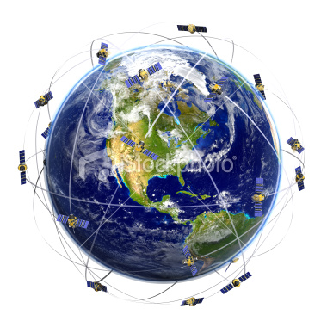



[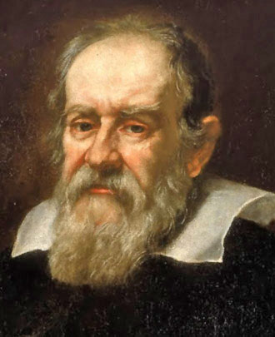](http://upload.wikimedia.org/wikipedia/commons/c/cc/Galileo.arp.300pix.jpg)

Scientists are currently working on a European GPS named after the Italian physicist Galileo. The first of a total of 30 satellites was launched into space on 21 October 2011. This system will be able to measure the distance and the time between two places very accurately.

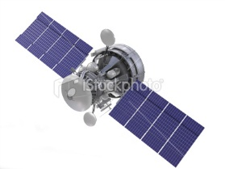

You need a GPS receiver that picks up these signals. Cars and mobile phones have such a GPS receiver. If the GPS receiver makes a connection with one satellite then you don't know anything, but if it connects to three or more satellites then you can calculate exactly where you are on earth.

A GPS does not only determine where you are on earth. It can also calculate which route you should take and when you will reach your destination. Maps from all over the world are stored in your GPS for this purpose. When you enter a destination, your GPS can calculate exactly how you should travel, which route is the fastest and how long it will take to get there. All this is calculated with the data that the GPS receiver gets from the satellites.

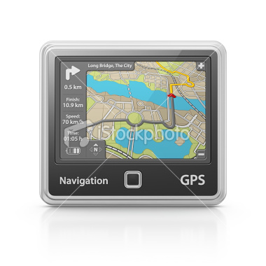

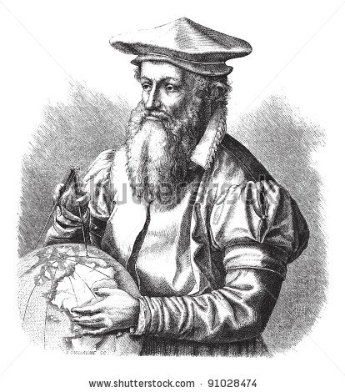

**DID YOU KNOW…**that the maps in your GPS are based on Mercator's work? Mercator is a famous Belgian cartographer that lived in the 16th century.

**Application phase 3 (application 1): How does a GPS work?**

What does a GPS need in order to work correctly? Can you find all the objects that it needs?

|  |  |  |  |
| --- | --- | --- | --- |
|  | sun |  | stars  stars Royalty Free Stock Vector Art Illustration |
|  |  |  |  |
| maps | radio  Digital Portable Radio Royalty Free Stock Photo |  | satellites |
| receiver |  | receiver  C:\Users\evlaere\Documents\VALIDIV\E-VALIDIV\E-VALIDIV Omgeving\Thema's\Oriëntatie - Evelien\Illustraties\GPS\stock-illustration-14154388-wireless-icons.jpg |  |

**Als juist: Good job! You know what a GPS needs in order to work properly.**

**Als fout eerste keer: Try again. What else do you need?**

**Als fout tweede keer: Oops! A GPS needs these things to work properly.**

**Application phase 3 (application 2): How does a GPS work?**

You are at the swimming pool with your bicycle (red drawing pin). You arranged to meet your friends in the park (red drawing pin). Can you put the GPS instructions in the correct order? The first instruction is already in place.

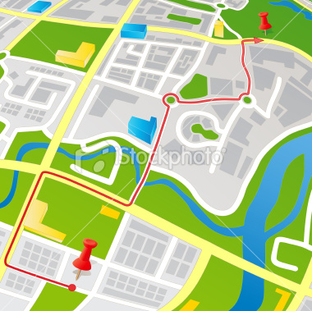

Continue for 50m. Take the second street on your right.

Continue for 50m until the roundabout. Take the first exit on the roundabout.

Continue for 100m until the roundabout. Take the third exit on the roundabout.

Your destination is on the left side of the road. You have reached your destination.

Continue for 50m. Take the first street on your right.

Leave the swimming pool. Take the second street on your right.

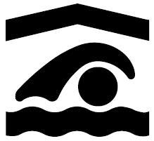

Continue for 50m. Take the first street on your left.

* Leave the swimming pool. Take the second street on your right.
* Continue for 50m. Take the second street on your right.
* Continue for 50m. Take the first street on your left.
* Continue for 100m until the roundabout. Take the third exit on the roundabout.
* Continue for 50m until the roundabout. Take the first exit on the roundabout.
* Continue for 50m. Take the first street on your right.
* Your destination is on the left side of the road. You have reached your destination.

**Als juist: Good job!**

**Als fout eerste keer: Try again. Read the instructions carefully.**

**Als fout tweede keer: Oops, better luck next time.**

You are at the car park with your bicycle (red flag). You arranged to meet your friends at the football pitch (red flag). Can you put the GPS instructions in the correct order? The first instruction is already in place.

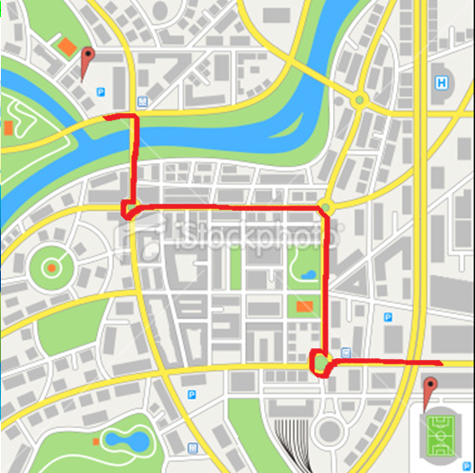

Leave the car park. Turn left immediately.

Continue for 200m until the roundabout. Take the first exit on the roundabout.

Take the next street on your right.

Continue for 200m until the roundabout. Take the third exit on the roundabout.

Continue for 100m. Your destination is on the right side of the road. You have reached your destination.

Continue for 100m over the bridge until the roundabout. Take the third exit on the roundabout.

**Als juist: Good job!**

* Leave the car park. Turn left immediately.
* Take the next street on your right.
* Continue for 100m over the bridge until the roundabout. Take the third exit on the roundabout.
* Continue for 200m until the roundabout. Take the first exit on the roundabout.
* Continue for 200m until the roundabout. Take the third exit on the roundabout.
* Continue for 100m. Your destination is on the right side of the road. You have reached your destination.

**Als fout eerste keer: Try again. Read the instructions carefully.**

**Als fout tweede keer: Oops, better luck next time.**

**Application phase 3 (application 3): How does a GPS work?**

Where do you need to go? You have a doctor's appointment but you don't remember how to get there. You enter the address in your GPS. Can you find the doctor's office now? Click on the doctor's house.

* Take the next street on your left.
* Take the next street on your right.
* Take the second street on your right.
* Take the next street on your left.
* Take the next street on your right.
* The doctor's house is on the right side of the road.

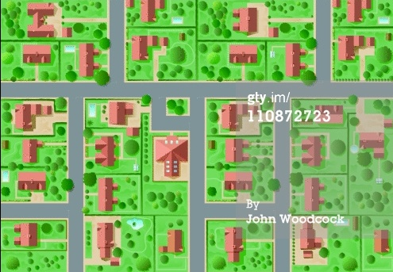

**YOU ARE HERE**





* Take the next street on your left.
* Take the next street on your right.
* Take the second street on your right.
* Take the next street on your left.
* Take the next street on your right.
* The doctor's house is on the right side of the road.

**YOU ARE HERE**



**Als juist: You have reached your destination!**

**Als fout eerste keer: Try again. Take a look at which street you must enter.**

**Als fout tweede keer: No, the doctor's house is here.**

Where do you need to go? You just bought some fruit in the shop. Now you want to go to the library to borrow some books and films. You do not know how to get from the shop to the library. You enter the address of the library in your GPS. Can you find the library? Click on the library.

**YOU ARE HERE**

* Take the second street on your right.
* Take the next street on your left.
* Take the next street on your right.
* The library is on the right side of the road.

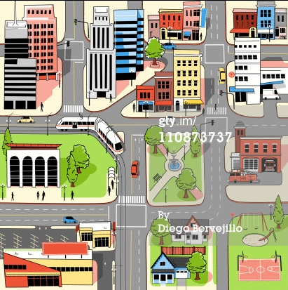



**YOU ARE HERE**



* Take the second street on your right.
* Take the next street on your left.
* Take the next street on your right.
* The library is on the right side of the road.



**Als juist: You have reached your destination!**

**Als fout eerste keer: Try again. Take a look at which streets you must enter.**

**Als fout tweede keer: No, the library is here.**

Where do you need to go? You just saw a film in the cinema. Now you want to go boating in the park. You do not know how to get from the cinema to the park. You enter the address of the park in your GPS. Can you find the entrance of the park? Click on the entrance of the park.

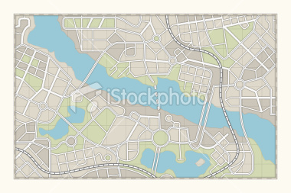

**YOU ARE HERE**

* Take the next street on your right.
* Take the third street on your left.
* Take the first exit on the roundabout.
* Take the second street on your left.
* Make a slight bend to the right.
* Take the first street on your left.
* The entrance of the park is on the left side of the road.





* Take the next street on your right.
* Take the third street on your left.
* Take the first exit on the roundabout.
* Take the second street on your left.
* Make a slight bend to the right.
* Take the first street on your left.
* The entrance of the park is on the left side of the road.



**Als juist: You have reached your destination!**

**Als fout eerste keer: Try again. Take a good look at the GPS instructions.**

**Als fout tweede keer: No, the entrance of the park is here.**

**Evaluation phase**

We are almost done! Have you learned something? Let's see what you remember!

1. What can you find on a road map?
2. streets of a district
3. motorways
4. parks
5. places to eat

**Als juist: Good job!**

**Als fout: Wrong, a road map shows motorways.**

1. Which map should you use if you want to walk through the Nature & Culture Park in Hasselt?
2. physical map
3. street map
4. political map
5. map

**Als juist: Good job!**

**Als fout: Wrong, to walk through the park it is best to use the map.**

1. Which statement about public transport is false?
2. Everyone can use public transport.
3. The buses, trams and metros of the STIB ride all over Belgium.
4. Trains are part of public transport.
5. The tram is the best form of public transport to take you from the Groenplaats to the Central Station in Antwerp.

**Als juist: Good job!**

**Als fout: Wrong. The buses, trams and metros of the STIB only ride in Brussels.**

1. Which statement about the GPS is true?
2. The GPS was developed by Galileo Galilei.
3. In order for a GPS to work we need rockets that fly around the earth.
4. You only find GPS devices in cars.
5. A GPS receiver uses signals from satellites to calculate your location on earth.

**Als juist: Good job!**

**Als fout: Wrong, a GPS receiver picks up signals from satellites. This makes it possible to calculate your location on earth.**