TOPIC: ORIENTATION

Subtopic 2: Mapping the world
Teaching phase 1: Making maps… How do you do that?
Application phase 1: Making maps… How do you do that?
Teaching phase 2: A legend is useful
Application phase 2: A legend is useful
Teaching phase 3: Treasure in sight!
Application phase 3: Treasure in sight!

Pre-test

Hello there! Do you know how maps are made and who makes them? You will discover that today! First answer these questions to see if you already know something about it.

- Which statement is true?
- Maps don't change anymore because we already know the whole world.
- Mercator is the inventor of the GPS.
- Natural disasters can make pieces of land disappear into the sea and can also create new land.
- Maps can only be used to find your way.

- What is the legend of a map?
- The legend provides a code that helps you find every street on the map.
- The legend shows the most important places of interest in a city.
- The legend shows who made the map.
- The legend shows the meaning of a symbol or colour on the map.

- Where is the elephant on this map?
- C2
- B2
- C1
- E4

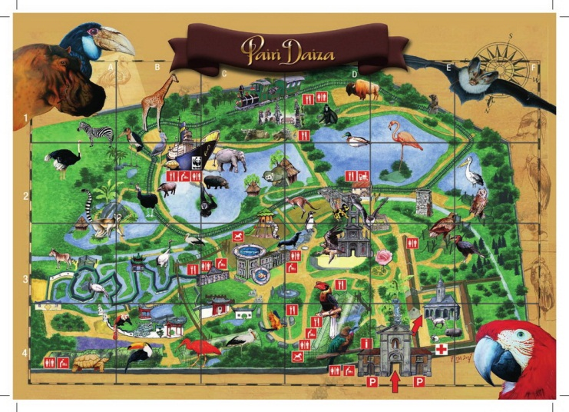

- Here is part of a street names index. Where can you find Lijsterbeslaan?
- On map D in square 9.
- On map 9 in square D.
- On map 1 in square D9.
- On map D9 in square 1.

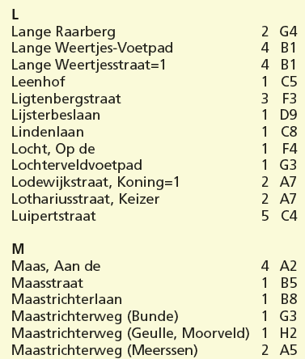

- What can you find where the arrow points?
- A rental point for wheelchairs.
- A lift for disabled people.
- A repair point for wheelchairs.
- A toilet for disabled people.
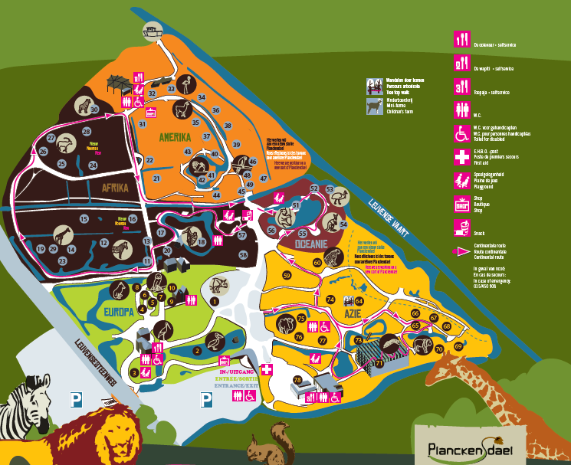

Teaching phase 1: Making maps… How do you do that?

How can you find your way in a place where you have never been? With the help of a map!
Maps give you an overview of an area such as a country, a city or an amusement park. They offer a wealth of information. There are lots of different kinds of maps: you have country maps, road maps, weather maps, tube maps, aviation maps, etc. There are even maps of the ocean floor. All these maps are made by cartographers.
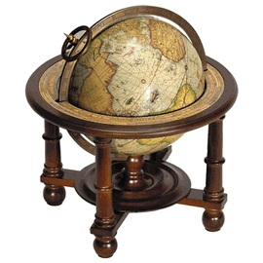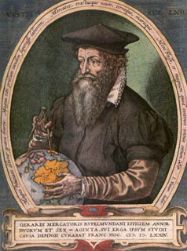
One of the most famous cartographers is Mercator. He was born in Rupelmonde, which is between Ghent and Antwerp, in 1512. Mercator was a very smart man. He was the first to use the word ‘atlas’. He used that word to refer to a book with a collection of maps of the world. We still use that word today, 500 years later. Mercator also made various globes and world maps. Even the maps that we use today in the GPS are based on his work. As you can tell, Mercator was a real genius.

You might think that we do not need cartographers anymore. We know the whole world, don't we? Well the earth is changing all the time: new streets are created, people change the borders and names of countries, natural disasters destroy pieces of coastline or islands, etc. Cartographers must map all these changes. They use aerial photos, which are made out of an airplane or by a satellite. The cartographer puts all the important information found in the picture on the map. Roads, rivers, parks and buildings are shown simply. Anything that is temporary, such as cars and people, is not shown on the map.

DID YOU KNOW…that new land can also be created? A new island appeared along the coast of Iceland in 1963. It was pushed up by volcanic eruptions on the ocean floor. The island was named Surtsey, which refers to the old Norse god of fire. 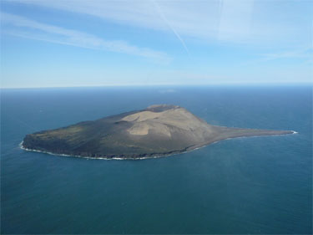 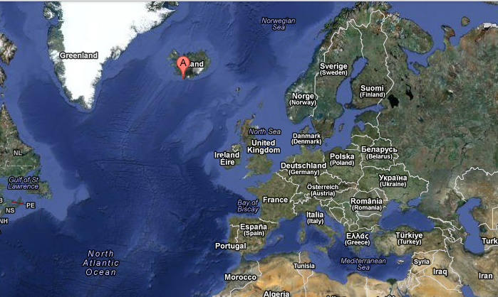

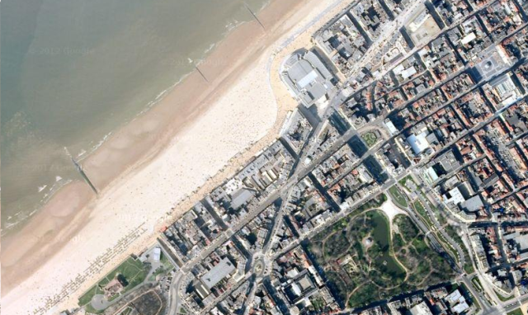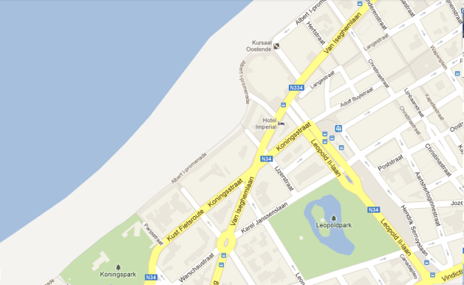

Application phase 1 (application 1): Making maps… How do you do that?

Imagine that you are a real cartographer! Cartographers make maps from photos. Can you match each satellite photo to its corresponding map?
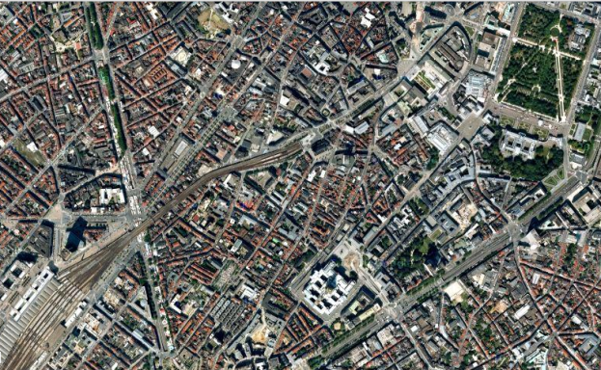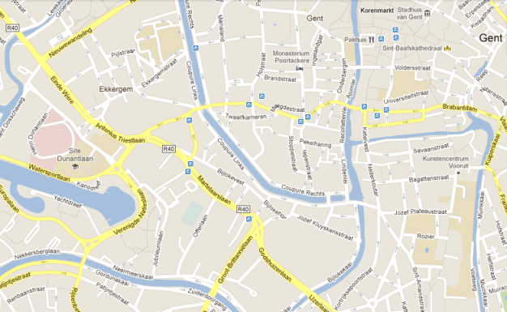
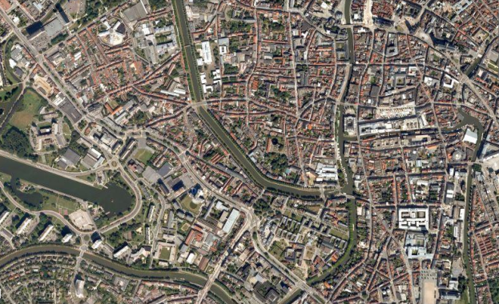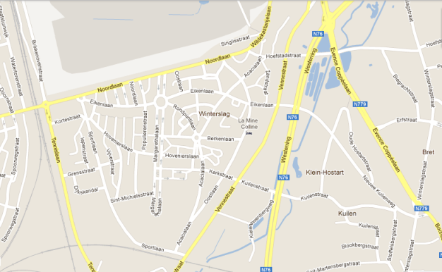
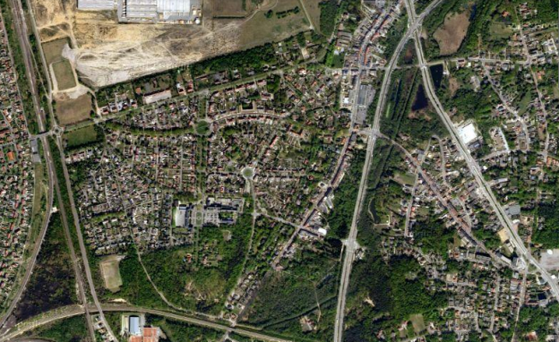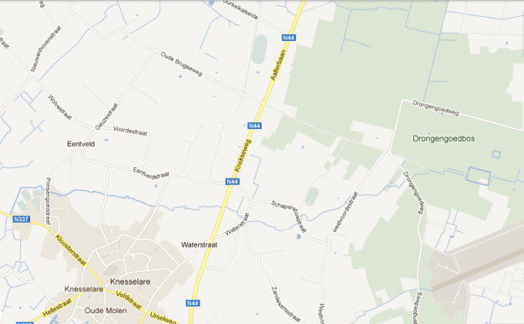
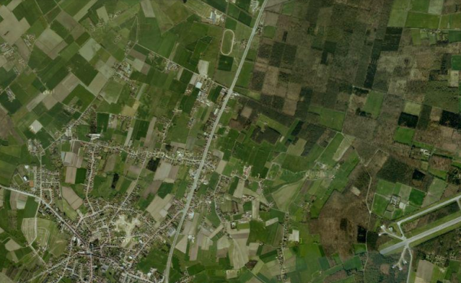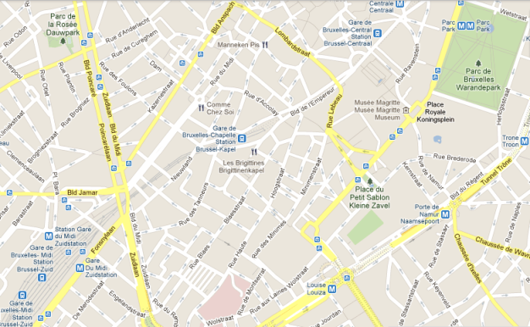

Als juist: Good job! You are a real cartographer!

Als fout eerste keer: Try again. Take a good look at the major roads and the rivers on the satellite photos.

Als fout tweede keer: You need to practice a bit more. Next time pay more attention to the roads, rivers and forests on the satellite photo.

Application phase 1 (application 2): Making maps… How do you do that?

The world is changing all the time. Do you think that cartographers should change their maps in the following situations?

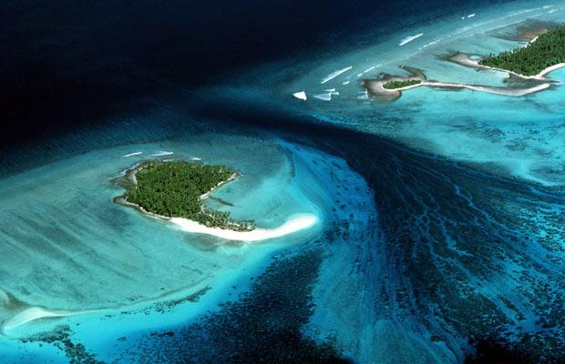

The island Kiribati is located in the Pacific Ocean. The sea level is rising very quickly due to global warming. The island is in danger of disappearing under water.



Als juist: Good advice!

Als fout: Wrong. The island is becoming smaller as the earth warms up. Cartographers must draw the island smaller on the map. If, in the future, the island is completely under water then cartographers will have to show this on the map.
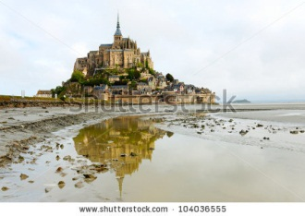

Mont Saint-Michel is a small, rocky peninsula in France. It is famous for the huge differences between high tide and low tide. At low tide you can walk around the island, but at high tide the island is completely surrounded by water.

Als juist: Good advice!

Als fout: Wrong. The change between high tide and low tide is a natural phenomenon that happens twice a day, every day. Cartographers do not have to change the maps.

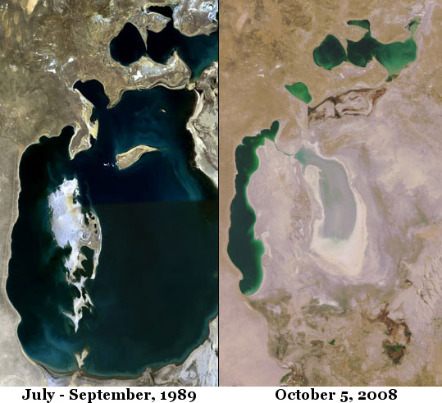

Over the years, the Aral Sea in Asia has dried up almost completely. People use the water from the sea to water their cotton fields.

Als juist: Good advice!

Als fout: Wrong. The Aral Sea is getting smaller because it is drying up. Cartographers must show a smaller sea on the map.
The world is changing all the time. Do you think that cartographers should change their maps in the following situations?
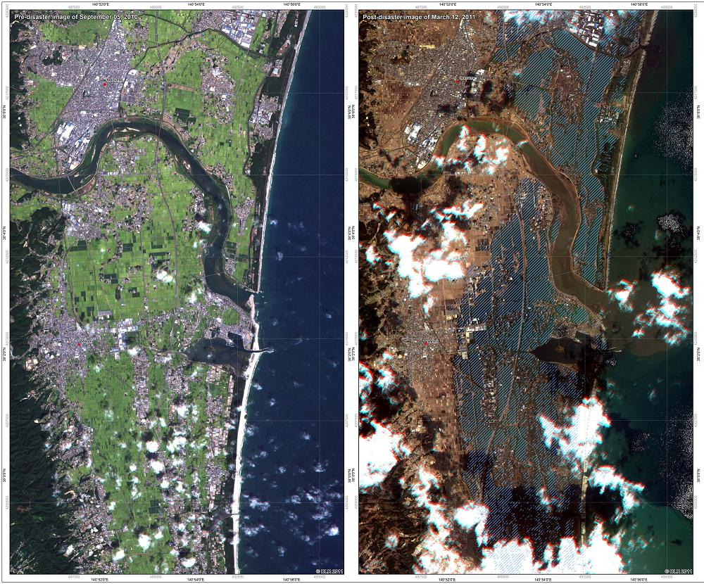

Japan was struck by a tsunami on 12 March 2011. A tsunami is a tidal wave that comes ashore and is caused by a seaquake. Large parts of the Japanese coast were destroyed. Factories were hit and houses were destroyed.
AFTER

BEFORE

Als juist: Good advice!

Als fout: Wrong. Cartographers will have to change the coastline on the maps, show which parts of the factories have been destroyed, and show where houses used to stand.

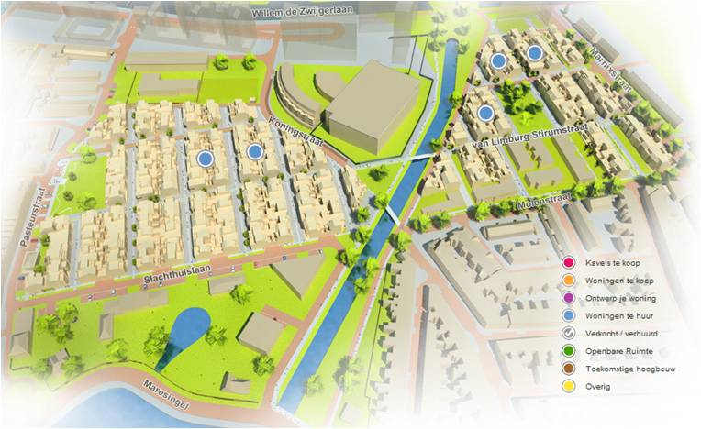

A new neighbourhood is being built near Hasselt. There is room for houses, parks and shops.

Als juist: Good advice!

Als fout: Wrong. Cartographers will have to show the new streets on the maps.

Teaching phase 2: A legend is useful

To read a book we must understand the language it is written in. The same is true of a map: to be able to read a map you must understand the language it is made in. You probably already noticed that there are lots of colours and symbols on maps. Have you ever wondered what those colours and symbols mean?
The colours on a map show what an area is used for. On this map you can immediately see where the park is: every park is shown in green. The areas with houses have a light grey colour. The places with offices are shown in dark grey.
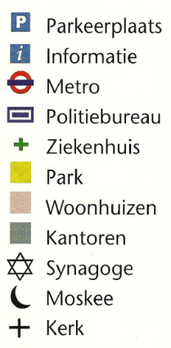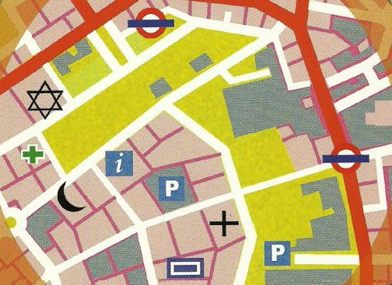
Maps also include lots of symbols. A symbol is a drawing with a certain meaning. Symbols allow you to show things on a map without having to make detailed drawings. That way you can easily see what a building is used for, where you can park your car or get on the metro. Many symbols are universal. That means they are used all over the world.
Just think of the P for parking or the cross for a hospital. That way people who speak a different language can find their way as well. Handy, don't you think? Can you find the information stand, the hospital and the police station on the map?
Some frequently used symbols
 Capital

City

Border

River
If you do not know what a symbol on the map means, you can always look it up in the legend. The legend explains all the symbols and colours. That way we know what the map is showing us. The legend is usually located on the side or the bottom of the map.

Car park
Information
Metro
Police station
Hospital
Park
Houses
Offices
Synagogue
Mosque
Church

Application phase 2 (application 1): A legend is useful

Can you help the children find what they are looking for? Point out the correct place on the map.

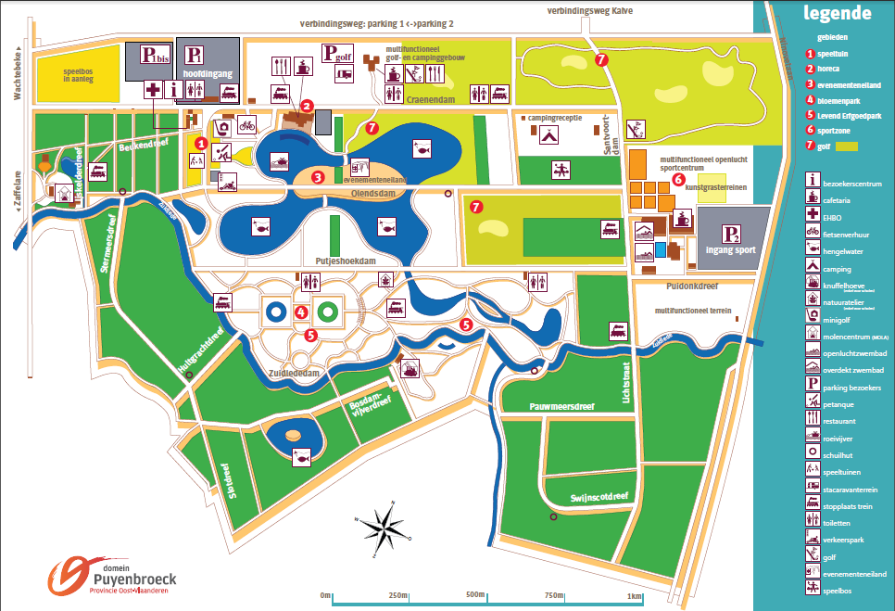
Chang hurt his foot while playing. Someone needs to look at it fast. Show Chang where he can find the first aid post.

legend

areas
1. playground
2. restaurants
3. events island
4. flower park
5. Living Heritage park
6. sports zone
7. golf

visitor's centre
cafeteria
First aid
bicycle rental
fishing pond
camp site
petting farm (only for schools)
nature workshop (only for schools)
miniature golf
windmill centre (MOLA)
outdoor swimming pool
indoor swimming pool
car park for visitors
petanque
restaurant
rowing pond
lodge
playgrounds
caravan plot
train halt
toilets
traffic park
golf
events island
amusement forest

Als juist: Good job!

Als fout eerste keer: Try again. Take a good look at the legend.

Als fout tweede keer: Wrong, the first aid post is here. Better luck next time!

Soraya and Louise are learning all about the traffic regulations and how to be safe in traffic in the traffic park. Can you show their friend Lars where they are?

Als juist: Good job!

Als fout eerste keer: Try again. Take a good look at the legend.

Als fout tweede keer: Wrong, the traffic park is here. Better luck next time!

Luna really needs to go to the toilet. She is at the outdoor swimming pool. Can you point out the closest toilet?

Als juist: Good job!

Als fout eerste keer: Try again. Take a good look at the legend.

Als fout tweede keer: Wrong, the closest toilet is here. Better luck next time!

Joaquin wants to play a round of miniature golf with his friends. Can you show them where they need to be?

Als juist: Good job!

Als fout eerste keer: Try again. Take a good look at the legend.

Als fout tweede keer: Wrong, the closest toilet is here. Better luck next time!

Application phase 2 (application 2): A legend is useful

Make your own legend! Can you come up with a symbol for the following words? Keep it simple and don't forget that people who speak a different language must be able to understand it as well. Try it! Here is one symbol for you.

swimming pool


railway

Good try!

windmill

Good job!

playground

Well done!

picnic area

Good try! Who knows, perhaps one of your symbols will be used on the legend of a map one day.

Application phase 2 (application 3): A legend is useful

Have you seen these symbols before? Connect each symbol with the correct explanation.

Airport

Hospital

Crossing

Railway

Public telephone

Internet access

Restaurant

Campsite









Als juist: Well done!

Als fout eerste keer: Try again. Think logically!

Als fout tweede keer: Oops. Better luck next time.

Teaching phase 3: Treasure in sight!

How can you look up where you are or where a certain place is? You use the grid that is drawn on the map. The grid is made up of horizontal and vertical lines, dividing the map into squares. Each square has a unique code. This code is called the coordinates. If you know the coordinates of a street or of the place where a treasure chest is buried then it is easy to find the right place on the map and draw out the path you must follow. How does that work? Those of you who have played the game Battleships already know how it works.

USING A GRID FOR DUMMIES
We heard that there is a treasure buried in the boat house at the Provincial Domain Zilvermeer. The boat house is in square E4 on the map. Can you find it?
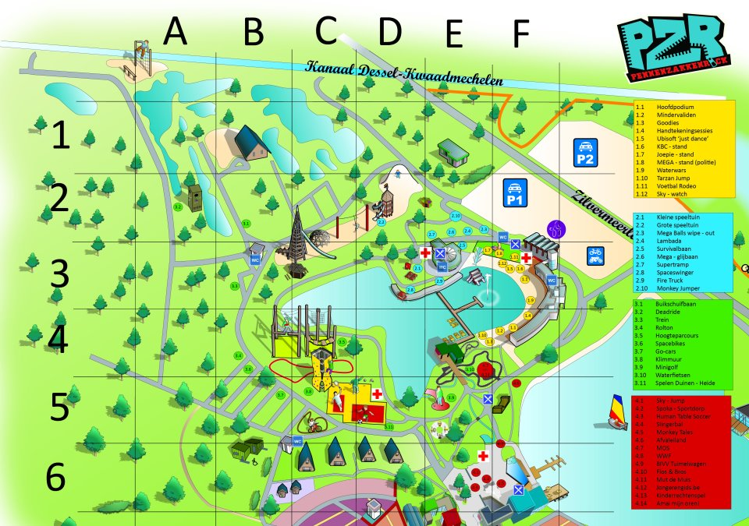

- First look at the top of the grid. Look for the column with the letter E.
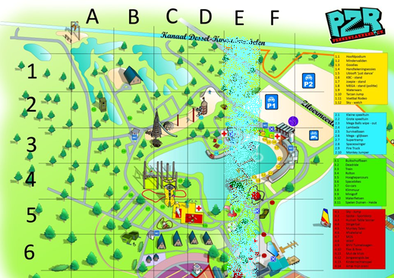

- Then look at the left side of the grid. Look for the row with the number 4.
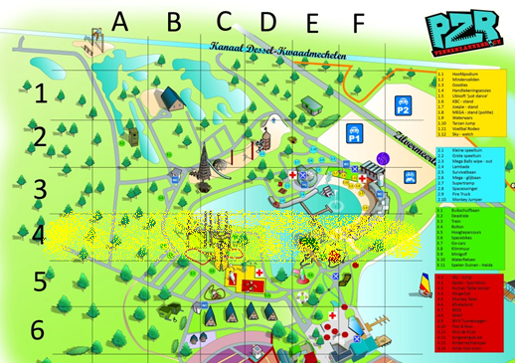

- The square where column E and row 4 come together is E4. That's where we find the boat house… and hopefully the treasure. It's that easy!
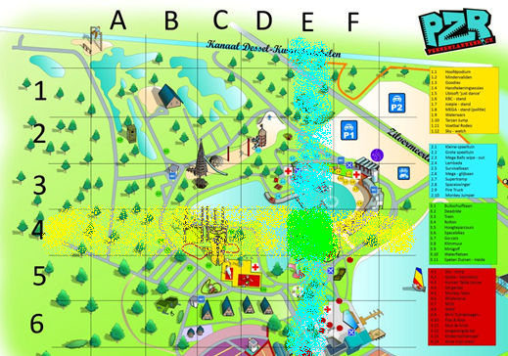
We can point out anyplace on earth in exactly the same way. The grid is also handy for looking up streets on a street plan. A street plan has a street names index, a list of all streets that you can find on the map. The street names are listed in alphabetical order from A to Z. After each street name you find the number of the map that the street is on and the unique code of the square where the street is located.
Number of the map
Number of the map
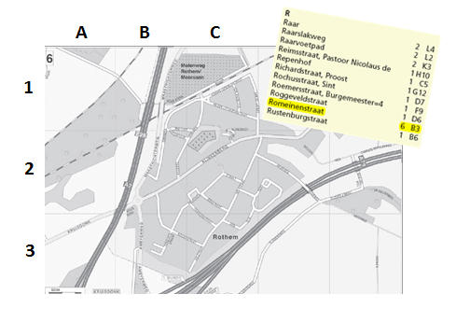
Code of the square
Application phase 3 (application 1): Treasure in sight!

Lets' go on a treasure hunt! Can you find all the objects on this treasure map? Combine the correct letter and the correct number to find the square.
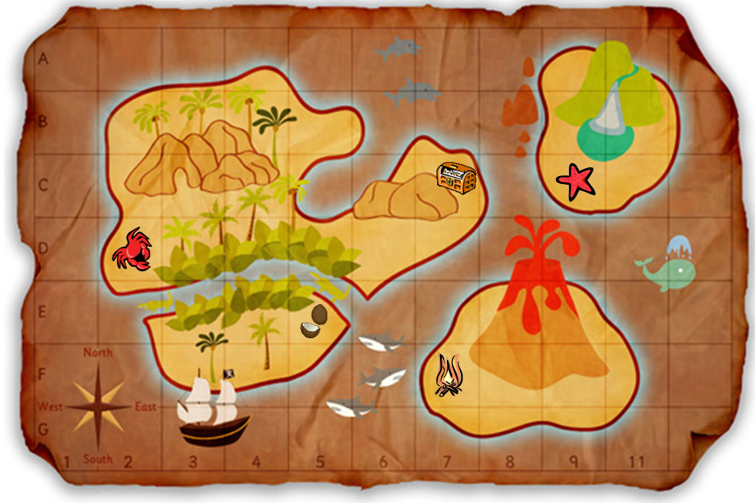
In which square do you find the crab?

A

B

C 1

D 2

E 3

F 4

G 5

H 6

I 7

J

K

Als juist: Good job!

Als fout eerste keer: Try again. First look at the column that the crab is in, then look at the row. Combine the letter of the column with the number of the row.

Als fout tweede keer: Oops, the crab is in column B and row 4, so in square B4.

In which square do you find the starfish?

A

B

C 1

D 2

E 3

F 4

G 5

H 6

I 7

J

K
Als juist: Good job!

Als fout eerste keer: Try again. First look at the column that the starfish is in, then look at the row. Combine the letter of the column with the number of the row.

Als fout tweede keer: Oops, the starfish is in column I and row 3, so in square I3.

In which square do you find the campfire that the pirates left behind?

A

B

C 1

D 2

E 3

F 4

G 5

H 6

I 7

J

K
Als juist: Good job!

Als fout eerste keer: Try again. First look at the column that the campfire is in, then look at the row. Combine the letter of the column with the number of the row.

Als fout tweede keer: Oops, the campfire is in column G and row 6, so in square G6.

In which square do you find the coconuts?

A

B

C 1

D 2

E 3

F 4

G 5

H 6

I 7

J

K

In which square do you find the treasure chest? (Answer: G3)
Als juist: Good job!

Als fout eerste keer: Try again. First look at the column that the coconuts are in, then look at the row. Combine the letter of the column with the number of the row.

Als fout tweede keer: Oops, the coconuts are in column E and row 5, so in square E5.

In which square do you find the treasure chest?

A

B

C 1

D 2

E 3

F 4

G 5

H 6

I 7

J

K

Als juist: Good job!

Als fout eerste keer: Try again. First look at the column that the treasure chest is in, then look at the row. Combine the letter of the column with the number of the row.

Als fout tweede keer: Oops, the treasure chest is in column G and row 3, so in square G3.

Application phase 3 (application 2): Treasure in sight!

On a deserted island… You and your friends are on a deserted island. Everyone is very hungry. Luckily there are a few good things to eat on the island. Can you collect everything to make a delicious meal? Click on the right square.
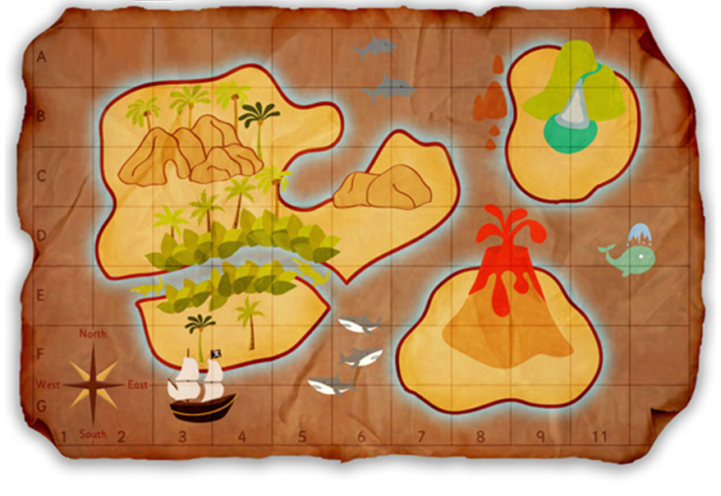
Go on land in square D6.

Als juist: Good job!

Als fout eerste keer: Try again. First find column D then row 6. The place where the column and the row come together is square D6.

Als fout tweede keer: Oops, you must go on land here.

You need wood to make a fire. You can find wood in square B4.
Als juist: Good job!

Als fout eerste keer: Try again. First find column B then row 4. The place where the column and the row come together is square B4.

Als fout tweede keer: Oops, you can find wood here.

The previous island visitors left some matches behind. The matches will come in handy for your campfire. Go get them in square I6.
Als juist: Good job!

Als fout eerste keer: Try again. First find column I then row 6. The place where the column and the row come together is square I6.

Als fout tweede keer: Oops, you can find the matches here.

Delicious fish swims in the sea. Try to catch a few fish in square E3.
Als juist: Good job!

Als fout eerste keer: Try again. First find column E then row 3. The place where the column and the row come together is square E3.

Als fout tweede keer: Oops, you can find the fish here.

You are all very thirsty. Luckily there is a water source on the island with pure water. Collect some water in square J2.
Als juist: Good job!

Als fout eerste keer: Try again. First find column J then row 2. The place where the column and the row come together is square J2.

Als fout tweede keer: Oops, the water source is here.

Feedback after entire exercise: Fantastic! You collected wood, matches, fish and water. You saved your friends from starving to death! Go ahead and cook your fish. Enjoy your meal!

Application phase 3: Treasure in sight!

Can you help me find the street I am looking for? Click on the right answer.

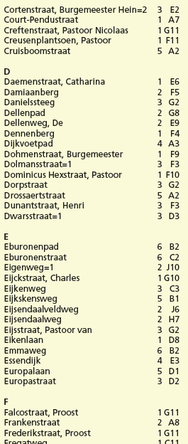
I am looking for the street Dennenberg.
- I find this street on map 1 in square F4.
- I find this street on map 1 in square F9.
- I find this street on map 2 in square E9.
- Dennenberg is not in this street names index.

Als juist: Good job!

Als fout eerste keer: Try again. Are you looking at the right line?

Als fout tweede keer: No, Dennenberg is located on map 1 in square F4.

I am looking for the Europalaan.
- I find this street on map 1 in square D.
- I find this street on map D in square 1.
- I find this street on map 5 in square D1.
- The Europalaan is not in this street names index.
Als juist: Good job!

Als fout eerste keer: Try again. The first number is the map number.

Als fout tweede keer: No, the Europalaan is located on map 5 in square D1.

I am looking for the Gasthuisstraat.
- I find this street on map 1 in square G11.
- I find this street on map 3 in square E2.
- I find this street on map 1 in square H11.
- The Gasthuisstraat is not in this street names index.

Als juist: Good job!

Als fout eerste keer: Try again.

Als fout tweede keer: No, the Gasthuisstraat is not in this street names index.

I am looking for the Henri Dunantstraat.
- I find this street on map 3 in square F.
- I find this street on map 3 in square D3.
- I find this street on map 3 in square F3.
- The Henri Dunantstraat is not in this street names index.

Als juist: Good job!

Als fout eerste keer: Try again. Street names with the name of a person are always ordered based on the last name of the person.

Als fout tweede keer: No, the Henri Dunantstraat is in the street names index under the letter D for Dunant. The street is on map 3 in square F3.

Evaluation phase

Well done! Can you answer these questions to show what you learned?

- Where on the map can you find what this symbol means?
- In the street names index.
- In the legend.
- On the back of the map.
- In the upper left corner of the map.



Als juist: Good job!

Als fout: Oops! You find the meaning of symbols in the map's legend.

- Where on the map is the treasure if you know that the treasure is marked with a cross?
- F8
- C4
- A1
- D5
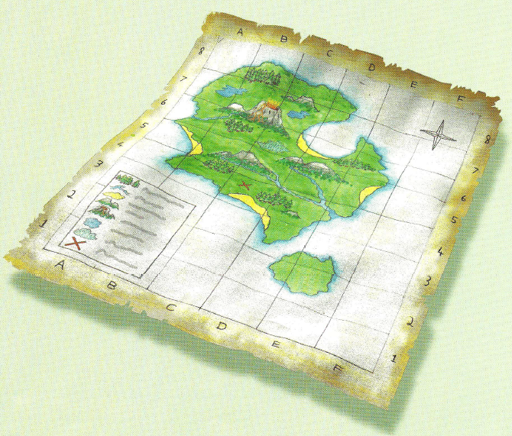
Als juist: Good job!

Als fout: Oops! The cross is in column C and row 4. So the treasure is hidden in square C4.

- Which statement about cartographers is false?
- The job of cartographer does not exist anymore.
- A cartographer makes a map out of aerial photos.
- Mercator was a cartographer.
- The people, cars and bicycles that are on the aerial photo do not have to be drawn on the map.

Als juist: Good job!

Als fout: Oops! The job of cartographer still exists. The earth is changing all the time: new streets are created, people change the borders and names of countries, natural disasters destroy pieces of coastline or islands, etc.

- Here is part of a street names index. Where can you find the Ingendaalstraat?
- On map B in square 6.
- On map 1 in square B6.
- On map 1 in square C7.
- The Ingendaalstraat is not found in this part of the street names index.

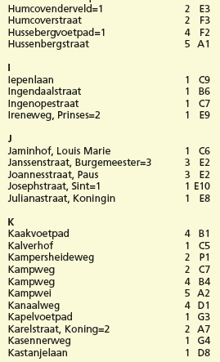
Als juist: Good job!

Als fout: Oops! The Ingendaalstraat is on map 1 in square B6.
- What can you find where the arrow points?
- A market.
- An ice cream stand.
- A podium.
- A fair.

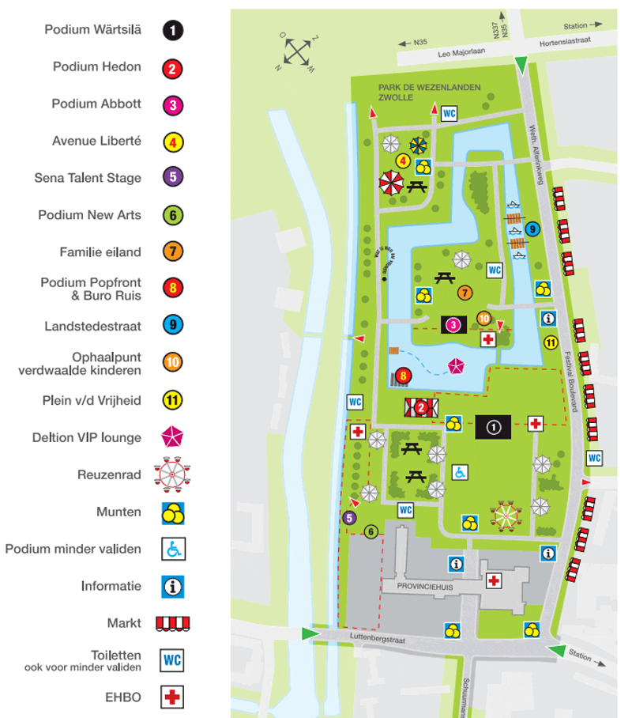
Podium Wärtsilä
Podium Hedon
Podium Abbott
Avenue Liberté
Sena Talent Stage
Podium New Arts
Family island
Podium Popfront & Buro Ruis
Landstedestraat
Collection point lost children
Liberty Square
Deltion VIP lounge
Ferris wheel
Coins
Podium for disabled
Information
Market
Toilets
also for disabled people
First aid

Als juist: Good job!

Als fout: Oops! If you look at the legend, you see that the symbol stands for a market.

