**TOPIC: ORIENTATION**

**Subtopic 1: NESW… What?**

Teaching phase 1: Orientation?!

Application phase 1: Orientation?!

Teaching phase 2: Memory aid

Application phase 2: Memory aid

Teaching phase 3: How does a compass work?

Application phase 3: How does a compass work?

**Pre-test**

1. The arrow on this drawing points at which point on the compass?
2. southwest
3. northeast
4. northwest
5. southeast

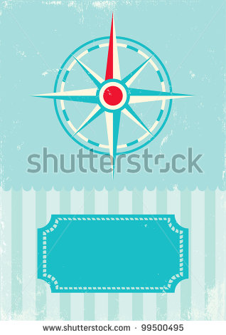

1. The correct order of the cardinal directions is:
2. north – east – west – south
3. north – south – east – west
4. north – east – south – west
5. north – west – south – east
6. Which statement about a compass is correct?
7. A compass helps you find your direction compared to the north.
8. Depending on the place where you stand, the compass will show a different direction.
9. You must never hold a compass too close to water, otherwise it will spin like crazy.
10. The compass was invented in Europe.
11. Where is the North Pole? The compass will help you.

**1**

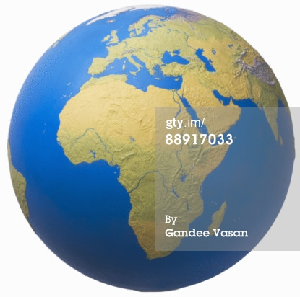 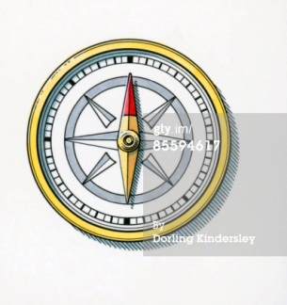

**4**

**2**

**3**

1. At point 1.
2. At point 2.
3. At point 3.
4. At point 4.

**Teaching phase 1: Orientation?!**



It's not always easy to find your way. It helps if you know which direction you need to go. To know that, you must orient yourself. Orienting yourself means that you try to find a place and try to find a direction that will bring you to that place. Various instruments help you with this.

We are going to show you a few of these instruments.

To orient yourself, you must understand the compass rose. That is a star that shows directions. The most important directions are the four cardinal directions: north, east, south and west. We always start at the top with north. Then we go clockwise and add east, south and west.

NORTH

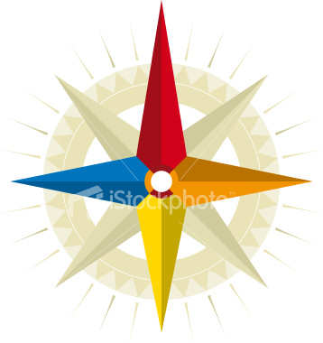

WEST

SOUTH

EAST

Between each of these cardinal directions there is an intermediate direction. These intermediate directions allow you to be more exact about where a place is located or where the wind comes from. Which intermediate direction is located between the directions north and east? Northeast. And between the directions east and south? Southeast.

NORTH



northwest

southwest

southeast

northeast

WEST

SOUTH

EAST

Did you notice that each intermediate direction is a combination of two cardinal directions? First you check if the intermediate direction is closest to the south or the north of the compass rose. Then you decide if the intermediate direction is closest to the east or the west of the compass rose. Then you combine these two cardinal directions, which will give you the intermediate direction!

**Application phase 1 (application 1): Orientation?!**

Do you know which cardinal direction is located where you see a circle?

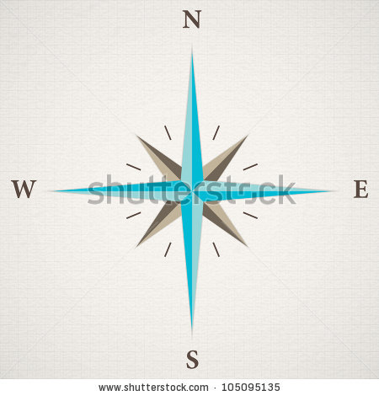

* north
* west
* south
* east

**Als juist: Congratulations!**

**Als fout eerste keer: Try again.**

**Als fout tweede keer: That's not correct. North is always placed at the top of the compass rose.**



* north
* west
* south
* east

**Als juist: Good job!**

**Als fout eerste keer: Try again.**

**Als fout tweede keer: Better luck next time! West is on the left side of the compass rose.**



* north
* west
* south
* east

**Als juist: Good job!**

**Als fout eerste keer: Try again.**

**Als fout tweede keer: Better luck next time! East is on the right side of the compass rose.**

**Application phase 1 (application 2): Orientation?!**

Now let's try the same thing with the intermediate directions. On the first few exercises we will show you the cardinal directions.



* northeast
* southwest
* southeast
* northwest

WEST

SOUTH

EAST

NORTH

**Als juist: Well done!**

**Als fout eerste keer: Try again. First check if the intermediate direction is closest to the north or the south. Then check if the intermediate direction is closest to the east or the west. Combine the two cardinal directions.**

**Als fout tweede keer: The intermediate direction is closest to the north and the west. The correct answer is northwest.**



* northeast
* southwest
* southeast
* northwest

WEST

SOUTH

EAST

NORTH

**Als juist: Well done!**

**Als fout eerste keer: Try again. First check if the intermediate direction is closest to the north or the south. Then check if the intermediate direction is closest to the east or the west. Combine the two cardinal directions.**

**Als fout tweede keer: The intermediate direction is closest to the south and the east. The correct answer is southeast.**



* northeast
* southwest
* southeast
* northwest

**Als juist: Well done!**

**Als fout eerste keer: Try again. First check if the intermediate direction is closest to the north or the south. Then check if the intermediate direction is closest to the east or the west. Combine the two cardinal directions.**

**Als fout tweede keer: The intermediate direction is closest to the south and the west. The correct answer is southwest.**



* northeast
* southwest
* southeast
* northwest

**Als juist: Well done!**

**Als fout eerste keer: Try again. First check if the intermediate direction is closest to the north or the south. Then check if the intermediate direction is closest to the east or the west. Combine the two cardinal directions.**

**Als fout tweede keer: The intermediate direction is closest to the north and the east. The correct answer is northeast.**

**Application phase 1 (application 3): Orientation?!**

This compass rose is really pretty, but the maker forgot something crucial! Can you put the directions in the right place?

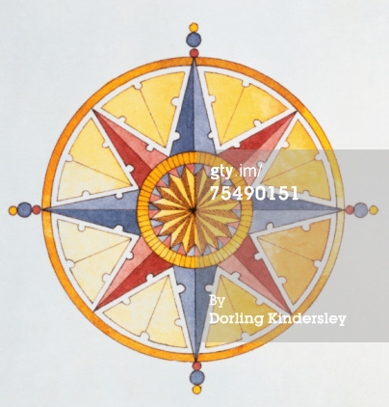

northeast

east

southwest

north

northwest

southeast

south

west

**Als juist: Good job! You put all the directions in the right place!**

**Als fout eerste keer: Try again. Don't forget that north is at the top of the compass rose.**

**Als fout tweede keer: That's not completely correct. Take a good look at the solution before you continue.**

**Teaching phase 2: Memory aid**

Do you know how to remember the right order of the directions?

To help you remember which direction comes after north or south you can use a memory aid. That is an easy way to help you remember something difficult. For example, to know which direction comes after east you can try this memory aid: ‘Naughty Elephants Squirt Water’. How do you do that?

A MEMORY AID STEP-BY-STEP

The following steps help you on your way:

1. You put the directions in the right order, just like on the compass rose. That is:

north – east – south – west

1. You take the first letter of each direction: N, E, S and W.
2. Now look for a new word for each letter and put those words together into a sentence. Be sure to put the four words in the right order and make an understandable sentence.

For example:

N Naughty

E Elephants

S Squirt

W Water

1. Result: Naughty Elephants Squirt Water. Now you will never forget the order of the directions! Now you also know which direction comes after east: south!



**Application phase 2 (application 1): Memory aid**

Can you think up another memory aid to help you remember the directions? Give it a try!

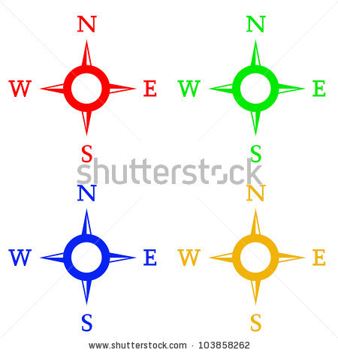

**Thank you! We will try that one to remember the directions.**

**Application phase 2 (application 2): Memory aid**

Can you connect each abbreviation with the correct direction?

|  |  |
| --- | --- |
| NW | west |
| S | northwest |
| E | north |
| SW | east |
| NE | southeast |
| W | northeast |
| SE | southwest |
| N | south |

**Als juist: Good job! You are a pro!**

**Als fout eerste keer: Try again.**

**Als fout tweede keer: That's not completely correct. Take a good look at the right answers before you continue.**

**Teaching phase 3: How does a compass work?**

**A LONG HISTORY…**

The first real compass for orientation was invented by the Chinese in the 12th century. Later the Arabs brought the compass to Europe.

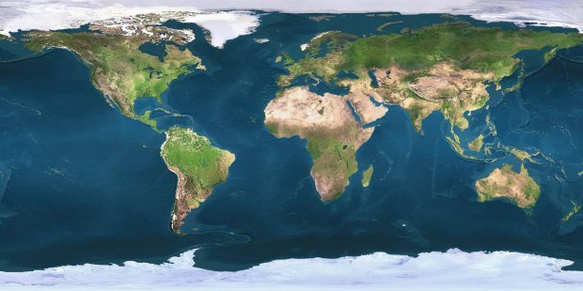

We know the directions and where they are on the compass rose. Now we can use a compass to orient ourselves and find our way. A compass allows you to find your direction compared to the north. That is handy if you are walking somewhere without traffic signs, if you walk through a forest, or if you are on a boat at sea. How does a compass work?

A compass is a handy instrument that shows you where north is. That way you also know where south, east and west are. Every compass has two parts, a compass rose and a magnetic needle.

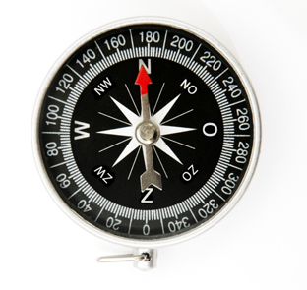

**WATCH OUT!**

Never hold a compass too close to a magnet or metal, for example a car or a container ship. If you do, the compass might not work!

N

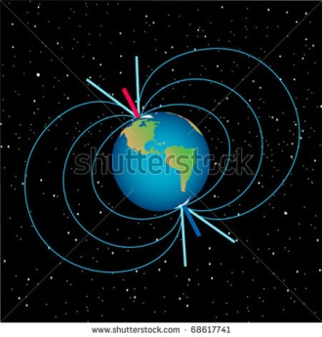

The compass rose shows the different directions.

The magnetic needle has a red arrowhead that can spin on the plate. If you lay the compass horizontally, for example on the ground, then the red arrowhead will always point to the north.

Why does the needle of the compass point to the north? The needle is magnetic. That means it has a north pole and a south pole. As you might know, the earth is also a big magnet with a North Pole and a South Pole. The compass always points in the direction of the North Pole. That's why the compass always shows where north is.

S

**Application phase 3 (application 1): How does a compass work?**

Can you point out the different directions on the compass?

Where is south?

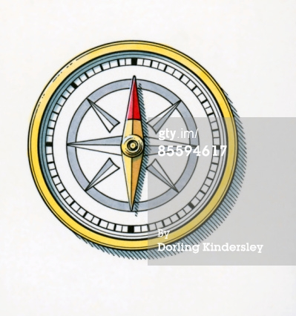

**Als juist: Congratulations!**

**Als fout eerste keer: Try again. Do you remember which direction the red arrowhead always points to?**

**Als fout tweede keer: Wrong, south is here. Imagine the compass rose and remember that the red arrowhead always points north.**

Where is east?



**Als juist: Congratulations!**

**Als fout eerste keer: Try again. Do you remember which direction the red arrowhead always points to?**

**Als fout tweede keer: Wrong, east is here. Imagine the compass rose and remember that the red arrowhead always points north.**

Where is northwest?



**Als juist: Congratulations!**

**Als fout eerste keer: Try again. Do you remember which direction the red arrowhead always points to?**

**Als fout tweede keer: Wrong, northwest is here. Imagine the compass rose and remember that the red arrowhead always points north.**

Where is north?



**Als juist: Congratulations!**

**Als fout eerste keer: Try again. Do you remember which direction the red arrowhead always points to?**

**Als fout tweede keer: Wrong, north is here. Imagine the compass rose and remember that the red arrowhead always points north.**

Where is southeast?



**Als juist: Congratulations!**

**Als fout eerste keer: Try again. Do you remember which direction the red arrowhead always points to?**

**Als fout tweede keer: Wrong, southeast is here. Imagine the compass rose and remember that the red arrowhead always points north.**

**Application phase 3 (application 2): How does a compass work?**

Where is the North Pole on this map? The compass will help you. Click on the North Pole.

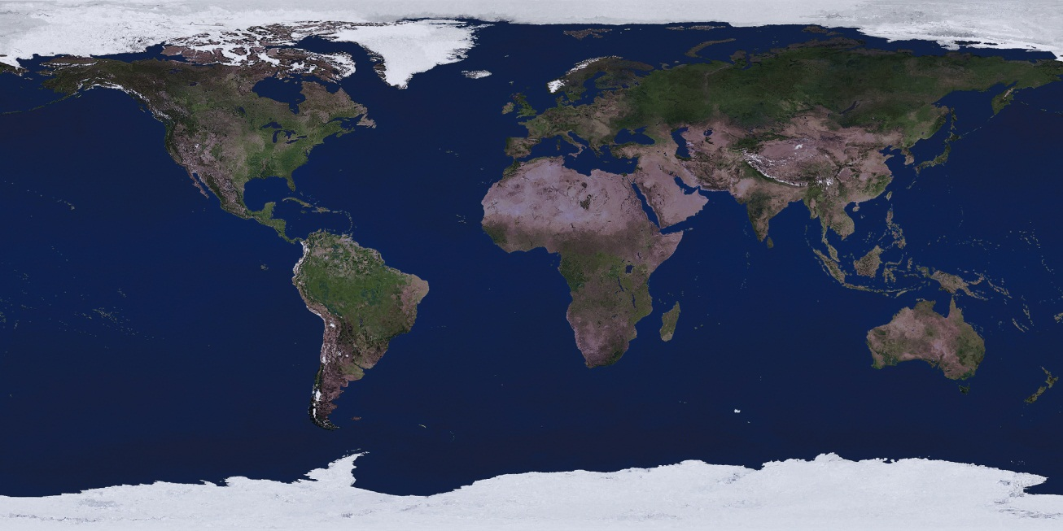

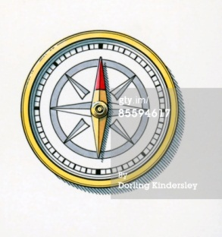

**Als juist: Well done!**

**Als fout eerste keer: Try again. Remember that the red arrowhead always points north.**

**Als fout tweede keer: Wrong, the North Pole is here. The compass always points north, in the direction of the North Pole.**

Where is the South Pole on this map? The compass will help you. Click on the South Pole.

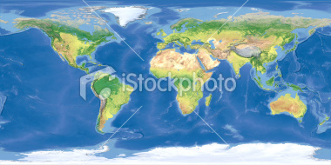



**Als juist: Well done!**

**Als fout eerste keer: Try again. Remember that south is across from north.**

**Als fout tweede keer: Wrong, the South Pole is here. The compass always points north, in the direction of the North Pole. South is across from north, so the South Pole is across from the North Pole.**

Where is the South Pole on this map? The compass will help you. Click on the South Pole.



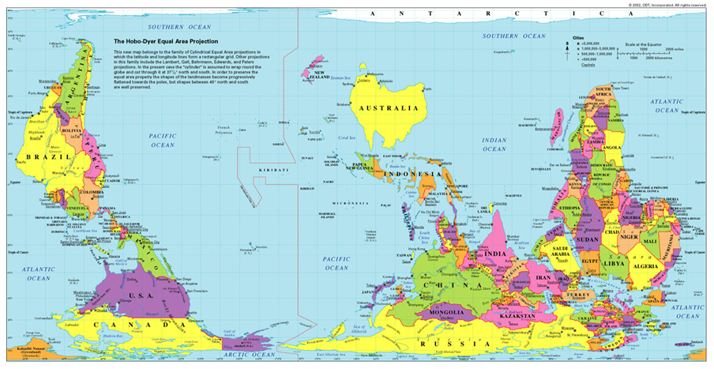

**Als juist: Well done!**

**Als fout eerste keer: Try again. Did you pay attention to the red arrowhead on the compass?**

**Als fout tweede keer: Wrong, the South Pole is here. The map is upside down. You can tell by looking at the compass: the red arrowhead points to the bottom, it points north.**

Where is the North Pole on this map? The compass will help you. Click on the North Pole.

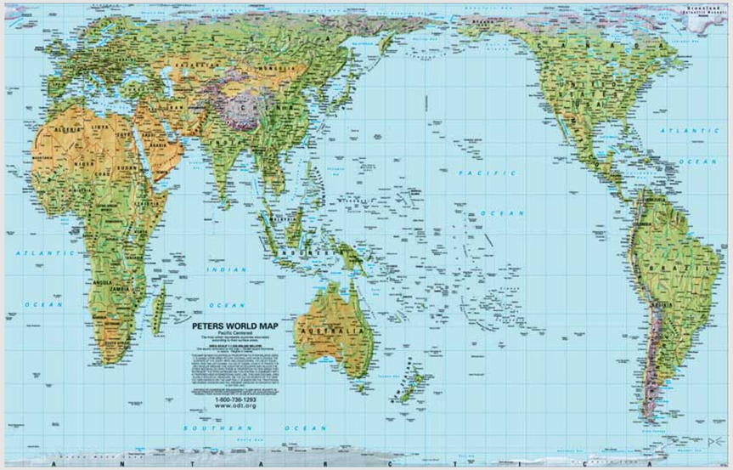



**Als juist: Well done!**

**Als fout eerste keer: Try again. Did you pay attention to the red arrowhead on the compass?**

**Als fout tweede keer: Wrong, the North Pole is here. The map is turned. You can tell by looking at the compass: the red arrowhead points north.**

**Evaluation phase**

1. The arrowhead on this drawing points at which direction?
2. southwest
3. northeast
4. northwest
5. southwest



**Als juist: Good job!**

**Als fout: Too bad, the arrowhead points southwest.**

1. The correct order of the cardinal directions is:
2. N – S – E – W
3. N – E – S – W
4. N – E – W – S
5. N – W – S – E

**Als juist: Good job!**

**Als fout: Oops! The correct order of the cardinal directions is north (N), east (E), south (S) and west (W).**

1. Which statement about a compass is false?
2. The compass was originally invented in China.
3. The red magnetic arrowhead on a compass always points north.
4. If you hold a compass close to metal then it always points north.
5. A compass has two parts: a magnetic needle and a compass rose.

**Als juist: Good job!**

**Als fout: What a pity. The sentence 'If you hold a compass close to metal then it always points north' is not correct. If you hold a compass close to metal then it spins out of control and cannot find north.**

1. Where is the South Pole? The compass will help you.

**1**

 

**4**

**2**

**3**

1. At point 1.
2. At point 2.
3. At point 3.
4. At point 4.

**Als juist: Good job!**

**Als fout: Oops! The South Pole is at point 3. You can tell by looking at the compass. The red arrowhead points north. South is across from north.**