**Topic: On the road**

Subtopic 2: Going to school in a different country

Phase 0: MC a

1. People with the same culture share…
2. … the same traditions, habits and language.
3. … the same hair colour and shoe size.
4. … the same surname.
5. What is the capital of the United States of America?
6. New York
7. Washington D.C.
8. London
9. Why are schools in different parts of the world a little bit different?
10. Because people in different countries speak different languages than people in Belgium.
11. Because people in different countries are not as smart as people in Belgium.
12. Because people in different countries have different habits than people in Belgium.

Phase 1: Lesson a

**Different cultures, what does that mean?**

Have you ever heard about a difference in culture? There are many different cultures all over the world.

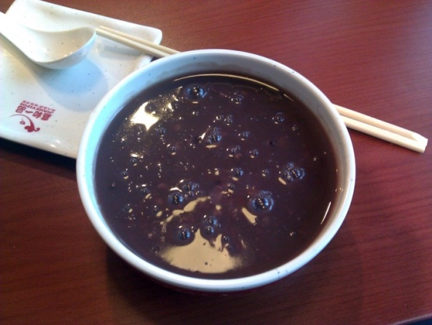What would it be like to go to school in a different country? These young people will tell you all about it!

**Every family has its own culture.**

Different cultures also exist within the same country. Every family has its own culture. In some families it is normal to eat breakfast in your pyjamas but that is not allowed in other families.

Schools in different cultures are also different. Weiyi from China, Brian from the United States of America, Güray from Turkey and Constanza from Argentina will tell us more about their schools. Maybe you will really like the habits of other cultures!

Let's look at an example! Belgians have a different culture than people in China.

For example, the Belgians do a lot of cycling but people cycle less in China. The Chinese eat rice soup for breakfast while the Belgians usually eat sandwiches or cornflakes. Want to know what rice soup looks like? Here is a photo of black rice soup.

One culture is not better than another, they are just different.

Every culture has pleasant and less pleasant parts.

**What is a culture?**

People that live and think in the same way are part of one culture.

That means that they share the same traditions, habits and language.

**Hello everybody! My name is Güray. I'm from Turkey. In Turkey we speak Turkish and the capital is Ankara. This is our flag:**

**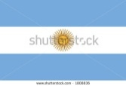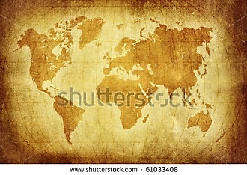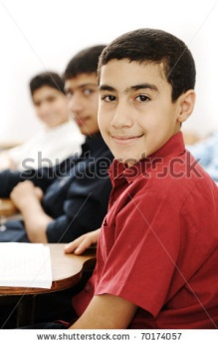**

**Hi everybody! My name is Weiyi. I'm from China. Beijing is the capital of China. China is located in Asia and we speak Chinese. This is our flag:**

**Hello! I'm Brian. I'm from the United States of America. You can also call it the US. The US is a very large country located in North America. In the US we speak English. The capital is Washington D.C. and this is our flag:**

**Hi everybody! My name is Constanza. My country is Argentina. Argentina is located in the southern part of South America. We speak Spanish in Argentina. The capital is Buenos Aires. This is our flag:**

Phase 2: Application a

## Drag everything to the correct country.

Brian, Constanza, Weiyi and Güray have taught us some things about their countries. Do you remember the capitals, flags and languages of the different countries? Teach your four international friends something about Belgium too. Drag all the words and flags to the correct column.

|  |  |  |  |  |
| --- | --- | --- | --- | --- |
| Weiyi from China | Constanza from Argentina | Güray from Turkey | Brian from the US | You from Belgium |
|  |  |  |  |  |
| Drag the Chinese **flag** here. | Drag the Argentine **flag** here. | Drag the Turkish **flag** here. | Drag the US **flag** here. | Drag the Belgian **flag** here. |
| Drag the **capital** of China here. | Drag the **capital** of Argentina here. | Drag the **capital** of Turkey here. | Drag the **capital** of the US here. | Drag the **capital** of Belgium here. |
| Drag the **language** that is spoken most often in China here. | Drag the **language** that is spoken most often in Argentina here. | Drag the **language** that is spoken most often in Turkey here. | Drag the **language** that is spoken most often in the US here. | Drag the **three** official **languages** of Belgium here. |

Beijing, Chinese, Buenos Aires, Spanish, Ankara, Turkish, Washington D.C., English

Brussels and Dutch, French, German

Als juist: Very good! You know the flags, capitals and languages of these countries very well.

Als fout eerste keer: Very good! But there are still a few things in the wrong place. Try to improve your answer.

Als fout tweede keer: Good try. They are not all correct. Take a good look at the correct answers and you will do better next time!

## C:\Users\avdrwild\AppData\Local\Microsoft\Windows\Temporary Internet Files\Content.Word\Private school in Kathmandu2.jpgSay Weiyi, what is school like in China?

Weiyi is from China. She goes to school in Shanghai. That is a very big city by the sea. About 23 million people live in Shanghai. That is twice as many people as in all of Belgium! This is Weiyi's school. It looks a bit like a chessboard, don't you think?

The children in Weiyi's school must wear a uniform. It is a red sweater with a white shirt and a black tie. Do you like it? Do you have to wear a uniform at your school? Write down what you think the ideal uniform looks like:

## Say Weiyi, what is school like in China?

There are nine other children in Weiyi's class. The photo shows her classmates. Would you like to be in such a small class? Tick the things that are good about a small class. You can tick three boxes.

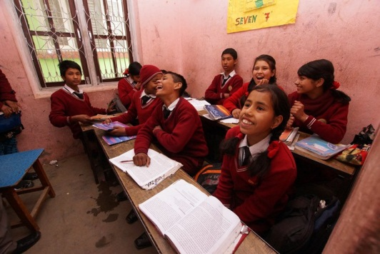 The teacher has enough time to answer everyone's questions.

The students can talk a lot because the teacher cannot keep an eye on everyone.

Everyone can see the blackboard at all times because there are only two rows in the class.

It feels good in the class because everyone knows each other.

I needn't worry if I have an argument with a classmate because there are still a lot of other students in the class.

Als juist: Good job! Everything is correct. Since there are very few students in the class, everyone can ask questions, see the blackboard properly, and everyone knows each other very well. The students cannot talk as much and arguments with classmates are very unpleasant.

Als fout eerste keer: You still have not ticked everything correctly. Take a good look and try to improve your answer.

Als fout tweede keer: Almost perfect! Since there are very few students in the class, everyone can ask questions, see the blackboard properly, and everyone knows each other very well. The students cannot talk as much and arguments with classmates are very unpleasant. Have a look at the correct answers.

## H:\Validiv\E-Validiv\thema onderweg\subthema cultuur\afbeeldingen\foto's school VS\IMG_1042.JPGHey Brian, what is school like in the US?

****

Brian is from the United States of America. He lives and goes to school in Washington D.C., the capital of the US. This is Brian's school. Shall we take a look?

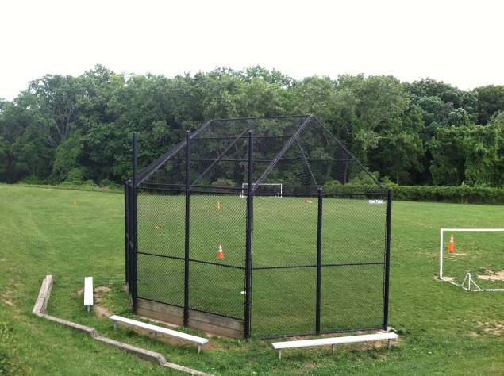

Brian's favourite moment of the day is playtime. At school they have lots of sports pitches like a baseball field and a basketball court. This is a photo of the baseball field.

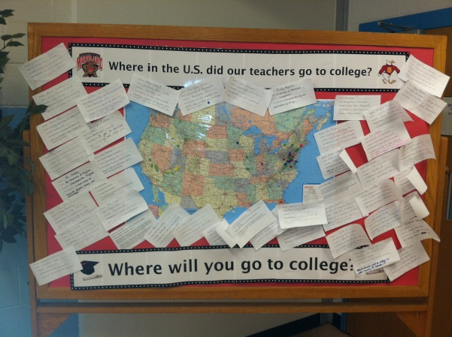

At Brian's school there is a big map of the US. Someone has marked where each of his teachers studied. He likes to dream about what he will do after secondary school. Have you thought about that? What would you like to do? Write it down here:

## Hey Brian, what is school like in the US?

Everyone eats their lunch at school. Some students bring a lunch from home. Others eat a hot meal at school. What would you like best? Tick one box. There are no right or wrong answers. Just choose the answer that suits you best.

I prefer to bring my own lunch to school. That way I get food that I like.

I prefer eating a hot meal at school even though they sometimes serve something that I don't like.

I prefer to see the school menu. That way I can choose which days I bring my own lunch and which days I eat a hot meal.

Als juist: Well done! That way you always eat something that you like!

Als fout eerste keer: Are you sure? You can change your answer if you want.

Als fout tweede keer: Bon appétit!

## Güray, what is school like in Turkey?

This is Güray. He goes to school in Antalya. That is a city in southern Turkey, near the sea. It is a beautiful city with lovely beaches. Lots of tourists visit Antalya on holiday. Would you like to know what Güray's school is like? ****

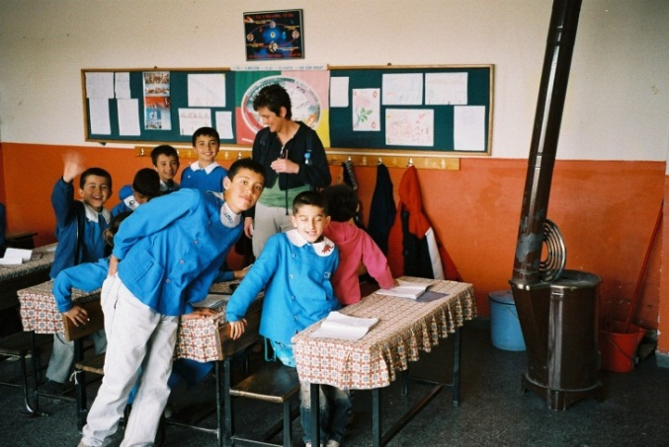Cosiness is very important in Güray's class. That's why the school puts tablecloths on all the benches. There is an old stove in the class. That way it does not get too cold in the winter. But they do not use the stove very often because the weather in Antalya is usually very good. Do you have any ideas on how to make your class cosier? Write them down here:

## Güray, what is school like in Turkey?

In Güray's school it is important to have good manners. That's why everyone wears a clean uniform. Even the teacher dresses nicely. He wears a suit and tie.

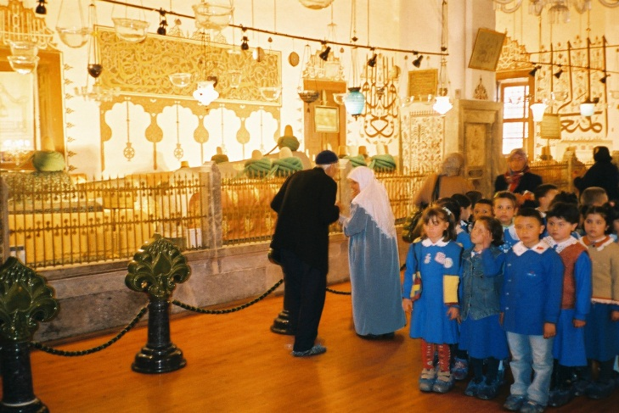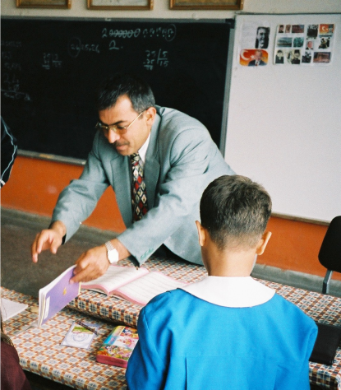From time to time Güray's class goes on an outing. On this photo you see him standing in line on an outing in the Dervish museum. Do you go on outings with your class? Write down one place where you have been on a school outing:

## Hey Constanza, what is school like in Argentina?

Constanza is from Argentina. She goes to school in Goya. That is a small city to the north of Argentina, close to Brazil and Paraguay. Shall we take a look at her school?

Constanza has to be at school at eight o'clock every morning. School lasts until one in the afternoon. She never has to stay at school for lunch. Argentineans take a siesta in the afternoon. During the siesta no one works or follows lessons. The siesta was invented in warm countries because it is too hot to work in the afternoon. Shops are also closed. The siesta ends at five in the afternoon. Another group of children then go to Constanza's school. They follow lessons until ten at night.

Why is there a siesta in Argentina? Tick the correct box.

The siesta allows people to rest in the afternoon because it is too hot to work.

The siesta allows people to take a nap in the afternoon so they can stay up later at night.

The siesta allows students to study in the afternoon so they do not have to study in the evenings.

The siesta allows people to go swimming in the afternoon because it is nice and warm outside.

Als juist: Yes! That's right. The siesta was invented so that people do not have to work in such hot weather.

Als fout eerste keer: That is not the correct answer. Read the statements again and try to improve your answer.

Als fout tweede keer: No, that is not the correct answer. The siesta allows people to rest in the afternoon because it is too hot to work.

## Hey Constanza, what is school like in Argentina?

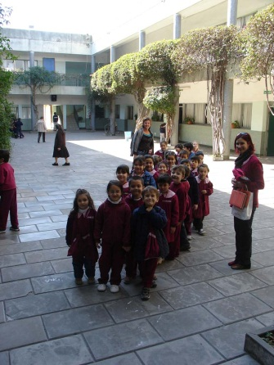

At Constanza's school, all the students have to stand in line on the playground before the lessons start in the morning. Everyone sings the Argentine national anthem and they raise the Argentine flag. Do you know the Belgian national anthem?

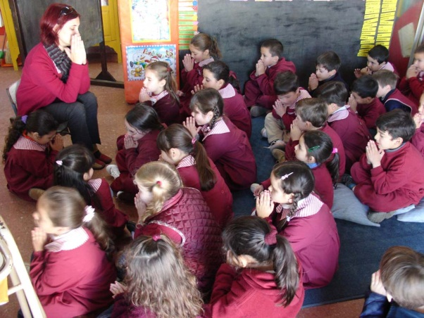

When they enter the classroom, the first thing they do is pray. The teacher says a prayer and all the students listen carefully and think to themselves quietly.

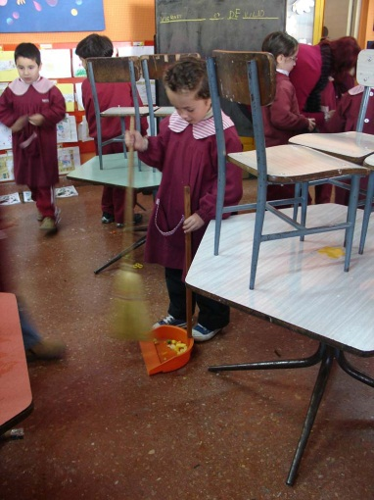

At school all the students work together to make sure that the school stays clean. Before they go home at one o'clock, they sweep the classroom so that the cleaners have less work. The entire class helps out so the work is done quickly. Do you help keep your school clean? What could you do to ensure that your school stays clean? Write your ideas here:

## We can learn from each other!

What did you think of Güray, Brian, Weiyi and Constanza's schools? The culture in other countries and other schools is a little bit different. Don't start thinking that all the schools in Turkey, the US, China or Argentina are the same. There are big differences between schools in Belgium and the same is true in other countries.

What did you like in the schools of the four students that you just met? Which elements would you like to have at your school?

Tick which elements of the schools you would like to have at your school. You can tick more than one box.

|  |  |
| --- | --- |
|  |  |
| A beautiful school building like Weiyi's school in China | To be able to choose if I eat a hot meal at school or bring something from home like Brian in the US |
| A smaller class like Weiyi in China | Lessons very early in the morning and no school in the afternoon like Constanza in Argentina |
| Wearing a uniform like Weiyi, Constanza and Güray | Singing the national anthem before starting the lessons like Constanza in Argentina |
| A baseball field and basketball court like Brian in the US | A prayer before starting the lessons like Constanza in Argentina |
| Teachers that wear a suit like in Güray's school in Turkey | Working together to keep the school clean like Constanza in Argentina |
| Tablecloths on the benches like in Güray's school in Turkey |  |

Als juist: Interesting! Hopefully your dreams for a nicer school will come true!

Als fout eerste keer: Did you read everything? You can still tick some more ideas.

Als fout tweede keer: Interesting! Hopefully your dreams for a nicer school will come true!

## We can learn from each other!

Are there things about your school that you would like to share with the students that you just met? You can give them tips about how to make their school better or more fun. Write a letter to one of the four international students. Explain how your school works and which things would be fun to try at their school.

Which student are you going to write a letter to? Tick one of the boxes. You can write your letter below (you get 5 minutes).

Feedback als klaar met schrijven: “What a great letter! Your far-away friend will surely love it! But we have to continue because you still have to take a test.”

I want to write a letter to Weiyi in China I want to write a letter to Brian in the United States

I want to write a letter to Güray in Turkey I want to write a letter to Constanza in Argentina



Phase 3: MC

1. Cultures are…
2. … all the same.
3. … not better than one another, just different.
4. … different and some are better than others.

* Als juist: Good job! That is correct.
* Als fout: Oops! The correct answer is: Cultures are not better than one another, just different.

1. What are the three official languages in Belgium?
2. Dutch, Flemish and French.
3. Dutch, French and English.
4. Dutch, French and German.

* Als juist: Yes! That's right! Well done!
* Als fout: Wrong. The correct answer is Dutch, French and German.

1. Why does every family have its own culture?
2. Because the members of each family share a number of habits.
3. Because the members of each family live in the same house.
4. Because the members of each family are all different.

* Als juist: That's right! Each family has its own culture because they share the same habits.
* Als fout: No, that’s not correct. They have their own culture because they share the same habits.