**Topic: On the road**

Subtopic 1: Watch out for the traffic!

Phase 0: MC a

Before we begin this lesson, we will ask you a few questions. This is not a test so don't worry if you make mistakes. During the lesson you will learn the correct answers.

1. Why is the air pollution that hangs above cities called smog?
2. Smog is a combination of the words 'smoke' and 'fog'.
3. Smog sounds like an engine that is starting.
4. Smog can be pronounced correctly in different languages.
5. Smog sounds boring and grey, which is what it looks like.
6. Which of the following sentences is true?
7. If you have an airbag in the car you should not wear a seat belt.
8. It is a good idea to wear a helmet when cycling but it is not required.
9. You only have to wear a seat belt in the front seat.
10. You only have to turn your bicycle lights on when it is completely dark.
11. What does this traffic sign mean?
12. 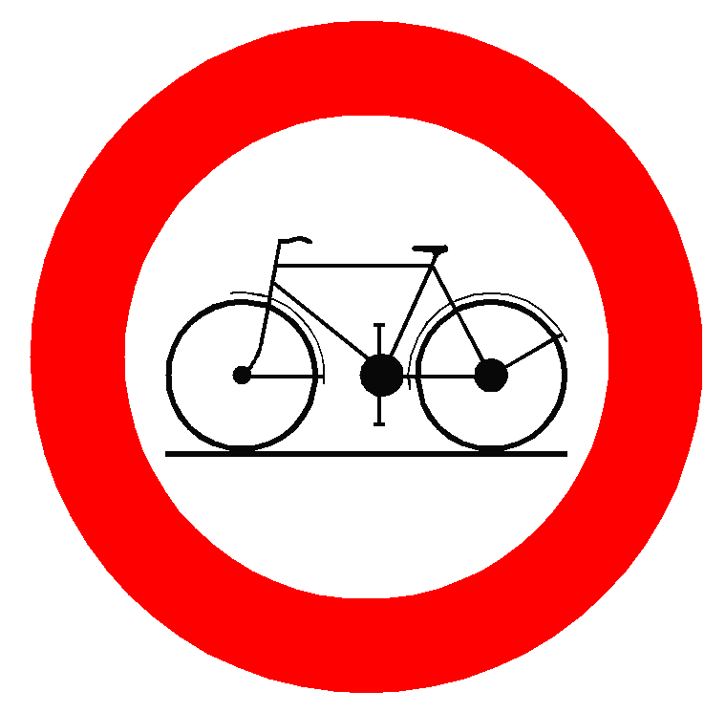All cyclists must use this cycle track.
13. Cyclists are not allowed to turn into this street.
14. This sign is meant for drivers of cars, they must look out for cyclists.
15. Cyclists have right of way.
16. What is carpooling?
17. A sport that is a bit like billiards.
18. Parking the car at the station and continuing the trip by train.
19. A special bus that takes you to the swimming pool.
20. Several people that ride together in the same car to a destination.

Phase 1: Lesson a

How do you go to school every day? Do you walk? Ride your bicycle? Take public transportation? Does someone bring you by car? The roads can be very busy sometimes and that can be dangerous!

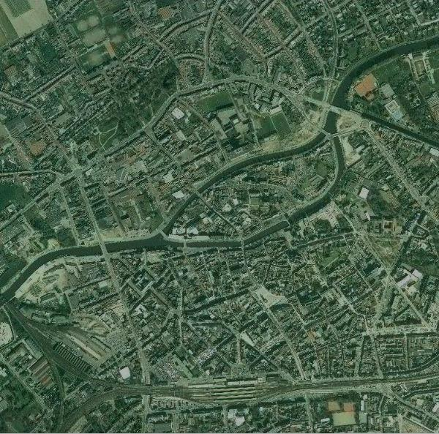How do you go to school every day?

In the newspaper:

**Two road deaths per day in Belgium**

Belgium – There are 45,000 traffic accidents in Belgium every year, that is about 123 per day. Luckily most road accidents are not fatal. Across Belgium 800 people die in road accidents every year, that is about two per day.

http://westerbroek.com/joomla/images/gis/markers/Gevaarsbord.pngCyclists and pedestrians are more likely to be injured in road accidents than drivers. That is because they have little or no protection.   
Therefore they are called ‘vulnerable road users’.

|  |
| --- |
| How can you protect yourself against accidents? |
| Unfortunately accidents happen, but there are easy ways to make sure that the consequences are less severe.  Do you ride a bicycle? Be sure to wear a helmet.  Are you driven by car?  - A seat belt is required in the front seat and the back seat of a car.  - Always wear a seat belt, even if the car has an airbag!  Do you like to roller skate? Did you know that you can get protection for your knees, wrists and elbows? This protection will help prevent breaking bones if you should fall. |

|  |
| --- |
| How can you prevent accidents?  Sometimes it is difficult for drivers to see pedestrians and cyclists. When it is dark they cannot see you very well and accidents can happen.  Pedestrians and cyclists must make sure that they can be seen by drivers.    They can do this by:  - turning on their cycle lights  - wearing a reflective vest  - attaching reflectors to the front and rear wheels of your bicycle.  You are required to turn your lights on at twilight or when it is dark. If you cannot see further than 200 metres in front of you then you must turn your lights on!  How does a reflector work?  A reflector is made up of millions of small shiny beads. Those beads reflect the incoming light back to the object that gives off the light. Reflectors work best when they are clean! |



Phase 2: Application a

What protects who? Choose the objects that protect each of these people in traffic. One person can be protected by several objects. Drag the correct protection to each person.

|  |
| --- |
|  |
|  |
|  |

‘roller skates’

‘bicycle’

‘car’

‘knee protectors’

‘helmet’

‘seat belt’

‘reflective vest’

* Als juist: Congratulations! You matched all persons with the correct objects.
* Als fout eerste keer: A few things are in the wrong place. Try again.
* Als fout tweede keer: Oops! Not all objects are in the right place. Better luck next time! Look at the correct answers.

Correct or incorrect? Read the sentences and decide whether they are correct or incorrect.

|  |  |  |
| --- | --- | --- |
| If you have an airbag in the car then you do not need to wear a seat belt.   * This is incorrect. Even if you have an airbag in the car, you are required to wear a seat belt. | http://www.fcblaasveld.be/7325/20102011/afbeeldingen/Verkeerslicht_Groen_TP.pngcorrect | http://www.fcblaasveld.be/7325/20102011/afbeeldingen/Verkeerslicht_Rood_TP.pngincorrect |
| When it gets dark it becomes more difficult to see cyclists. To make sure that they are visible, they must use lights and reflectors.   * This is correct. When it starts to become dark cyclists must turn on their lights so they are visible to motorists. | http://www.fcblaasveld.be/7325/20102011/afbeeldingen/Verkeerslicht_Groen_TP.pngcorrect | http://www.fcblaasveld.be/7325/20102011/afbeeldingen/Verkeerslicht_Rood_TP.pngincorrect |
| People die in most accidents in Belgium.   * This is incorrect. Luckily most traffic accidents do not result in death. | http://www.fcblaasveld.be/7325/20102011/afbeeldingen/Verkeerslicht_Groen_TP.pngcorrect | http://www.fcblaasveld.be/7325/20102011/afbeeldingen/Verkeerslicht_Rood_TP.pngincorrect |
| A reflector does not give off light. It only reflects light that shines on it.   * This is correct. The shiny beads in the reflectors send the light back. | http://www.fcblaasveld.be/7325/20102011/afbeeldingen/Verkeerslicht_Groen_TP.pngcorrect | http://www.fcblaasveld.be/7325/20102011/afbeeldingen/Verkeerslicht_Rood_TP.pngincorrect |

The traffic doctor gives good advice about traffic. The traffic doctor is sick today but a question has come in. Can you help him? This is the e-mail that he received this morning.

Dear traffic doctor,

I have a dance lesson tomorrow. It is the first time that I will be returning home by bicycle. Mum says that it is sometimes difficult for cars to see cyclists. What can I do so that the cars see me?

Greetings, Alyssa

What would you advise Alyssa to do? Write a reply to Alyssa.

reflectors – reflective vest – cycle light

Perhaps you can write something about a reflective vest. What else can Alyssa use?

Thank you for your answer! The traffic doctor does not have to worry about this letter anymore!

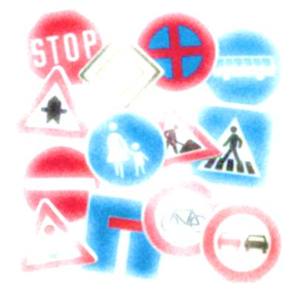Phase 1: Lesson b

Are you familiar with all the traffic signs that you see on your way to school?  
Do you ever see these signs? Do you know what they mean?

Traffic signs

Here are the most important traffic signs and their meaning.

|  |  |  |  |  |
| --- | --- | --- | --- | --- |
|  | **No entry**  Sometimes there is a small sign below it that says ‘except cycles’. That means that the 'no entry' sign does not apply for cyclists. You are allowed to turn into this street with your bicycle. |  |  | **Mandatory cycle track**  This sign shows the cycle track that all cyclists must use. |
|  |  |  |  |  |
|  | **No entry for cycles**  Cyclists are not allowed to turn into this street. Cars, however, can enter this street. |  |  | **Advanced stop lines**  Sometimes you see this sign at traffic lights. Just in front of the traffic lights there is an area where cyclists must wait for the light to turn green. The cars are behind the cyclists. |

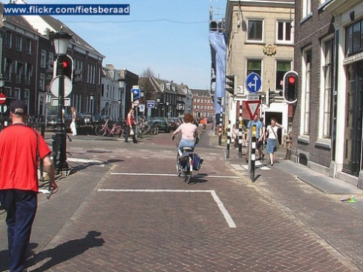



Right of way? What is that?

Giving priority or 'right of way' means that you stop in traffic and let someone else go first.

Here are a few situations when you must do that:

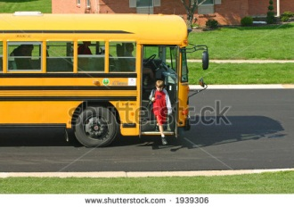

A bus that is leaving the bus stop has priority. Let the bus go first.

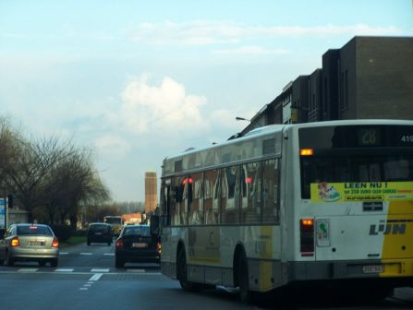

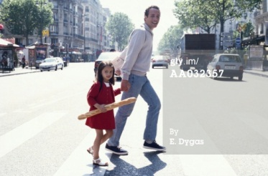

If pedestrians want to cross the street at a pedestrian crossing then you must let them go first.

Passengers getting on or off a bus or tram do not always watch out. You must wait before you continue your trip.

Phase 2: Application b

Which traffic sign belongs to which explanation? Match the explanations to the correct traffic signs.

Als juist: Good job! Everything is in the right place!

Als fout eerste keer: A few things are in the wrong place. Can you fix that?

Als fout tweede keer: Oops, this is not completely correct. Take a look at the correct answers. You will do better next time.

When must you give priority?

Colour the dots next to the situations when you must give priority. You will have to colour more than one dot.

1. You are riding alongside a bus. At the bus stop ahead a few people are waiting to get on the bus. 🡪 CORRECT, you must give priority.
2. A car is leaving a garage and it wants to drive on the road. 🡪 INCORRECT, do not give priority.

* They are not obliged to stop but they must make sure that the driver of the car has seen them (eye contact). To prevent accidents, it is better to stop too often than not enough.

1. You ride to an intersection and see that the lights are green for you. Some pedestrians are waiting to cross the street, they have a red light. 🡪 INCORRECT, do not give priority.
2. A pedestrian crossing is coming up and two people arrive who want to cross the street. 🡪 CORRECT, you must give priority.

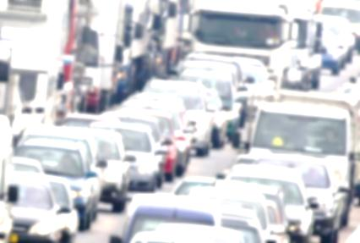Phase 1: Lesson c

Why are there so many traffic jams? Can we do something about it? Read the text below and you will find out!

Have you ever listened to the travel news on the radio?

Sometimes you hear that **the E313 is saturated**.   
But what does that mean?

**E313?** The E313 is a motorway. All European motorways start with the letter E and end with a number.

**Saturated?** If the E313 is saturated then that means there is a traffic jam on the E313.

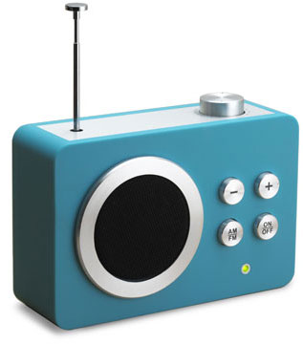

How do traffic jams start?

1. There are too many cars.

There are 5 million cars in Belgium. That means about one car for every two people. Do we need all those cars?

1. Most cars only have one person in them.
2. Everyone has to be in the same place at the same time.

The busiest moments on the road are between 8 and 9 in the morning and between 6 and 7 in the evening. At other moments of the day it is much quieter on the road.

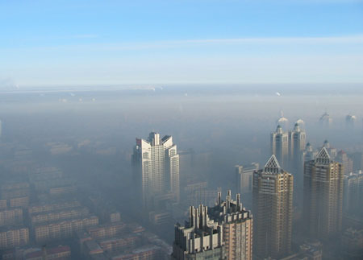

What problems are caused by those cars?

1. Smog

Smog is a combination of smoke and fog and refers to smoky fog.

Smog is formed when the weather is warm and sunny.  
Smog is a grey cloud of exhaust gases that hang in the air.

1. Environment

Exhaust gases are also bad for the environment. They are one of the causes of global warming.

How to reduce traffic jams and environmental problems

1. Carpooling

Carpooling means that several people ride together in one car to their destination. That way there are fewer cars on the road and fewer traffic jams.

1. Use public transportation

Travelling by train or bus means there are fewer cars on the road. And trains and buses are a great way of getting to your destination.

Smog in the Chinese city of Harbin.

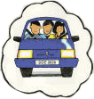

Phase 2: Application c

Radio reports about traffic jams



Travel news. Road construction is causing disruptions on the E40 in the direction of Ghent between Aalst and Erpe-Mere. Traffic must travel on one lane. There is slow traffic on the E314 in the direction of Leuven between Houthalen and Lummen. There is a traffic jam on the E19 in the direction of Brussels caused by an accident in Zemst. The right lane is closed. Speed patrols on the E17 in the direction of Antwerp between Sint-Niklaas and Haasdonk and in the direction of Kortrijk between Zulte and Waregem, as well as on the E34 in the direction of the Netherlands between Oud-Turnhout and Arendonk.

Read the questions and click on the radio to start the travel news. Listen carefully and answer the questions. If you missed something, don't worry. You can click on the radio to hear the travel news again. You can listen to the news three times.

* Why is there a disruption on the E40 in the direction of Ghent?..........................................................................................................
* Is there a traffic jam on the E40 in the direction of Brussels in Aalst? …………………………………………………………………………………………………
* Where was there an accident? ……………………………………………………………………………………………………………………………………………………………
* What does the travel news say about the E17 and the E34? ………………………………………………………………………………………………………………

Thank you for your answers! Now I can get to my destination on time!

How to tackle traffic jams?

How can we tackle traffic jams together? Choose the correct word by clicking on it.

* 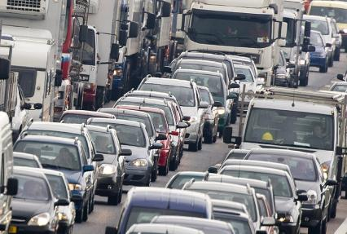There are traffic jams on Belgian roads every day. That is not only unpleasant, it is also good / bad for the environment.
* Als juist: Yes, that's right! Good job!
* Als fout: Incorrect. Traffic jams are bad for the environment. The cars give off exhaust gases and those are not good for the environment.
* On summer days / winter days a layer of smog sometimes hangs over big cities.
* Als juist: Good job! That is correct.
* Als fout: The smog usually hangs around on summer days. That often occurs when the weather is very warm and there is no wind.
* Carpooling means that people travel to work together in the same car / using public transportation.
* Als juist: That is great! Congratulations!
* Als fout: Carpooling is always by car. 'Carpooling' contains the word 'car'.

Phase 3: MC

1. Why are cyclists and pedestrians called vulnerable road users?
2. They ride less fast than cars or lorries.
3. They must protect themselves against accidents. Other road users do not have to do this.
4. They are less well protected than other road users.
5. They are often younger than other road users and have less experience in traffic.

* Als juist: That's right! Well done! Cyclists and pedestrians are called vulnerable road users because they are less well protected.
* Als fout: No, that’s not correct. Cyclists and pedestrians are called vulnerable road users because they are less well protected than other road users.

1. Which of the following sentences is true?
2. If pedestrians want to cross the street at a pedestrian crossing then they must always wait until there is no traffic.
3. A bus that is leaving the bus stop has priority.
4. Traffic signs are only important if you are driving a car.
5. It is safer for cyclists to ride in the middle of the road.

* Als juist: That's right. Good job! Always give a bus priority if it indicates that it wants to move out.
* Als fout: That's not right. This sentence is incorrect. The correct sentence is: A bus that is leaving the bus stop has priority.

1. What does this traffic sign mean?
2. 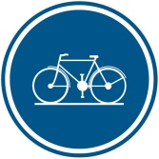All cyclists must use this cycle track.
3. Cyclists are not allowed to turn into this street.
4. This sign is meant for drivers of cars, they must look out for cyclists.
5. Cyclists have right of way.

* Als fout: Incorrect. This traffic sign means that all cyclists must use the cycle track.
* Als juist: Correct! Well done!

1. How do reflectors work?
2. Reflectors are charged in the sunlight and give off that light when it is dark.
3. I create energy when I cycle so that my reflectors shine.
4. Reflectors start to shine when you rub them together.
5. The small shiny beads in reflectors reflect the light that shines on it.

* Als juist: That's right! Well done!
* Als fout: No, reflectors reflect the light that shines on it.